|  |
| --- |
| System Document |
| Recreation Facility Management Scheduling System |
|  |
| **SAIT** |
| **4/15/2010** |

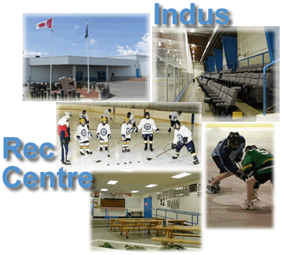

**Team Members:**

Corey Cantley

John Stuby

Jorge Pinochet

Kerri Lynch-O’Loughlin

**Client:** Indus Recreational Centre

**Instructor:** Randy Kaltenbach

Table of Contents

1.0 Preface 10

1.1 Purpose 10

1.2 Documentation Standards 10

2.0 System Overview 11

2.1 System Purpose 11

2.2 Clients 11

2.3 End-Users 11

2.4 Main Functions of the System 11

3.0 User Requirements 13

3.1 Business Overview and Objectives 13

3.2 Project Overview 13

3.2.1 Statement of the Problem 13

3.2.2 Project Scope 13

3.2.3 System Environment 14

3.2.4 Current System 15

4.0 System Requirements 16

4.1 Use Case Diagram 16

4.2 Use Case Descriptions and Scenarios 17

4.2.1 Maintain Employees 17

4.2.2 Maintain Facilities 18

4.2.3 Maintain Booking Types 18

4.2.4 Maintain Additional Charge(s) 19

4.2.5 Maintain Unpaid Invoices 20

4.2.6 Maintain Rates 21

4.2.7 Report All Invoices for a Client 22

4.2.8 Maintain Invoicing 23

4.2.9 Maintain Organizations 24

4.2.10 Maintain Clients 24

4.2.11 Maintain Bookings 25

4.2.12 View Bookings 26

4.2.13 Request Booking 26

4.2.14 View Invoices 27

4.4 Non-Functional Requirements 28

4.5 System Interface Requirements 29

4.5.1 Login: 29

4.5.1.1 Login Screen: 29

4.5.1.2 Logged in: 29

4.5.2 Schedule: 30

4.5.2.1 Schedule Screen: 30

4.5.2.2 Choose Facility 30

4.5.2.3 Choose Date: 31

4.5.2.4 Choose View: 31

4.5.2.5 Make a booking: 32

4.5.3 Accounting: 32

4.5.3.1 Accounting Screen: 32

4.5.3.2 Unpaid Booking: 33

4.5.3.3 Accounting Screen: 33

4.5.3.4 Enter Clients Name: 34

4.5.3.5 Search for a client: 34

4.5.3.6 View paid and outstanding invoices: 35

4.5.3.7 Details of bookings on invoice: 35

4.5.3.8 Email Report: 36

4.5.3.9 Invoice Emailed: 36

4.5.3.10 Print Report: 37

4.5.3.11 Print copy: 37

4.5.3.12 Export to Excel: 38

4.5.3.13 Open in excel: 38

4.5.3.14 Excel: 39

4.5.3.15 Payment Needed: 39

4.5.3.16 Report all Invoices: 40

4.5.3.17 Report containing all invoices: 40

4.5.3.18 New Invoice: 41

4.5.3.19 Choose booking to make new invoice: 41

4.5.4 Client: 42

4.5.4.1 Client Screen: 42

4.5.4.2 Search for a Client: 42

4.5.4.3 View Client: 43

4.5.4.4 Edit Client: 44

4.5.4.5 Client must be 10 digits: 44

4.5.4.6 Add a new Client: 45

4.5.4.7 New Client: 45

4.5.4.8 Client must have an email address: 46

4.5.5 Facilities: 46

4.5.5.1 Facilities Screen: 46

4.5.5.2 List Facilities: 47

4.5.5.3 Enter a Facility: 47

4.5.5.4 Search for a Facility: 48

4.5.5.5 View chosen Facility: 48

4.5.5.6 View Facility details: 49

4.5.5.7 Add new facility: 49

4.5.5.8 Facility Form: 50

4.5.5.9 Facility Name Error: 50

4.5.6 Employees: 51

4.5.6.1 List of Employees: 51

4.5.6.2 Search for Employees: 51

4.5.6.3 View Employee: 52

4.5.6.4 View Employee Details: 52

4.5.6.5 New Employee: 53

4.5.6.6 New Employee Form: 53

4.5.6.7 Employee Password Error: 54

4.5.7 Organization: 54

4.5.7.1 List Organization: 54

4.5.7.2 Search for Organization: 55

4.5.7.3 View search for organization: 55

4.5.7.4 View detail about organizations: 56

4.5.7.5 Add a new Organization: 56

4.5.7.6 New organization form: 57

4.5.7.7 Organization must have a name: 57

4.5.7.8 Organization must have a contact 58

4.6 Usability Requirements 59

4.7 Problem Domain Class Diagram 60

5.0 System Design 61

5.1 Layered Architecture 61

5.2 Hardware Architecture 62

5.3 Hardware Platform 62

5.3.1 Required Hardware Specifications for Development and Maintenance 62

5.3.2 Required Hardware Specifications for the Production System 62

5.3.3 Communication mechanism 63

5.4 Software Platform 64

5.4.1 Required Software Specifications for Development and Maintenance 64

5.4.2 Required Software Specifications for the Production System 64

5.4.3 Alternatives to Software: 65

5.5 Interaction Model 66

5.6 Persistence Model 67

5.6.1 Logical ERD 67

5.6.2 Physical ERD 68

5.7 Class Diagram 69

5.7.1 Problem Domain Layer 69

5.7.2 Persistence Layer 70

5.7.3 Logic Layer 71

5.7.4 HCI Layer 72

5.8 Interaction Sequence Diagrams 73

5.8.1 Additional Charge Sequence Diagram 73

5.8.2 Booking Sequence Diagram 74

5.6.3 Booking Type Sequence Diagram 75

5.6.4 Client Request Booking Sequence Diagram 76

5.6.5 Maintain Client Sequence Diagram 77

5.6.6 Client View Invoice Sequence Diagram 78

5.6.7 Employee Sequence Diagram 79

5.6.8 Facility Sequence Diagram 80

5.6.9 Invoice Sequence Diagram 81

5.6.10 Organization Sequence Diagram 82

5.6.11 Rate Sequence Diagram 83

5.6.12 Report All Client Invoices Sequence Diagram 84

5.6.13 Report Unpaid Invoices Sequence Diagram 85

5.6.14 View Booking Sequence Diagram 86

5.9 Statechart Diagram 87

5.10 Activity Diagram 88

5.11 Data Dictionary 89

6.0 Testing 90

6.1 Test Plans 90

Acceptance Test Criteria 90

Acceptance Testing Form 94

7.0 System Deployment 106

7.1 Overview 106

Purpose 106

Business Context 106

Summary 106

7.2 Assumptions, Dependencies, Constraints 107

Assumptions 107

Dependencies 107

Constraints 108

7.3 Operational Readiness 109

Deployment Diagram 109

Site Preparation 109

Assessment of Deployment Readiness 110

7.4 Data Creation/Conversion 110

7.5 Training and Documentation 111

Training 111

Documentation 111

Documents 112

Documentation Activities 112

7.6 Maintenance Planning 112

7.7 Release Planning 113

Release of the Product 113

Contingency Planning 113

7.8 Changeover Strategy 113

8.0 System Administration and Maintenance 114

8.1 System Administration 114

8.2 System Maintenance 114

9.0 Deficiency List 116

9.1 Requirements Not Met 116

9.2 Non-Functioning Components 116

Glossary 117

Appendix A 118

Interview Questions: 118

Interview Answers 118

Appendix B 120

User requests: 120

Appendices: C 121

Appendix D 125

Appendices: E 131

Appendices: F **Error! Bookmark not defined.**

Index 132

# 1.0 Preface

## Purpose

The purpose of this document is to outline the Indus Recreational Facility Management System (IRFMS) and uses. Our documentation of the system will allow for our programmers to use this document and expand on the core system. This document will encompass the following areas: HCI, persistence, and business functionality.

## Documentation Standards

* Cambria size 40: title of document
* Cambria size 22: subtitle of document, heading
* Title page bold: used for 1 or more bold items under the subheading
* Table of contents:
  + Heading 1: used for main subjects of document
  + Heading 2: used for pieces of main subject
  + Heading 3: used for sub information of main subject

Bold Throughout document: used for important information

# System Overview

### 2.1 System Purpose

The IRFMS is a facility management system that was designed to enable a user to maintain a facility with ease.

With an easy to use interface staff of the recreational centre can book events and customize the add-ons to meet the needs of their clientele. Scheduling can be done simply by clicking on the requested time and reserving that time slot for the client. If the client is not in the system they can be added simply by going to the ‘Client’ tab and then clicking on the ‘new client’ link. When it’s time to collect payment , an employee can click on the ‘Accounting’ tab and create an invoice for a particular booking or multiple bookings.

### 2.2 Clients

The clientele of the Indus recreational facility will benefit from the enhancements to the managerial system. They will be given their own online account where they can review invoices, view the centres schedule and also request a booking for a particular facility. This enables the staff of Indus to maintain control of the system while giving clients extra functionality by having access to their billings and bookings. For quick access to the schedule a client or member of the public can also view the schedule on the Indus website where there will be no requirement to login.

### 2.3 End-Users

* Facility manager: organizes and runs the scheduling for Indus
* Accountant: takes care of money tasks, and keeps/ updates the books
* General employees (upkeep of facility, caterers): clean facility and maintain all recreational resources
* General Public: View the invoices for their accounts, the schedules for the facilities they are interested in booking, and to request times for facilities.

### 2.4 Main Functions of the System

The Indus Recreational Facility will do the following:

* Create, delete, update and view additional charges
* Create, delete, update and view rates
* Create, delete, update and view facilities
* Create, delete, update bookings and view the schedule
  + - Clients will be able to view schedules
    - Clients will also be able to request facility times
* Create, delete, update and view clients
* Create, delete, update and view organizations
* Create, delete, update and view invoices
  + - Adds multiple bookings to an invoice
    - Clients will be able to view their invoices

# 3.0 User Requirements

# 3.1 Business Overview and Objectives

* Non- profit organization used to improve the lifestyle choices of the community, by providing an outlet for sports and recreation.
* To maintain and encourage the improvement of the quality of life for persons living in the rural community. To support and encourage volunteers to develop programs and services related to facilities based on the needs of the community.
* Provide recreational services
* Schedule time for persons to use their facilities.
* Provide catering resources and facilities.

## 3.2 Project Overview

### 3.2.1 Statement of the Problem

The main problems that the current system has are as follows:

* The invoicing process for both creating and printing is inefficient.
* The scheduling system is missing some functionality, in particular the ability to book catering, daily activities, outdoor facilities and meeting rooms using the program. This process is currently done through paper tracking.
* The system is too complex for users that need to be able to use it; the system needs to be simplified to accommodate those new to computers.

Problems integrating applications with accounting programs for invoices

### 3.2.2 Project Scope

The scope of the Recreation Facility Management Scheduling System is as follows:

The organization requires monthly invoices that must include an excel version of the invoice data. It must also contain information about each clients usage, and cost for the month. Contact information must also be included for the client should it be necessary to contact them.

The organization allows their clients to view the recreational centers schedule online. This currently includes the ice rink and banquet hall but it needs to be expanded to include meeting rooms, daily camps/daycare and outdoor fields. The calendar should also include a search option to show if there is free ice time at a requested time.

The organization may grow in the near future, so the system should contain an option to add new features to the system, such as new playing fields, ice rinks or more meeting rooms.

The invoices for each client should include an explanation of all costs and if this includes the banquet hall, have the catering costs on the same invoice. This should appear in an excel spreadsheet format.

* + Invoice Numbers are required to charge clients for booking, must auto populate when ringing clients up.

The organization requires remote access in two different ways, for the general public this will be limited to schedules of facility activities along with search option for free ice time, field time or room time. For employees it will show the full program and allow access to all functions, including, scheduling, invoicing and any and all other features.

### 3.2.3 System Environment

The current system uses various computers and software. The main business software they use is EZFacility, which manages their facility scheduling and also allows remote access to viewing facility schedules. The Indus recreational facility is being charged to access to this server monthly and it only manages 2 of their facilities.

They also use QuickBooks for their accounting needs. QuickBooks is able to import Excel files to manage invoices and the staff members at the Indus recreational have expressed interest in the new system being able to export information to excel for the purpose of important it into QuickBooks or other accounting software they may switch to in the future.

The facility manager of Indus also has a computer that is used mainly for the booking of facility times with the EZFacility system. The employees of Indus are unable is used mainly for the booking of facility times with the EZFacility system. The employees of Indus are unable to access their management system off site however, instead forced only to be able to view the schedule and physically write down the booking they receive and enter it into the system when they are back on site.

The Indus center hopes to be expanding in the near future. The current system that they are paying for will not be able to accommodate this change unless they are willing to pay a supplementary fee for each new facility they add to their system.

### 3.2.4 Current System

* The system that is currently being used at Indus Recreational Facility is EZFacility 4.0, it is a web based application that has limitations, which include:
  + integrating the application with accounting software
  + scheduling system is missing multiple parts of facility
  + System overall is too complex for users.
  + System is missing an option to increase facilities in the event of a twinning (addition of another recreational facility from a neighboring hamlet).

# 4.0 System Requirements

## 4.1 Use Case Diagram

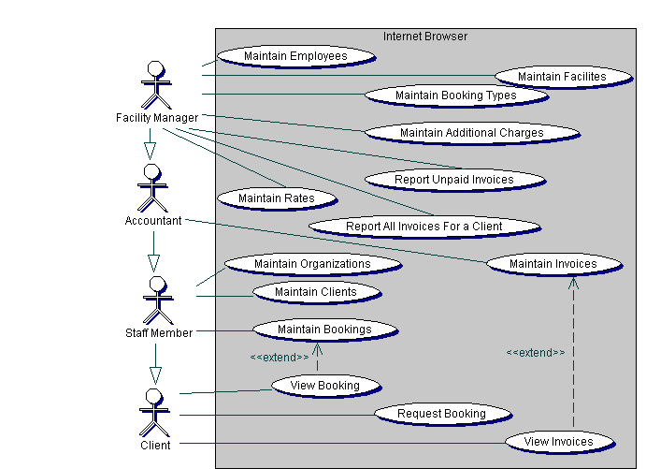

## 4.2 Use Case Descriptions and Scenarios

### 4.2.1 Maintain Employees

**Pre-Condition:** The staff member has selected the Employee tab of the application.

**Post-Condition:** None.

**Limitation:** Staff member can switch tabs at any moment.

|  |  |
| --- | --- |
| **Actor Action** | **System Response** |
|  | 1. Display all current employees. |
| 1. Select a current employee | 1. Display employee details |
| Staff member will either   1. Change information and save. | 1. If employee information is valid, system updates employee (refer to error flow *.1). |
| -or-   1. Delete | 1. If deletion of employee is successful, employee is deleted (refer to error flow *.1). |
| -or-   1. User will add new employee information and save | 1. If employee information is valid, system adds employee (refer to error flow *.1). |
| 1. User will search | 1. If employees are found- display list of all Employees found 2. If no employees are found- display error message (refer to error flow *.1). |

### 4.2.2 Maintain Facilities

**Pre-Condition:** The staff member has selected the Facility tab of the application.

**Post-Condition:** None.

**Limitation:** Staff member can switch tabs at any moment.

|  |  |
| --- | --- |
| **Actor Action** | **System Response** |
|  | * 1. Display all current facilities. |
| 1. Select a current facility | 1. Display facility details |
| Staff member either   1. Change information and save | 1. If facility information is valid, system updates facility (refer to error flow *.1). |
| -or-   1. Delete | 1. If deletion of facility is successful, facility is deleted (refer to error flow *.1). |
| -or–   1. User will add new facility information and click save | 1. If facility information is valid, system adds employee (refer to error flow *.1). |
| 1. User will search | 1. If facilities are found- display list of all Employees found 2. If no facilities are found- display error message (refer to error flow *.1). |

### 4.2.3 Maintain Booking Types

**Pre-Condition:** The staff member has selected the Management tab of the application.

**Post-Condition:** None

**Limitation:** Staff member can switch tabs at any moment.

|  |  |
| --- | --- |
| **Actor Action** | **System Response** |
|  | * 1. Display all current booking types. |
| 1. Select a current booking type | 1. Display booking type details. |
| Staff member will either   1. Change information and save. | 1. If booking type information is valid, system updates booking type (refer to error flow *.1). |
| -or-   1. Delete | 1. If deletion of booking type is successful, booking type is deleted (refer to error flow *.1). |
| -or-   1. User will add new booking type information and click save | 1. If booking type information is valid, system adds employee (refer to error flow *.1). |
| 1. User will click search | 1. If booking types are found- display list of all employees found 2. If no employees are found- display error message (refer to error flow *.1). |

### 4.2.4 Maintain Additional Charge(s)

**Pre-Condition:** The staff member has selected the Management tab of the application.

**Post-Condition:** None

**Limitation:** Staff member can switch tabs at any moment.

|  |  |
| --- | --- |
| **Actor Action** | **System Response** |
|  | * 1. Display all current additional charges. |
| * 1. Select a current additional charge |  |
|  | * 1. Display additional charge details. |
| Staff member either   1. Changes information and press save. | 1. If additional charge information is valid, system updates additional charge(s) (refer to error flow *.1). |
| -or-   1. Delete | 1. If deletion of additional charge is successful, additional charge is deleted (refer to error flow *.1). |
| -or-   1. User will add new additional charge information and press save. | 1. If additional charge information is valid, system adds additional charge (refer to error flow *.1). |
| -or-   1. User will search | 1. If additional charges are found- display list of all additional charges found. 2. If no additional charges are found- display error message (refer to error flow *.1) |

### 4.2.5 Maintain Unpaid Invoices

**Pre-Condition:** Accounting tab is selected.

**Post-Condition:** None

**Limitation:** Bookings must have been created.

|  |  |
| --- | --- |
| **Actor Action** | **System Response** |
| A staff member can:   * 1. Select the Report all Unpaid Invoices link | * 1. Search for all unpaid bookings. |
| * 1. Review report |  |
| * 1. Use browser to print report |  |
| * 1. Return to Accounting Screen | * 1. Displays Accounting screen |
| A staff member can:   * 1. Enter client name and hit the search button | * 1. Search for the client name   If found:   * 1. Display invoices for the client |
| A staff member can:   * 1. Select new invoice or an existing invoice (Alternate Flow 5.1) | * 1. Display Invoice information |
| A staff member can:   * 1. Enter client name and hit the search button | 1. Search for the client name   If found:   1. Display invoices for the client |
| A staff member can:  5.1.1. Choose to print |  |
| -and/or-  5.1.2. Choose to email |  |
| -and/or-  5.1.3. Choose to export as an excel document |  |
|  | 5.1.14. Print, email and export to excel as user has selected above |

### 4.2.6 Maintain Rates

**Pre-Condition:** The staff member has selected the Management tab of the application.

**Post-Condition:** None

**Limitation:** Staff member can switch tabs at any moment.

|  |  |
| --- | --- |
| **Actor Action** | **System Response** |
|  | * 1. Display all current rates. |
| 1. Select a current rate | 1. Display rate details. |
| Staff member selects either   1. Change information and save. | 1. If rate information is valid, system updates rate (refer to error flow *.1). |
| -or-   1. Delete | 1. If deletion of rate is successful, rate is deleted (refer to error flow *.1). |
| -or-   1. User will add rate information and save. | 1. If rate information is valid, system adds rate (refer to error flow *.1). |
| -or-   1. User will search | 1. If rates are found- display list of all rates found 2. If no rates are found- display error message (refer to error flow *.1). |

Error Flow *.1

At any time, invalid event information is entered or a database operation fails.

|  |  |
| --- | --- |
| **Actor Action** | **System Response** |
|  | *.1 Display error message. |
|  | *.2 Do not display invoices that have already been included and paid on another invoice. |

### 4.2.7 Report All Invoices for a Client

**Pre-Condition:** Accounting tab is selected.

**Post-Condition:** None

**Limitation:** Bookings must have been created.

|  |  |
| --- | --- |
| **Actor Action** | **System Response** |
| A staff member can:   1. Enter client name and hit the search button | 1. Search for the client name   If found:   1. Display invoices for the client |
| A staff member can:   1. Select Report all Client Invoices | 1. Display all Invoices for client |
| 1. Review report |  |
| 1. Use browser to print report |  |
| 1. Return to Accounting Screen | 1. Displays Accounting screen |
| A staff member can:   1. Enter client name and hit the search button | 1. Search for the client name   If found:   1. Display invoices for the client |
| A staff member can:   1. Select new invoice or an existing invoice (Alternate Flow 13.1) | 1. Display Invoice information |
| A staff member can:   1. Enter client name and hit the search button | 1. Search for the client name   If found:   1. Display invoices for the client |
| A staff member can:  13.1.1. Choose to print |  |
| -and/or-  13.1.2. Choose to email |  |
| -and/or-  13.1.3. Choose to export as an excel document |  |
|  | 13.1.4. Print, email and export to excel as user has selected above |

### 4.2.8 Maintain Invoicing

**Pre-Condition:** Accounting tab is selected.

**Post-Condition:** None

**Limitation:** Bookings must have been created.

|  |  |
| --- | --- |
| **Actor Action** | **System Response** |
| A staff member can:   1. Enter Client name and hit the search button | 1. Search for the Client name   If found:   1. Display invoices for the client |
| A staff member can:   1. Select new invoice or an existing invoice (Alternate Flow 4.1) | 1. Display Invoice information |
| A staff member can:   1. Add bookings to the invoice | 1. Search for bookings. 2. If bookings were already placed in another invoice and/or paid.(Error Flow *.2) |
| 1. Select the bookings to add to the invoice and click OK | 1. Add selected bookings to the invoice. |
| 1. Select bookings to remove from invoice and click remove | 1. Remove selected bookings from invoice |
| -optionally-  5.1.5. Select a description for the invoice |  |
| 5.1.6 Save the created invoice | 5.1.7 If the invoice information is valid create invoice  5.1.8 If the information isn’t valid (Error Flow *.1) |
| A staff member can:  4.1.10. Choose to print |  |
| -and/or-  4.1.12. Choose to email |  |
| -and/or-  4.1.14. Choose to export as an excel document |  |
| -then-  4.1.16. Click the report button | 4.1.17. Print, email and export to excel as user has selected above |
| Select an invoice and click remove | Removes invoice |

### 

### 4.2.9 Maintain Organizations

**Pre-Condition:** The staff member has selected the Organization tab of the application.

**Post-Condition:** None

**Limitation:** Staff member can switch tabs at any moment.

|  |  |
| --- | --- |
| **Actor Action** | **System Response** |
|  | 1. Display all current organizations. |
| 1. Select a current organization | 1. Display organization details. |
| User either   1. Changes information and saves. | 1. If organization information is valid, system updates organization (refer to error flow *.1). |
| -or-   1. Delete | 1. If deletion of organization is successful, organization is deleted (refer to error flow *.1). |
| -or-   1. User will add new Organization information and click save | 1. If organization information is valid, system adds organization (refer to error flow *.1). |
| 1. User will search | 1. If Organization are found- Display list of all Organizations found 2. If no Organizations are found- Display error message (refer to error flow *.1). |

### 4.2.10 Maintain Clients

**Pre-Condition:** The staff member has selected the Client tab of the application.

**Post-Condition:** None.

**Limitation:** Staff member can switch tabs at any moment.

|  |  |
| --- | --- |
| **Actor Action** | **System Response** |
|  | * 1. Display all current clients. |
| 1. Select a current client | 1. Display client details. |
| Staff member will either   1. Change information and save. | 1. If client information is valid, system updates client (refer to error flow *.1). |
| -or-   1. Delete | 1. If deletion of client is successful, client is deleted (refer to error flow *.1). |
| -or-   1. User will add new client information and click save | 1. If client information is valid, system adds client (refer to error flow *.1). |
| 1. User will search | 1. If Clients are found- Display list of all Clients found. 2. If no Clients are found- Display error message (refer to error flow *.1) |

### 4.2.11 Maintain Bookings

**Pre-Condition:** The staff member has selected the Schedule tab of the application. Default is selected.

**Post-Condition:** None

**Limitation:** Staff member can switch tabs at any moment.

|  |  |
| --- | --- |
| **Actor Action** | **System Response** |
| A staff member can:   1. Select another facility | 1. Display default schedule time for selected facility |
| -and/or-  3. Select another time frame | 4. Display Schedule for new time frame |
| -and/or-  5. Select another time to schedule | 6. Display schedule for new time |
| -and/or-   1. Click on a time slot | 1. If booking time is empty ( Alternate Flow 8.1) |

Alternate Flow 8.1

|  |  |
| --- | --- |
| **Actor Action** | **System Response** |
|  | 8.1.1. Populate with default facility event details (setup/teardown time, start time, rate, event length) |
| 8.1.2. Enter booking details (event name, client, catering information, number of people, additional charges, customize default details) |  |
| 8.1.3. The staff member will click save. | 8.1.4. If event information is valid, system adds booking (refer to error flow *.1). |
| 8.1.5 If booking time is not empty |  |
|  | 8.1.6. Populate with event details (event name, client, catering information, number of people, additional charges, setup/teardown time, start time, rate, event length) |
| A staff member will:  8.1.7. Change event details and press Save | 8.1.8. If event information is valid, system updates event (refer to error flow *.1). |
| -or-  8.1.9. Delete event | 8.1.10. If deletion of event is successful, event is deleted refer to error flow *.1). |

### 4.2.12 View Bookings

**Pre-Condition:** The client is in the Indus Recreation Centre website.

**Post-Condition:** None

**Limitation:** Client can switch browsers at any time

|  |  |
| --- | --- |
| **Actor Action** | **System Response** |
| A client can:   1. Click on Login to your account on web home page | 1. Display login screen |
| -and-   1. Login using their email and password | 1. Display current invoice |
| -and/or-   1. Select to view schedule | 1. Display schedule for today |
| -and/or   1. Select to logout | 1. Returns to login page |

### 4.2.13 Request Booking

**Pre-Condition:** The client is in the Indus Recreation Centre website.

**Post-Condition:** None

**Limitation:** Client can switch browsers at any time

|  |  |
| --- | --- |
| **Actor Action** | **System Response** |
| A client can:   1. Click on Login to your account on web home page | 1. Display login screen |
| -and-   1. Login using their email and password | 1. If login successful display current invoice. 2. If unsuccessful display ‘incorrect email or password’ |
| -and/or-   1. Select to view schedule | 1. Display schedule for today |
| -and/or   1. Select to request a booking | 1. Display request a booking form |
| 1. Complete booking request and email to Indus | 1. Opens default email client on clients machine |
| 1. Review and sent email |  |
| -and/or   1. Select to logout | 1. Returns to login page |

### 4.2.14 View Invoices

**Pre-Condition:** The client has is in the Indus Recreational Website

**Post-Condition:** None

**Limitation:** Client can switch browsers at any time

|  |  |
| --- | --- |
| **Actor Action** | **System Response** |
| A client can:   1. Click on Login to your account on web home page | 1. Display login screen |
| -and-   1. Login using their email and password | 1. Display current invoice |
| -and/or   1. Select to logout | 1. Returns to login page |

## 4.4 Non-Functional Requirements

* The new system must be responsive. This means that is must load faster then 30 seconds. The EZFacility currently takes 30 seconds, at minimum, to load the schedule for the 2 facilities they currently manage for Indus.
* Multiple facility employees must be able to access the database at the same time. Currently they have only 3 employees, however if they expand their facilities further they will at least double their current staff.
* The regular clients of the Indus recreational centre (for example sports leagues, activity groups, etc…) should be billed with a monthly invoice instead of the customary one-time pay of the non-regular clients.
* The system will be an easy to use program that non-technical users are able to understand. Error handling will catch and display all errors to inform the user of the error committed and how to fix it. As many errors should be caught correctly and handled as possible, to avoid fatal errors.

## 4.5 System Interface Requirements

### 4.5.1 Login:

### 4.5.1.1 Login Screen:

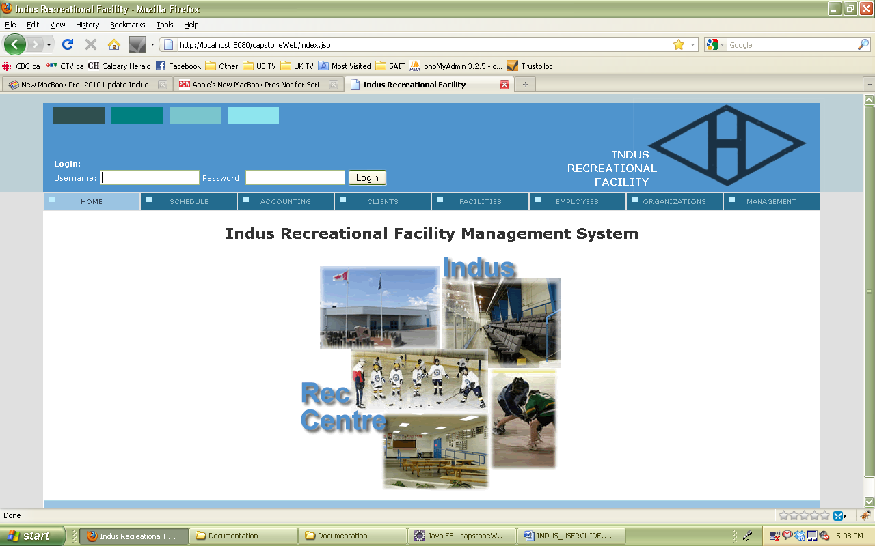

### 4.5.1.2 Logged in:

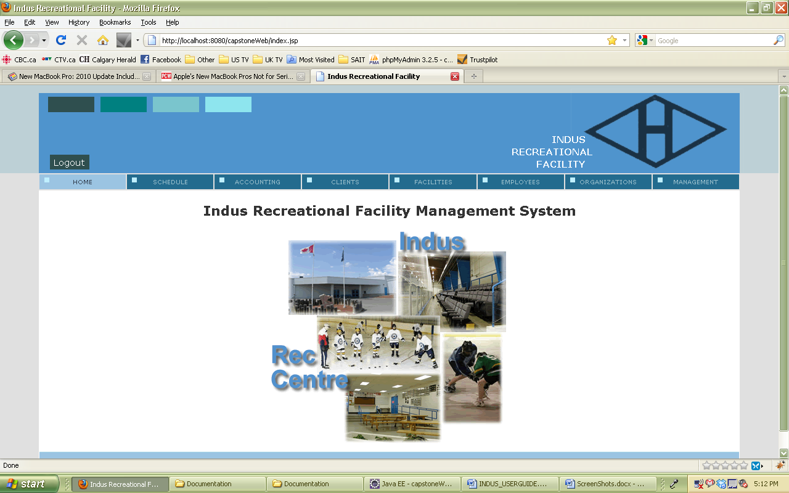

### 4.5.2 Schedule:

### 4.5.2.1 Schedule Screen:

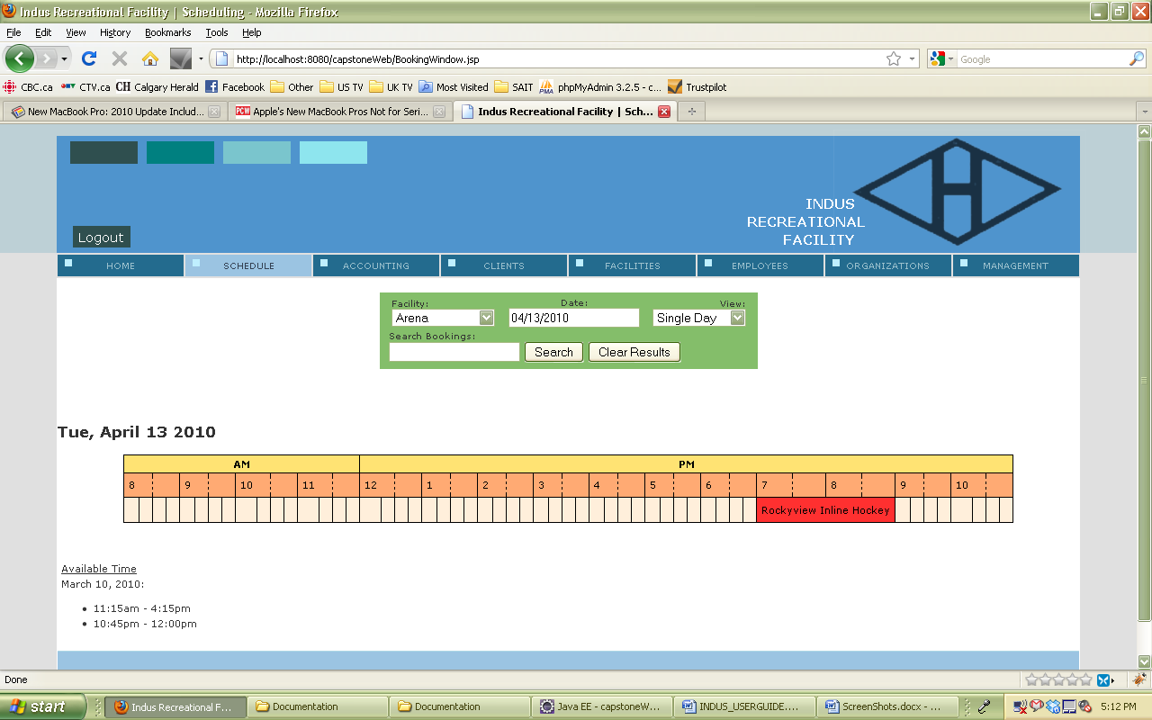

### 4.5.2.2 Choose Facility

### 

### 4.5.2.3 Choose Date:

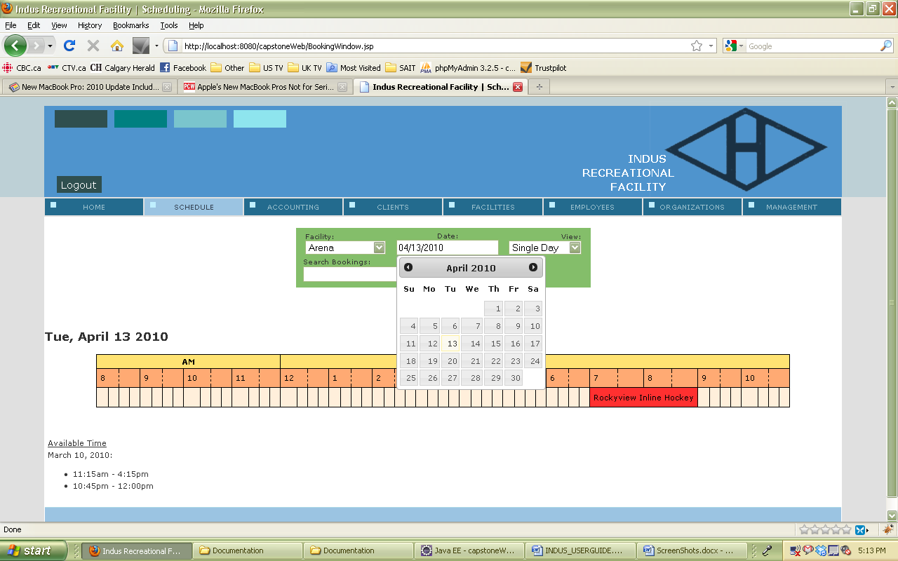

### 4.5.2.4 Choose View:

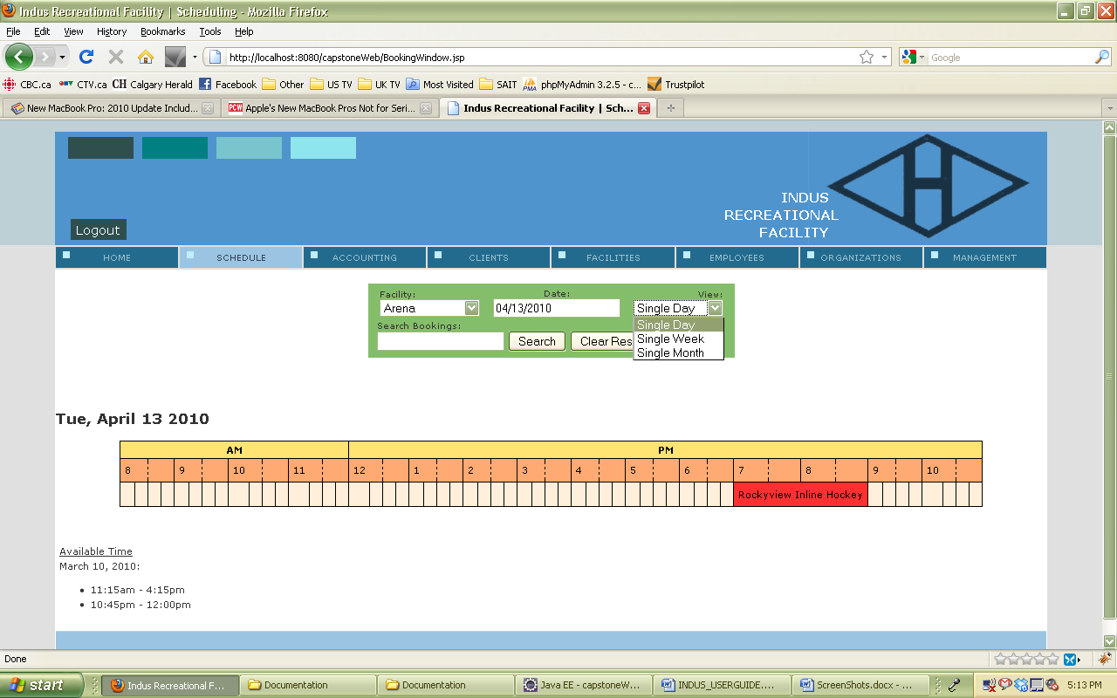

### 4.5.2.5 Make a booking:

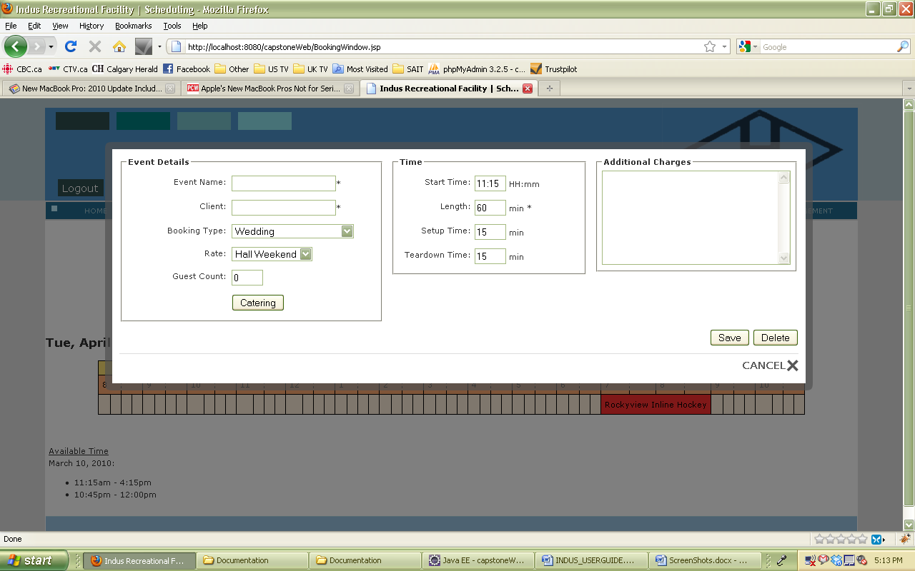

### 4.5.3 Accounting:

### 4.5.3.1 Accounting Screen:

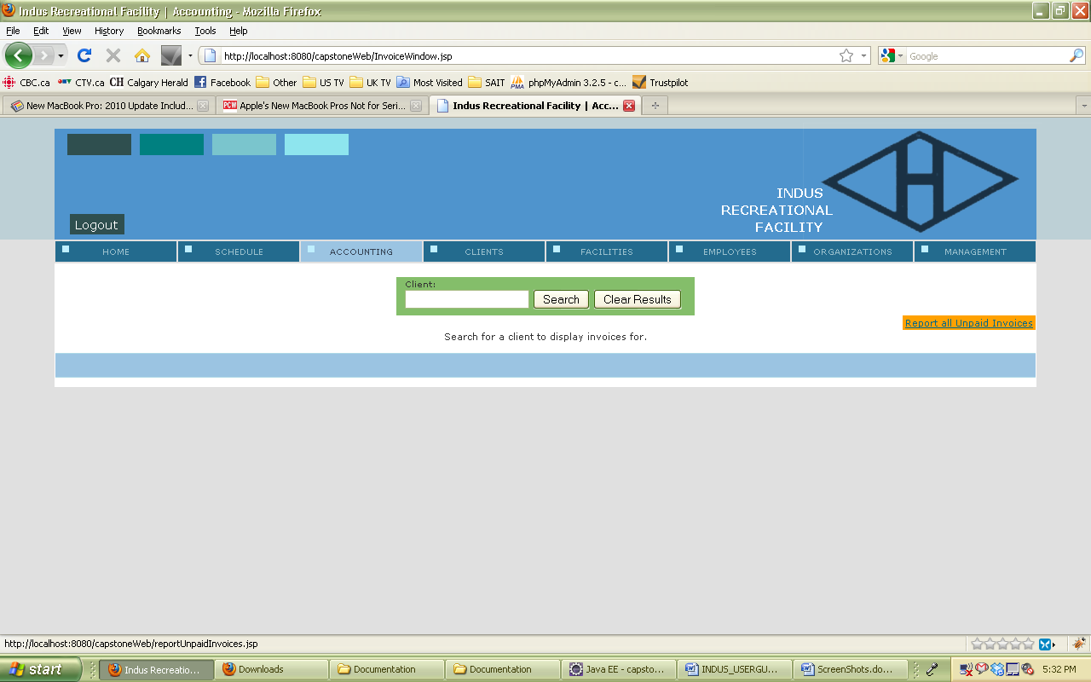

### 4.5.3.2 Unpaid Booking:

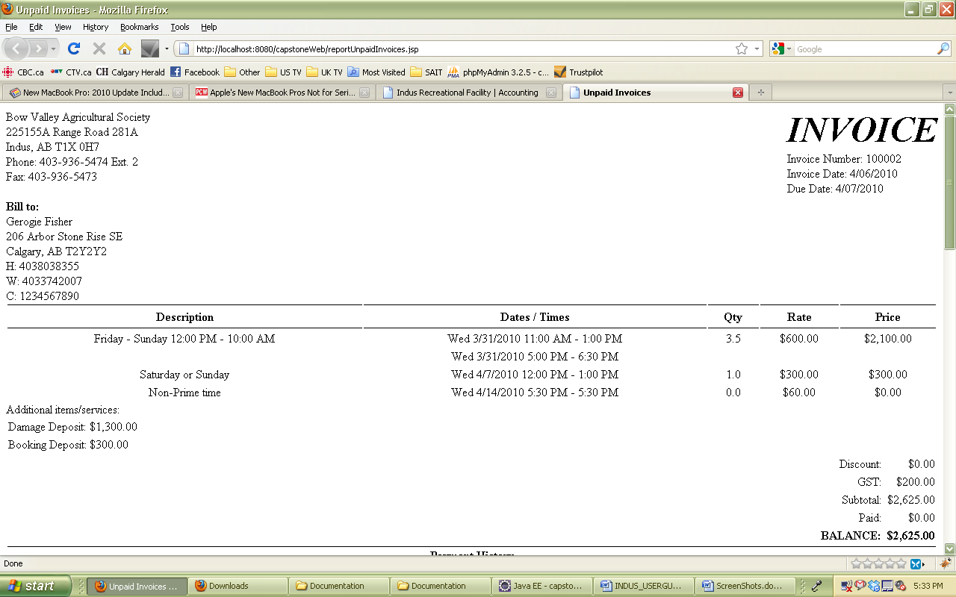

### 4.5.3.3 Accounting Screen:

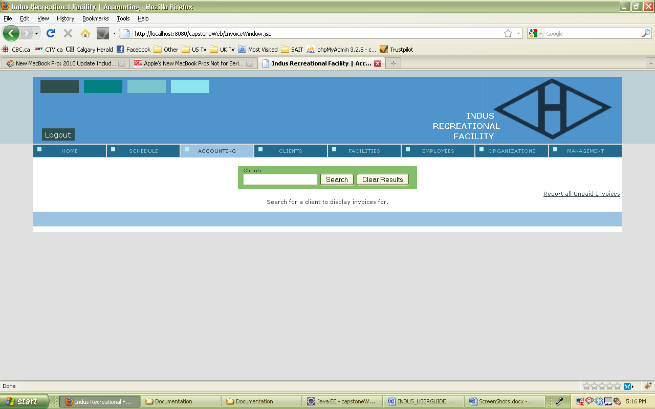

### 4.5.3.4 Enter Clients Name:

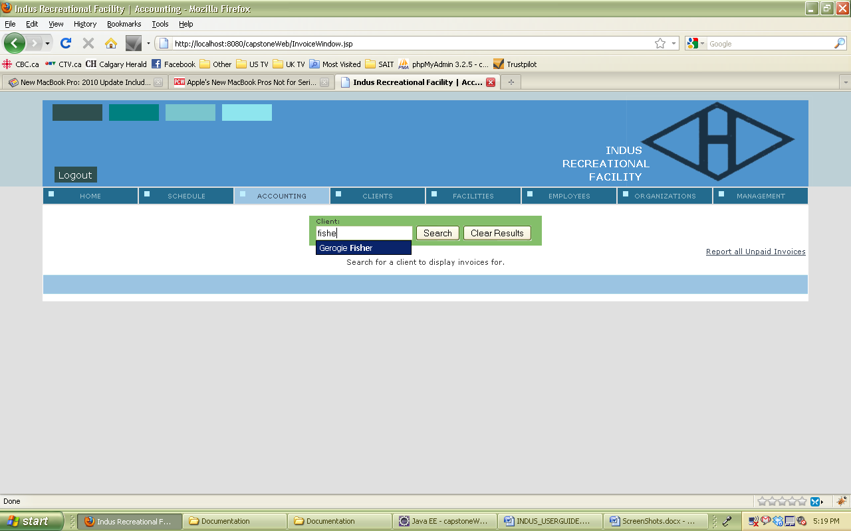

### 4.5.3.5 Search for a client:

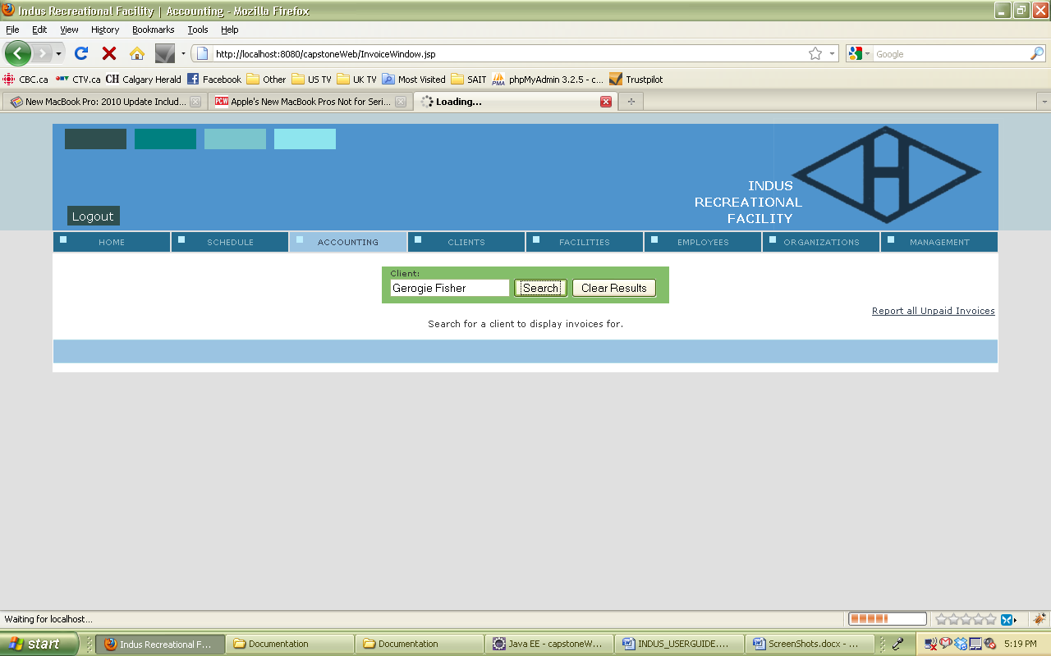

### 4.5.3.6 View paid and outstanding invoices:

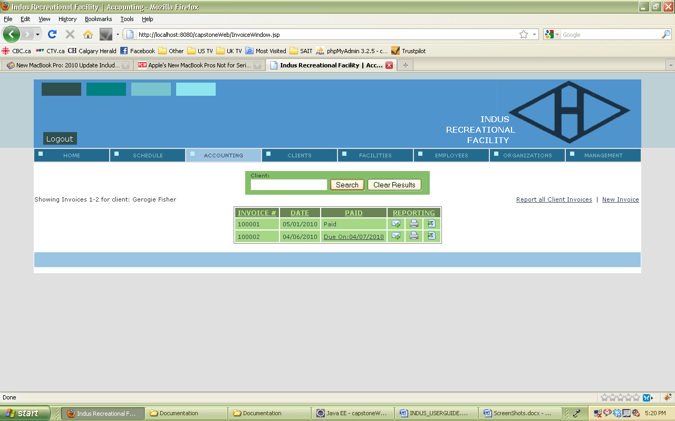

### 4.5.3.7 Details of bookings on invoice:

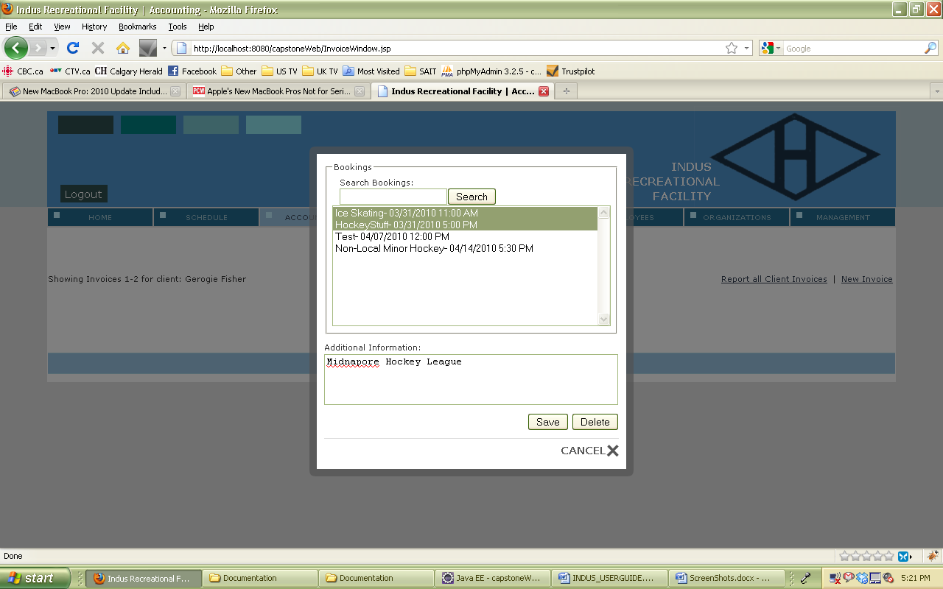

### 4.5.3.8 Email Report:

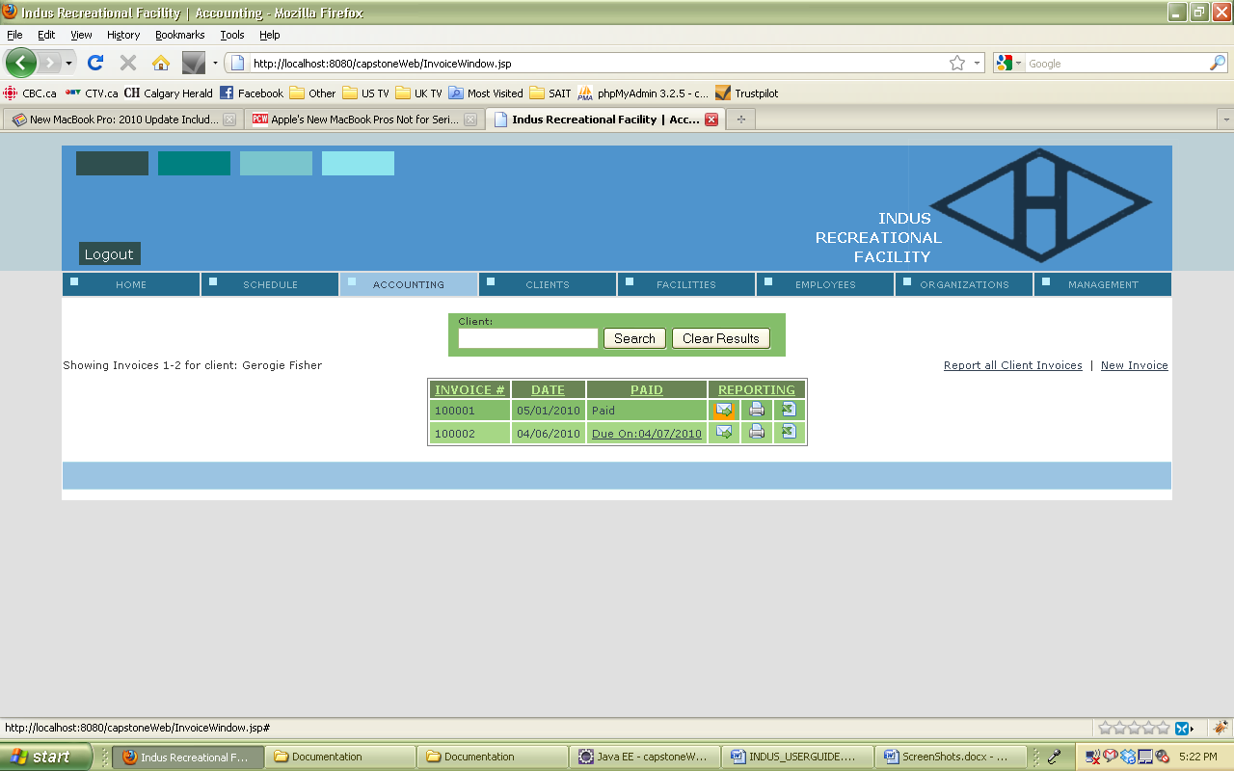

### 4.5.3.9 Invoice Emailed:

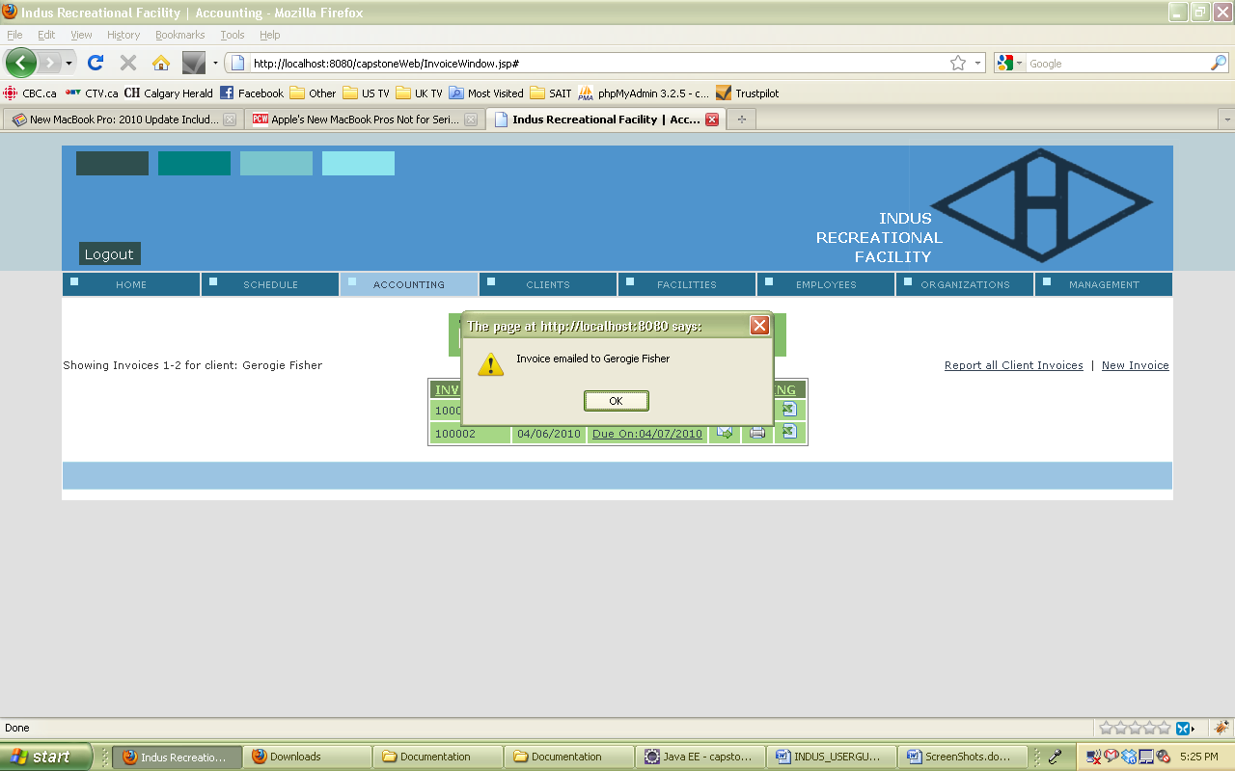

### 4.5.3.10 Print Report:

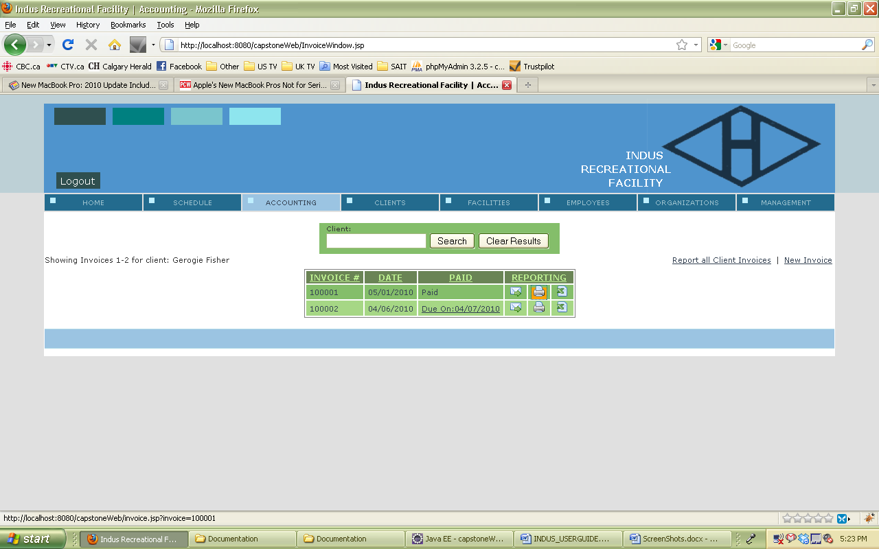

### 4.5.3.11 Print copy:

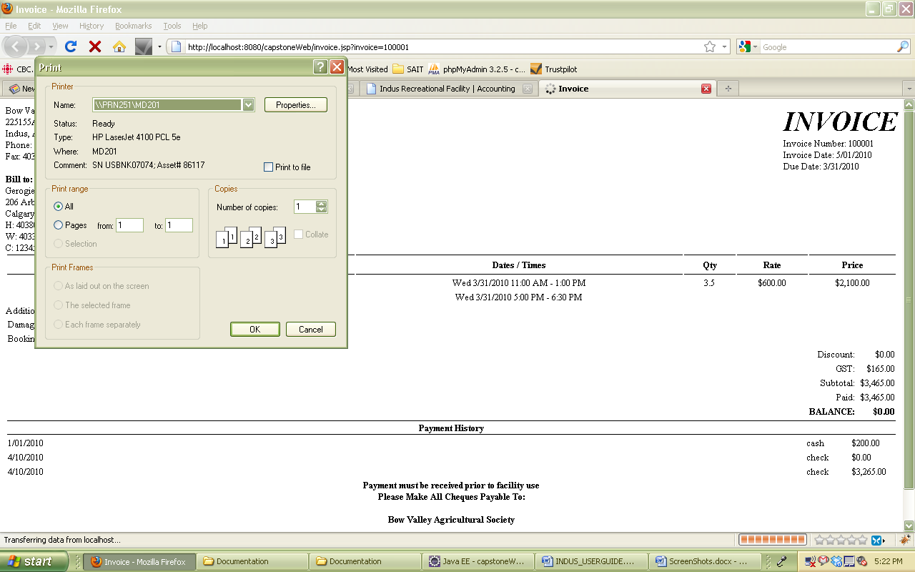

### 4.5.3.12 Export to Excel:

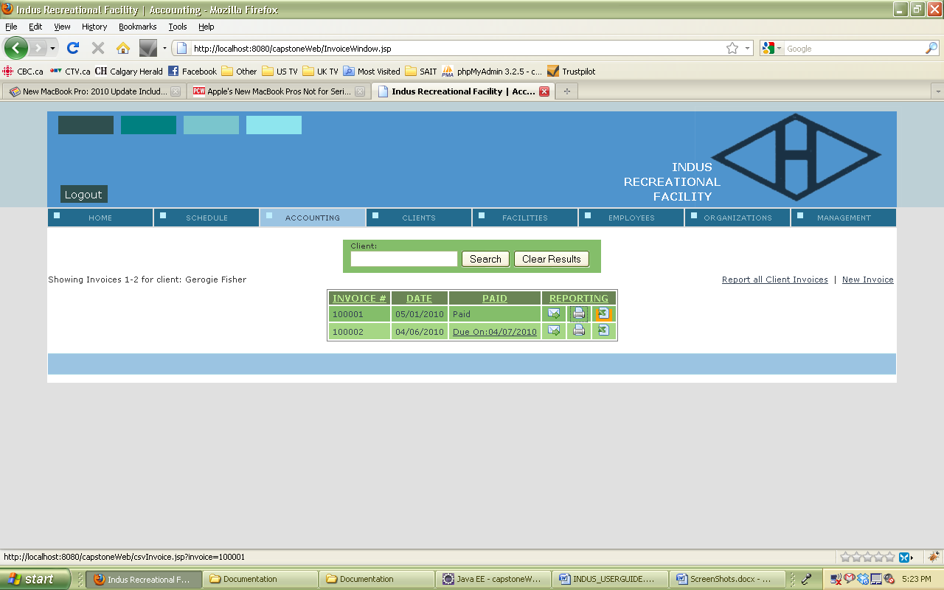

### 4.5.3.13 Open in excel:

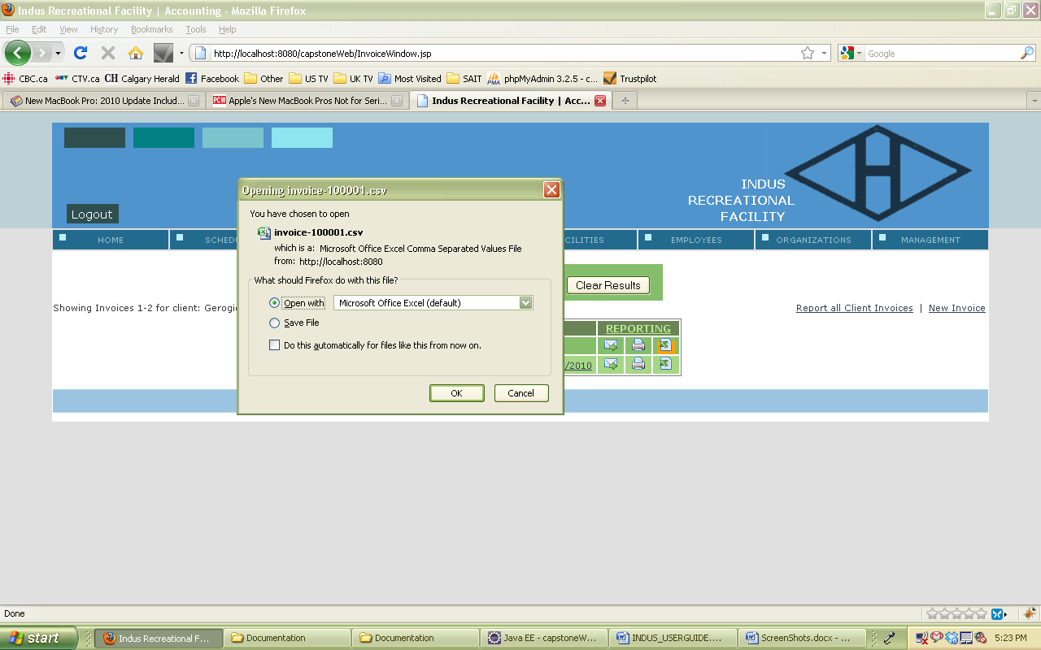

### 4.5.3.14 Excel:

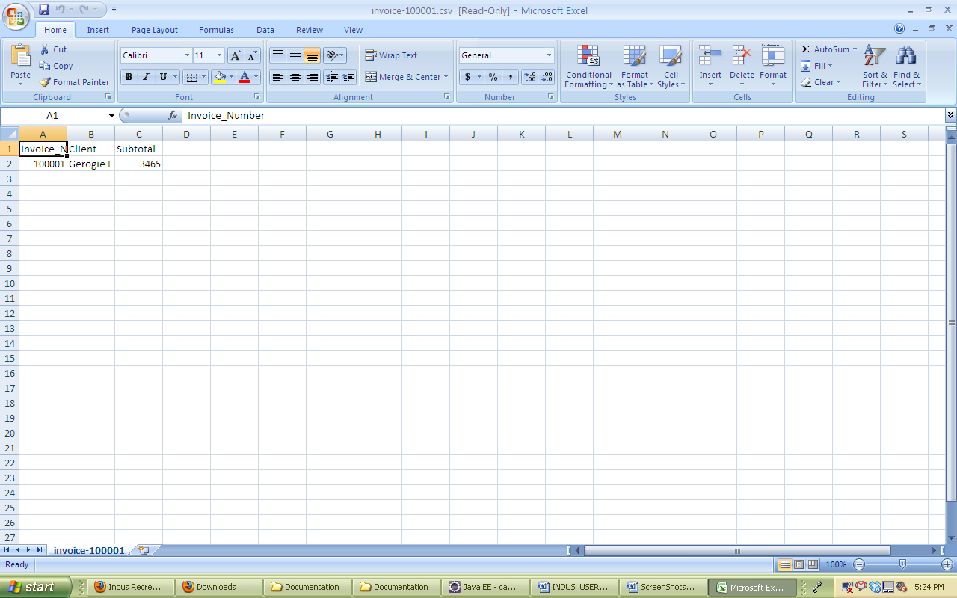

### 4.5.3.15 Payment Needed:

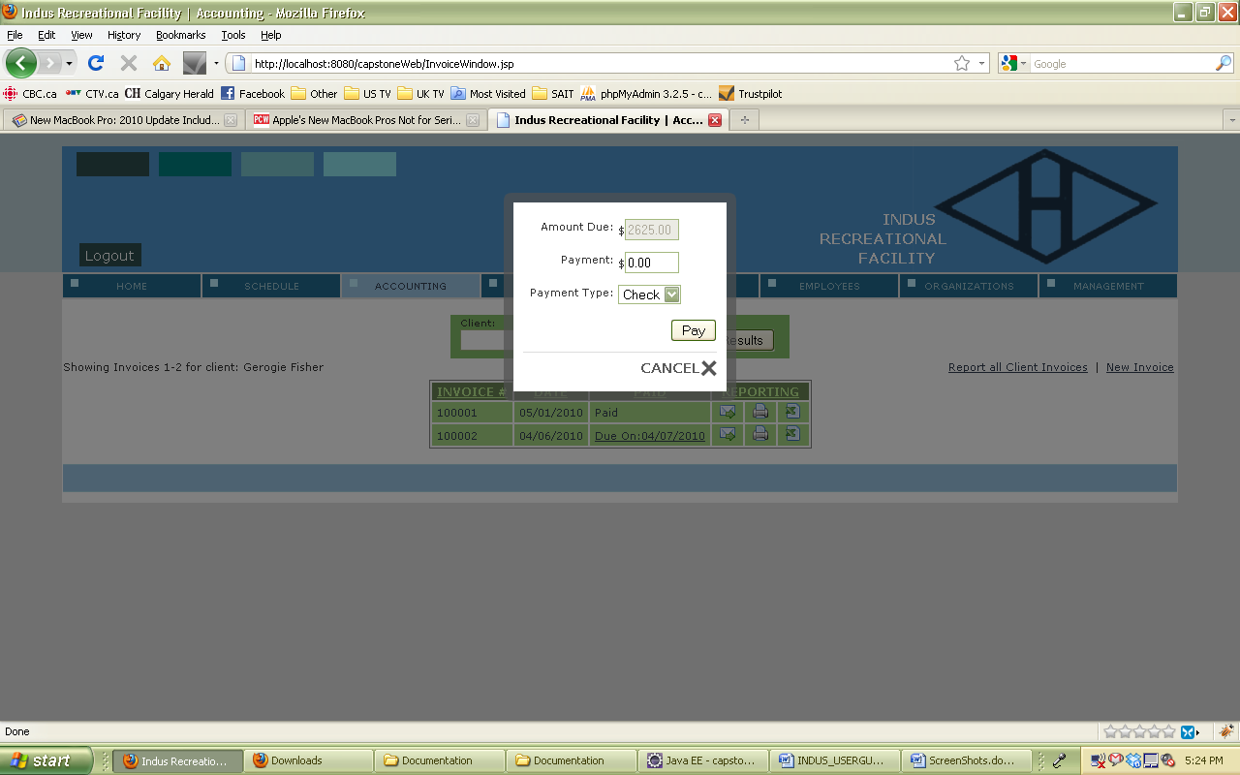

### 4.5.3.16 Report all Invoices:

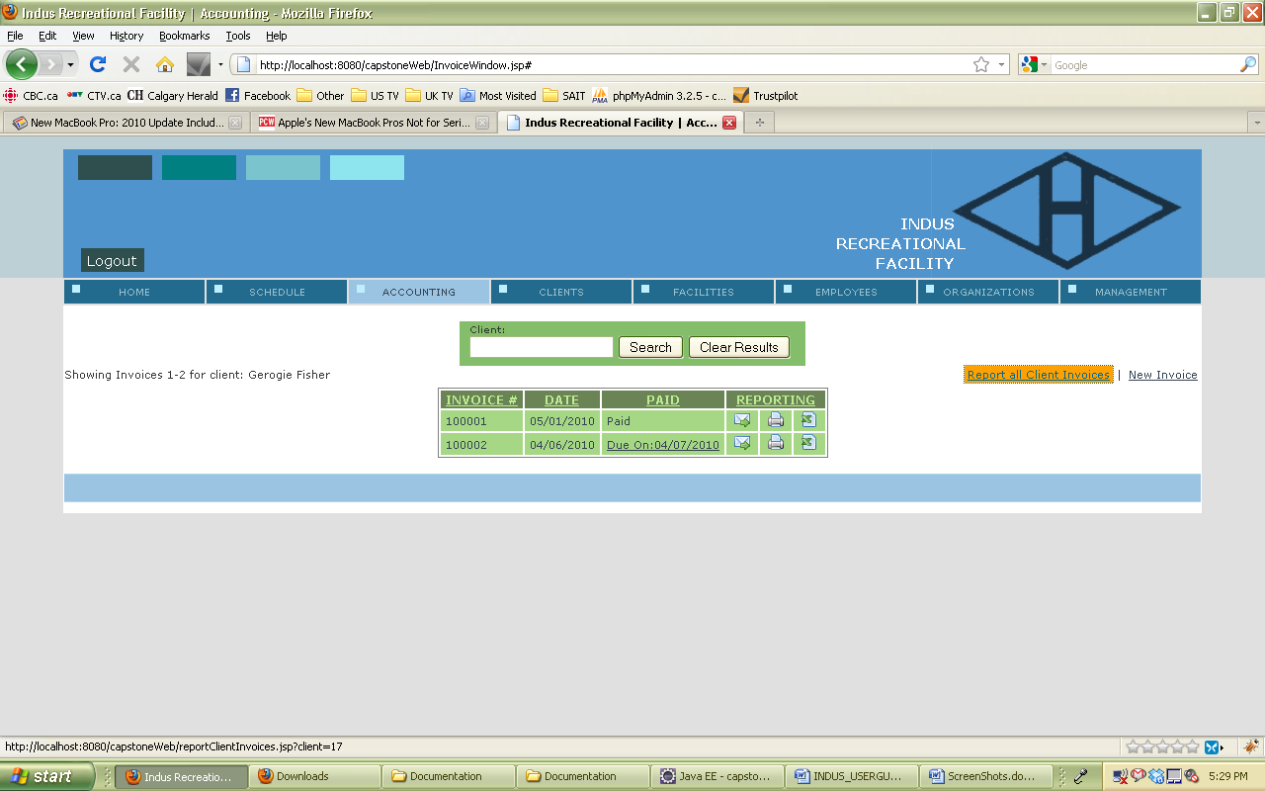

### 4.5.3.17 Report containing all invoices:

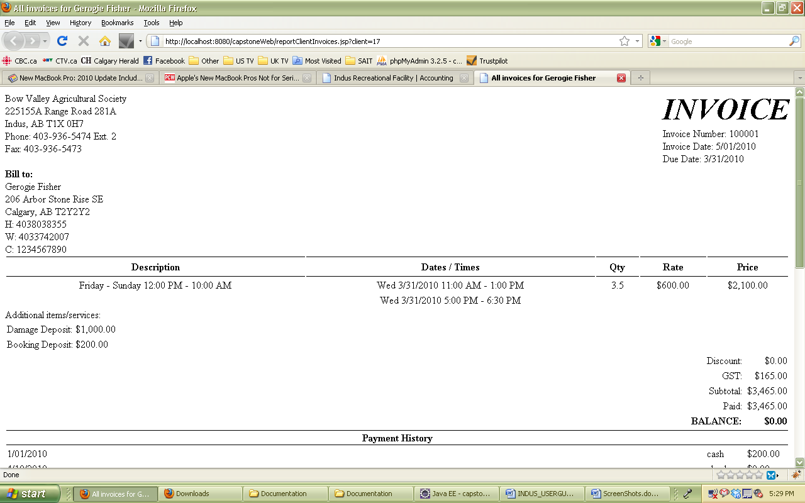

### 4.5.3.18 New Invoice:

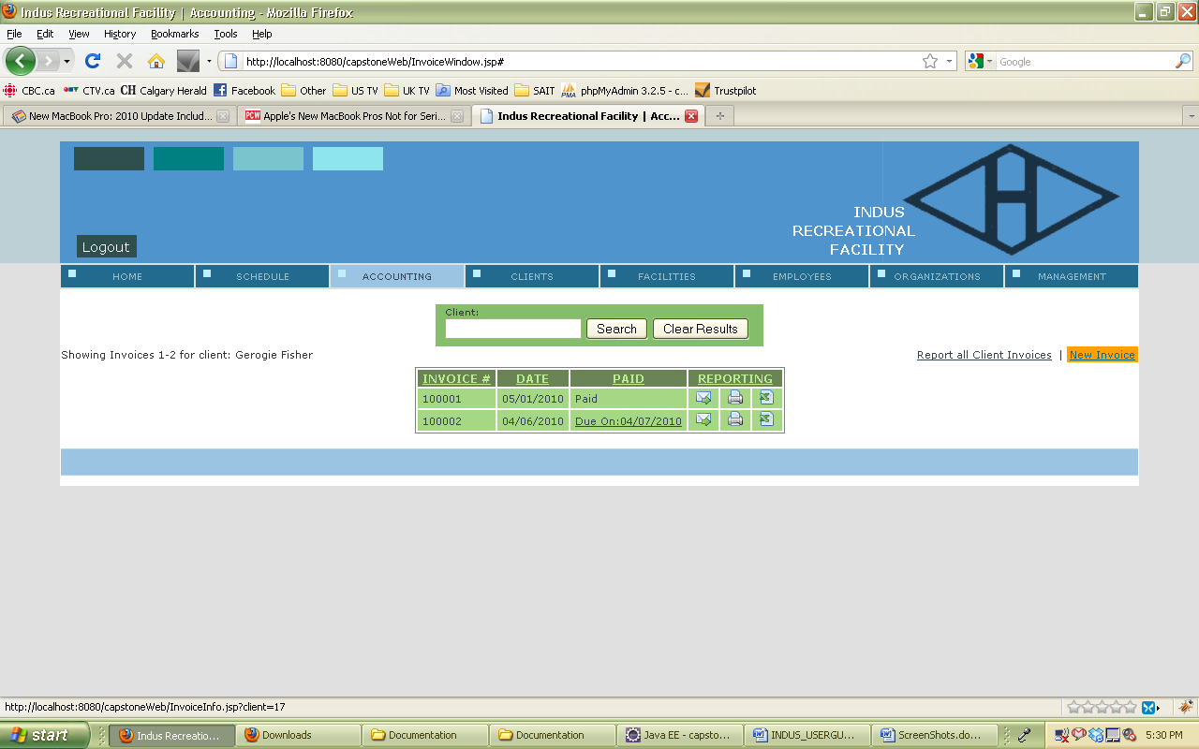

### 4.5.3.19 Choose booking to make new invoice:

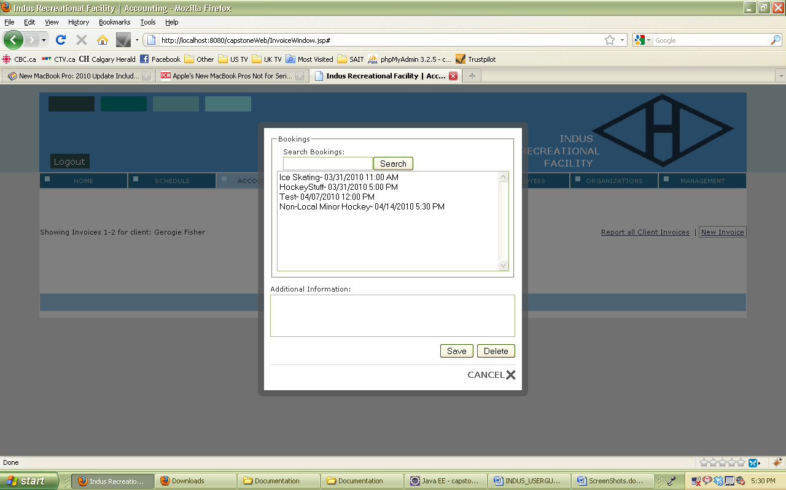

### 4.5.4 Client:

### 4.5.4.1 Client Screen:

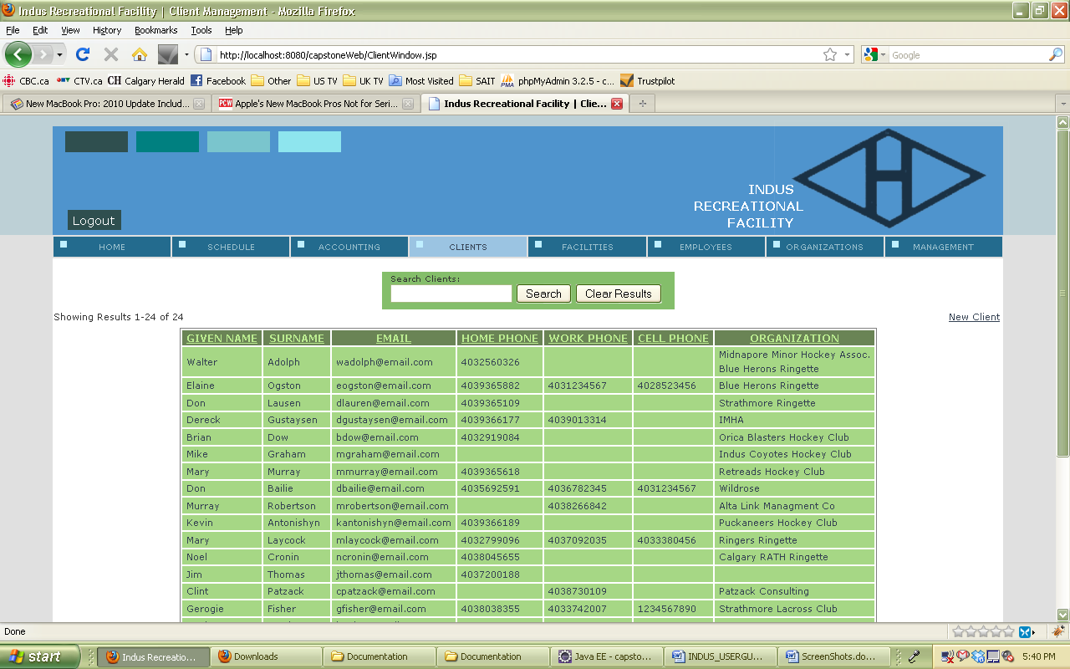

### 4.5.4.2 Search for a Client:

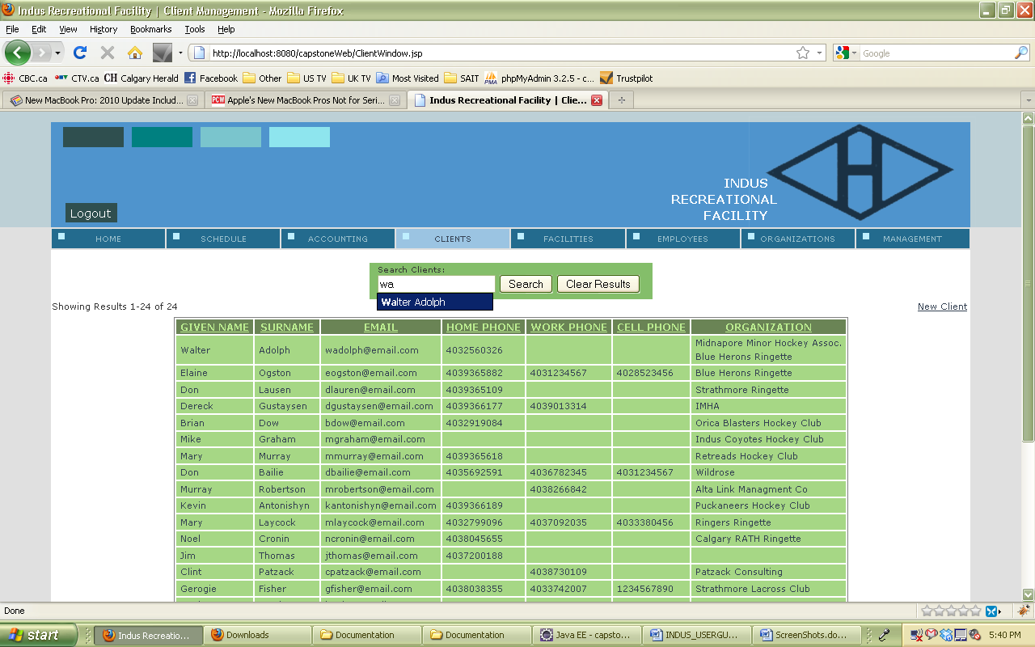

### 4.5.4.3 View Client:

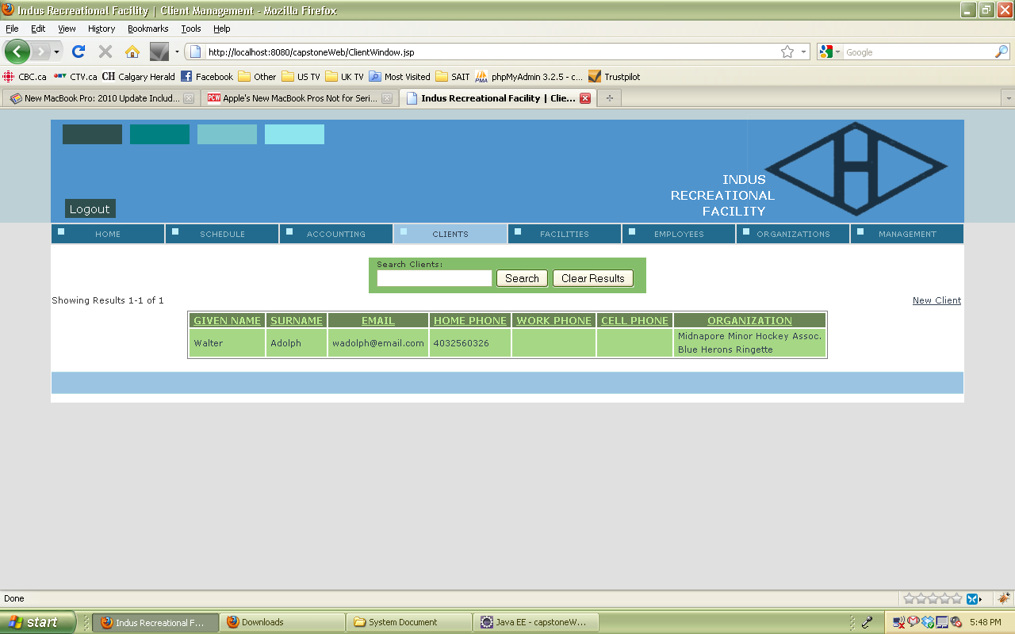

### 4.5.4.4 Edit Client:

### 

### 4.5.4.5 Client must be 10 digits:

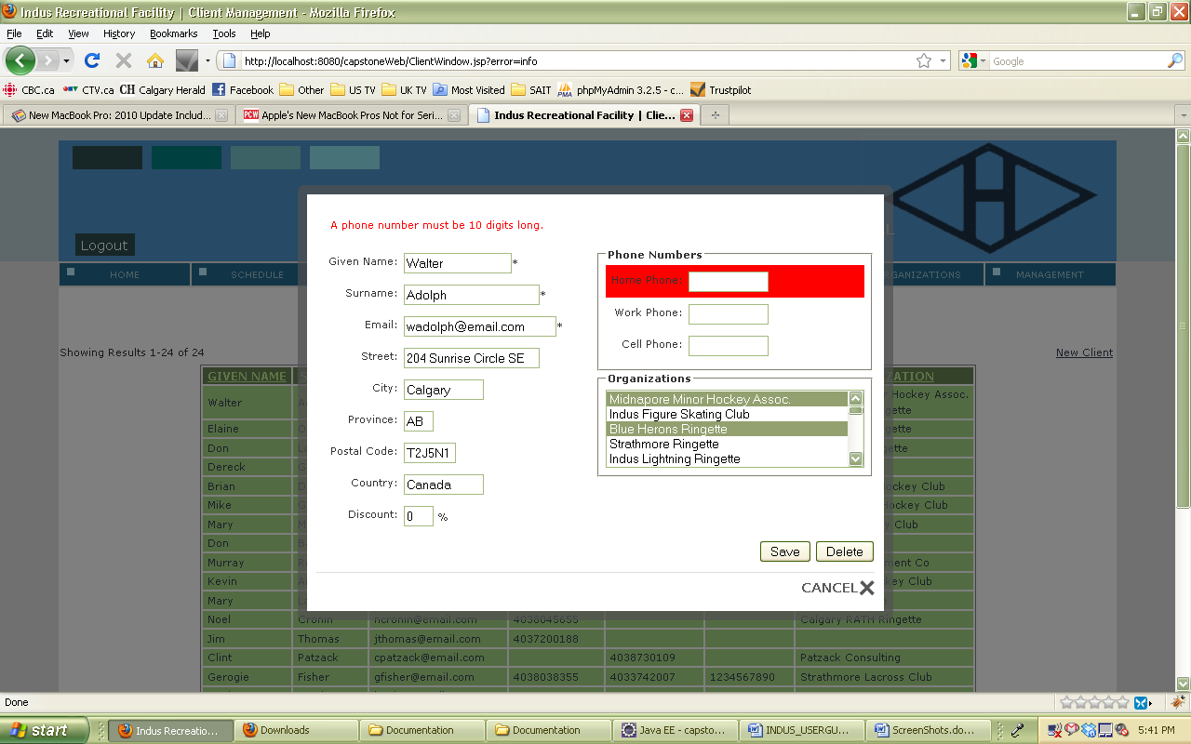

### 4.5.4.6 Add a new Client:

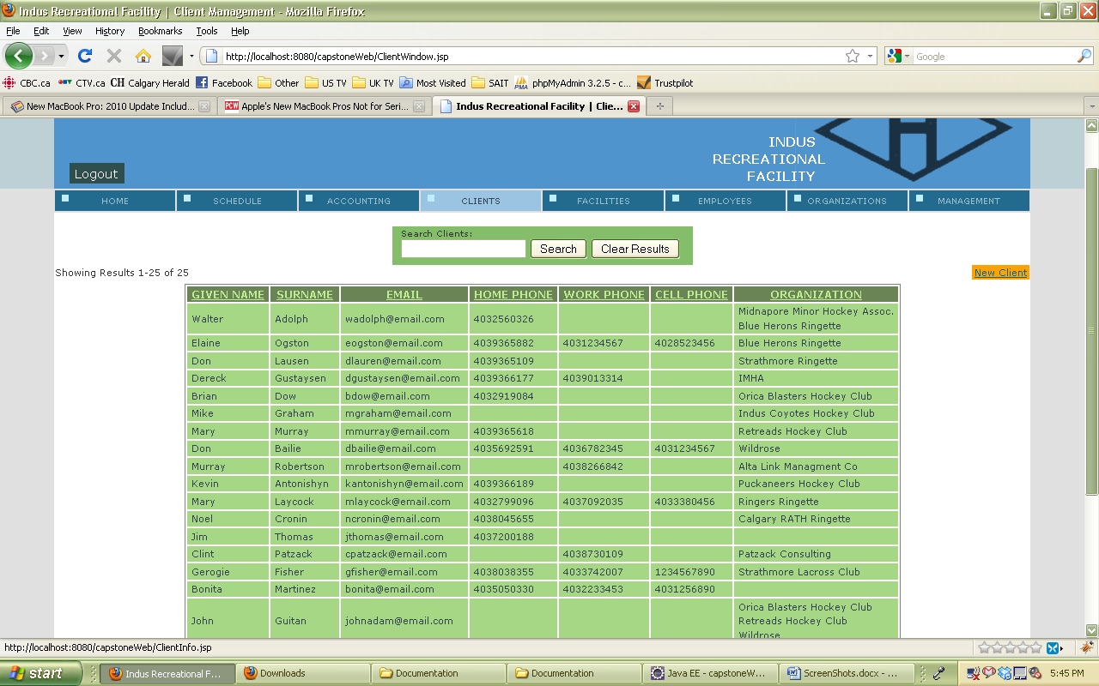

### 4.5.4.7 New Client:

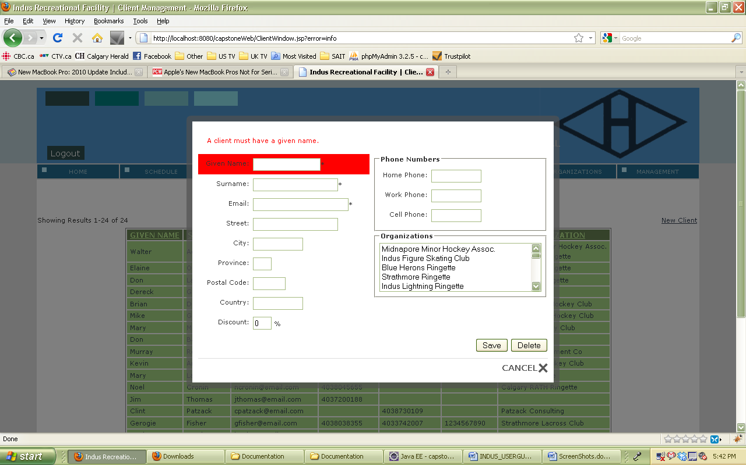

### 4.5.4.8 Client must have an email address:

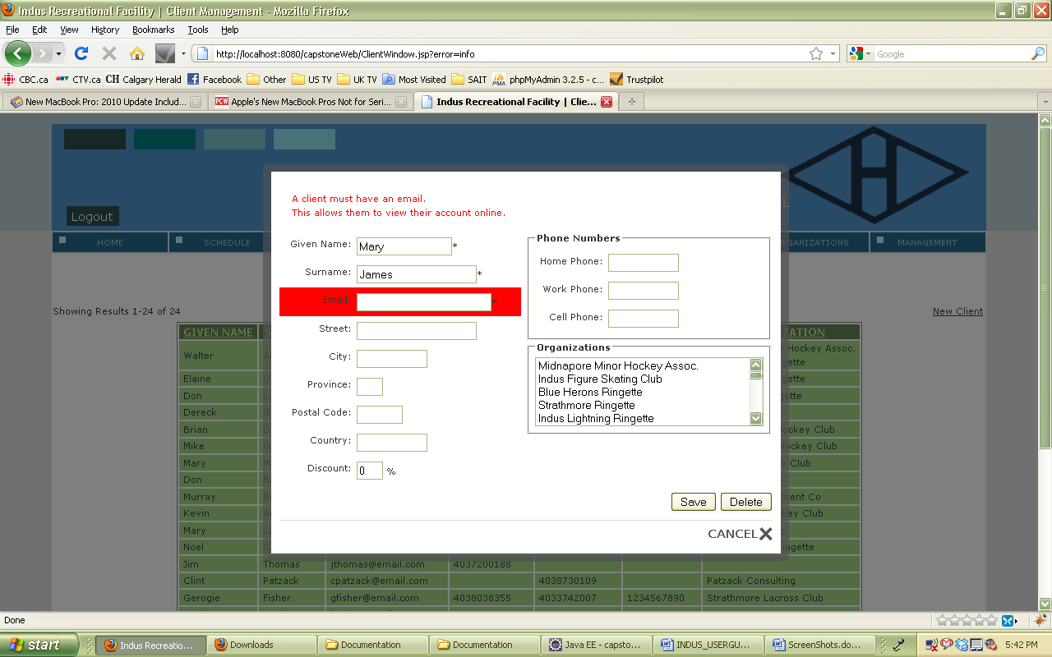

### 4.5.5 Facilities:

### 4.5.5.1 Facilities Screen:

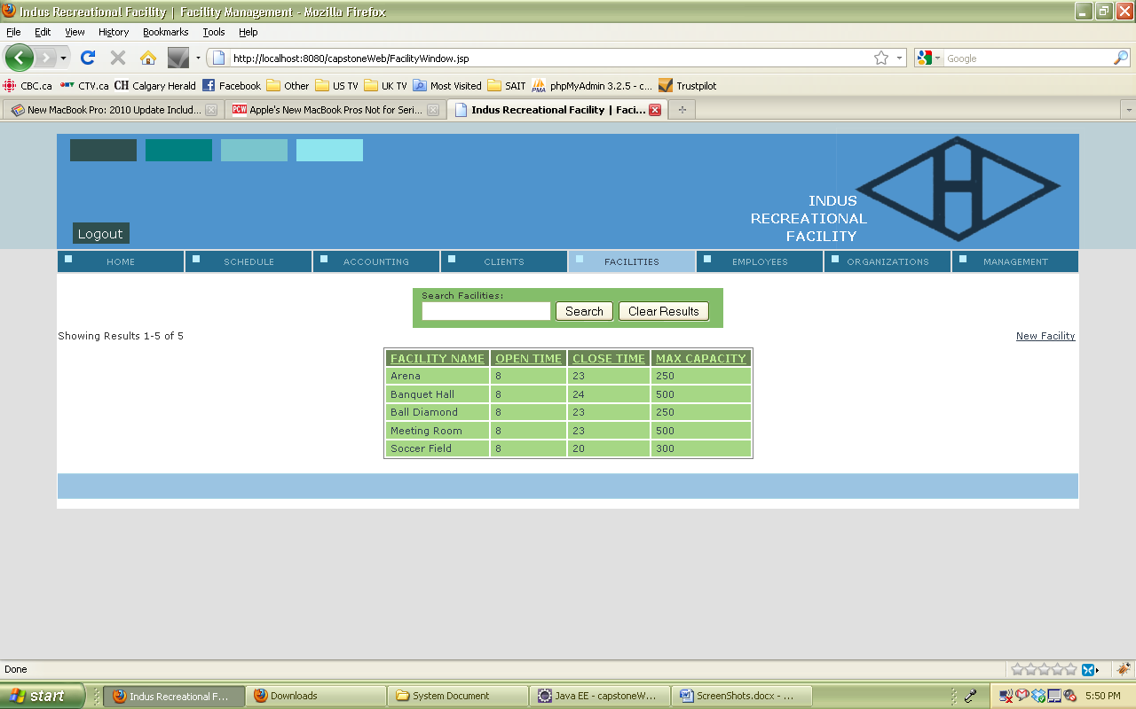

### 4.5.5.2 List Facilities:

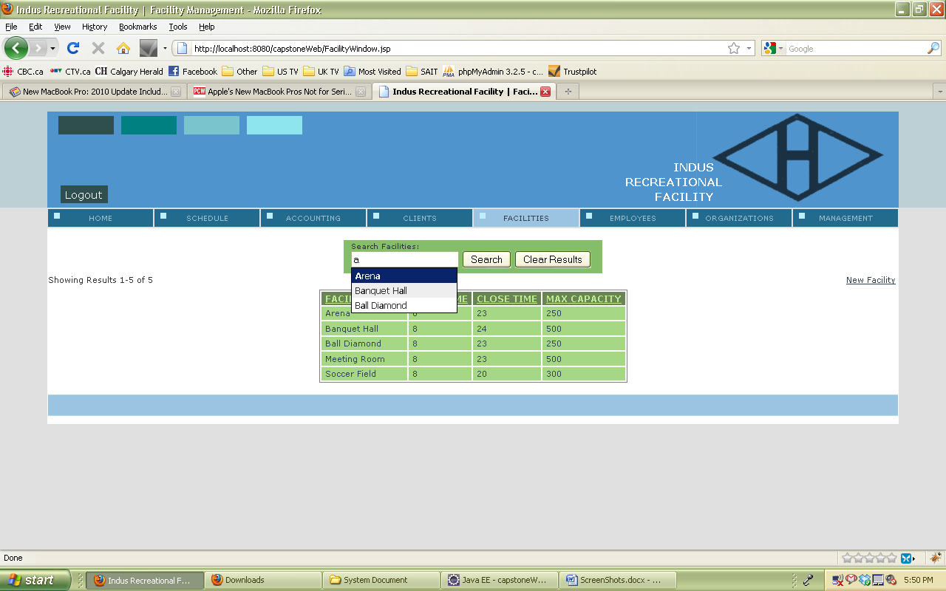

### 4.5.5.3 Enter a Facility:



### 4.5.5.4 Search for a Facility:

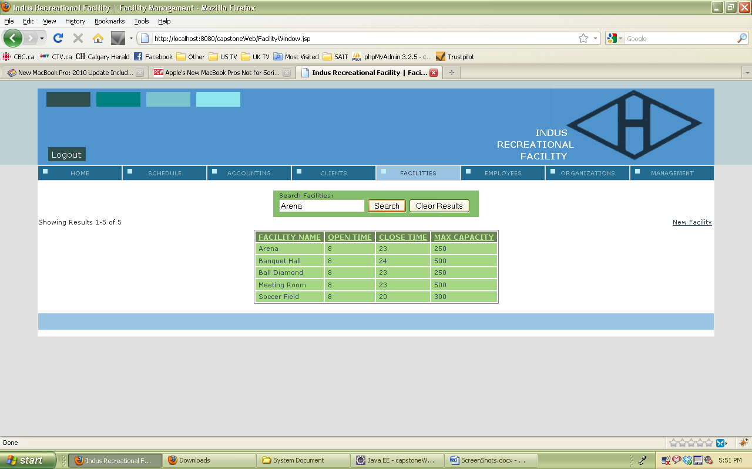

### 4.5.5.5 View chosen Facility:

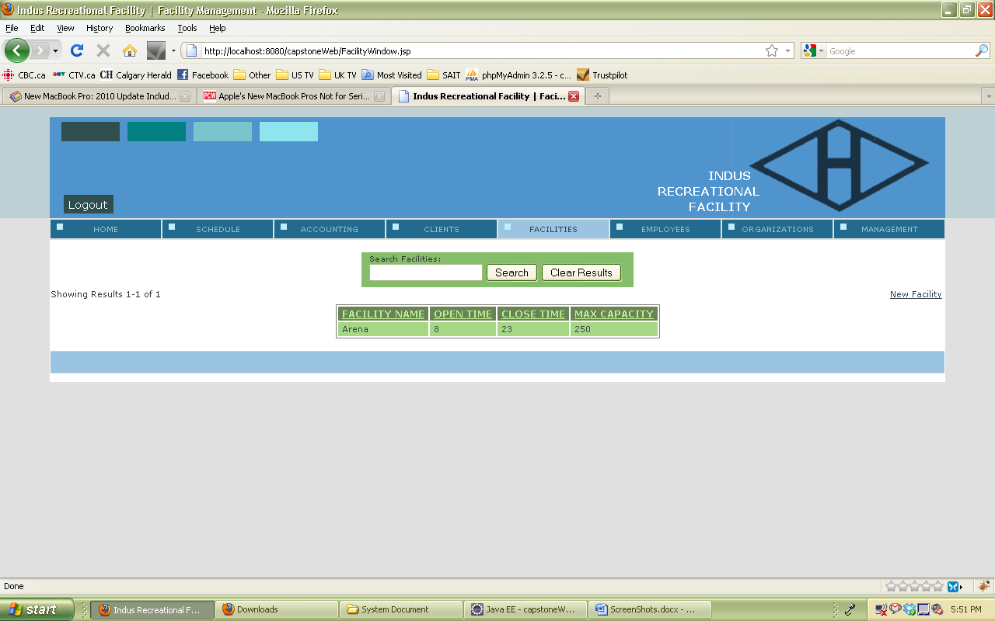

### 4.5.5.6 View Facility details:

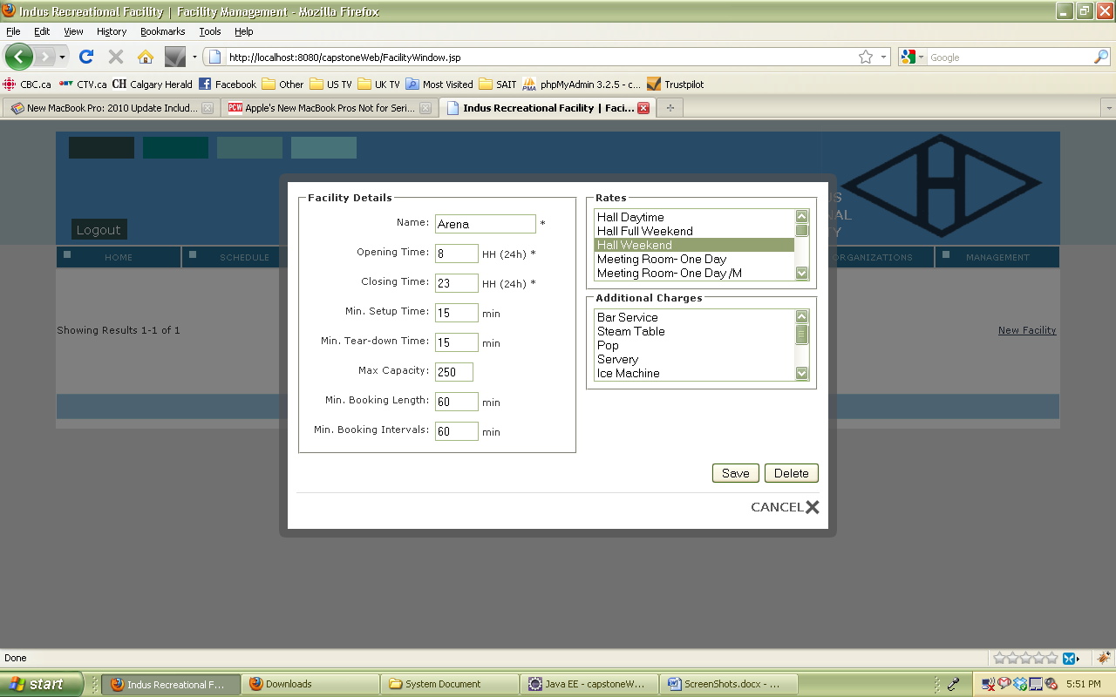

### 4.5.5.7 Add new facility:

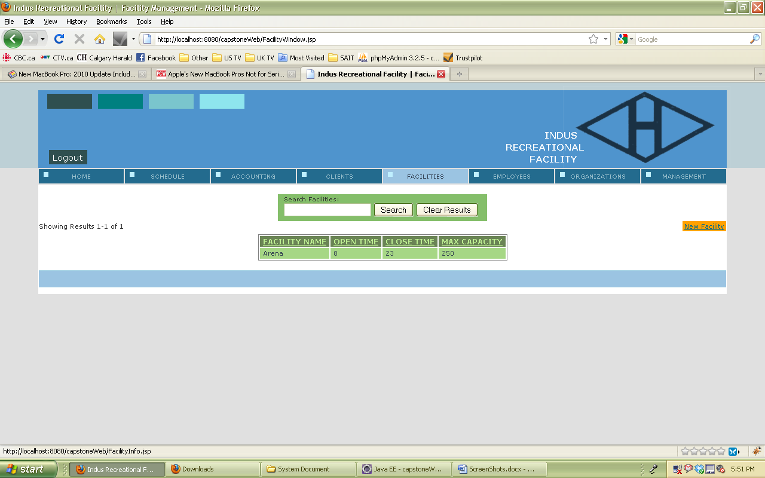

### 4.5.5.8 Facility Form:

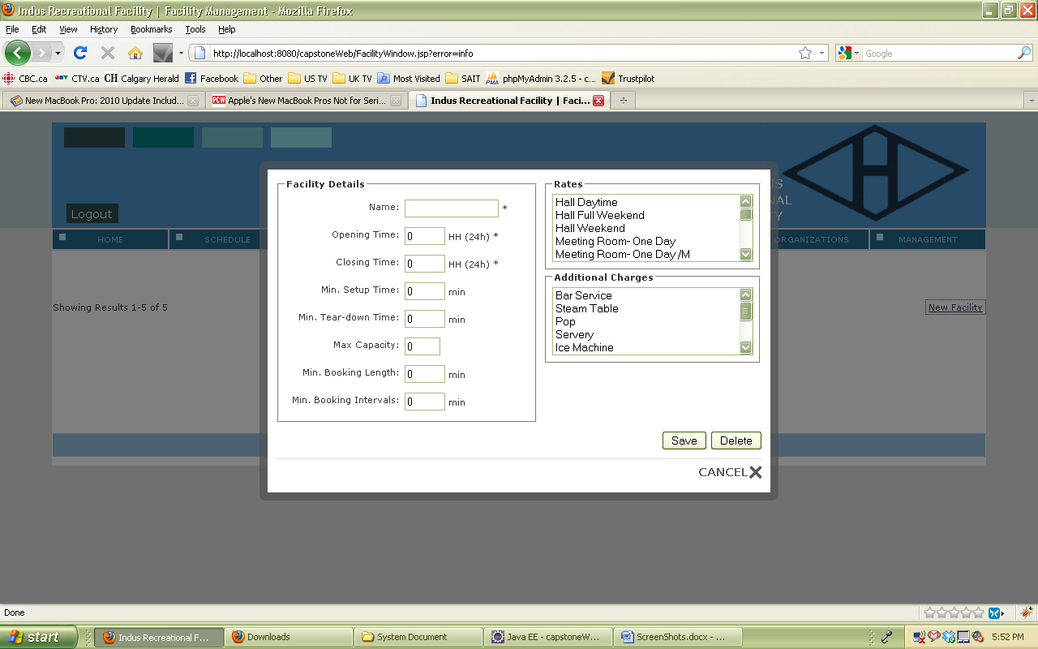

### 4.5.5.9 Facility Name Error:

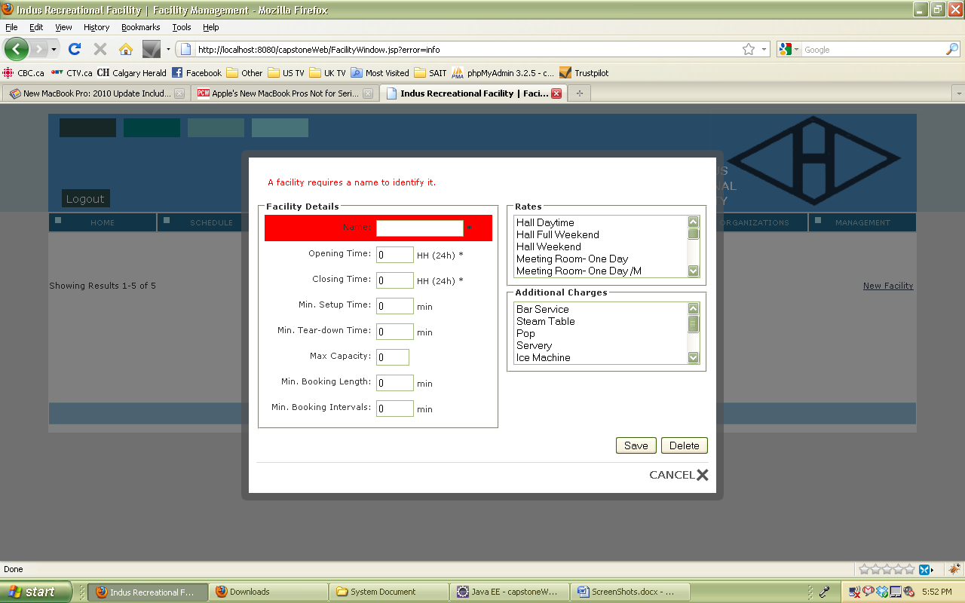

### 4.5.6 Employees:

### 4.5.6.1 List of Employees:

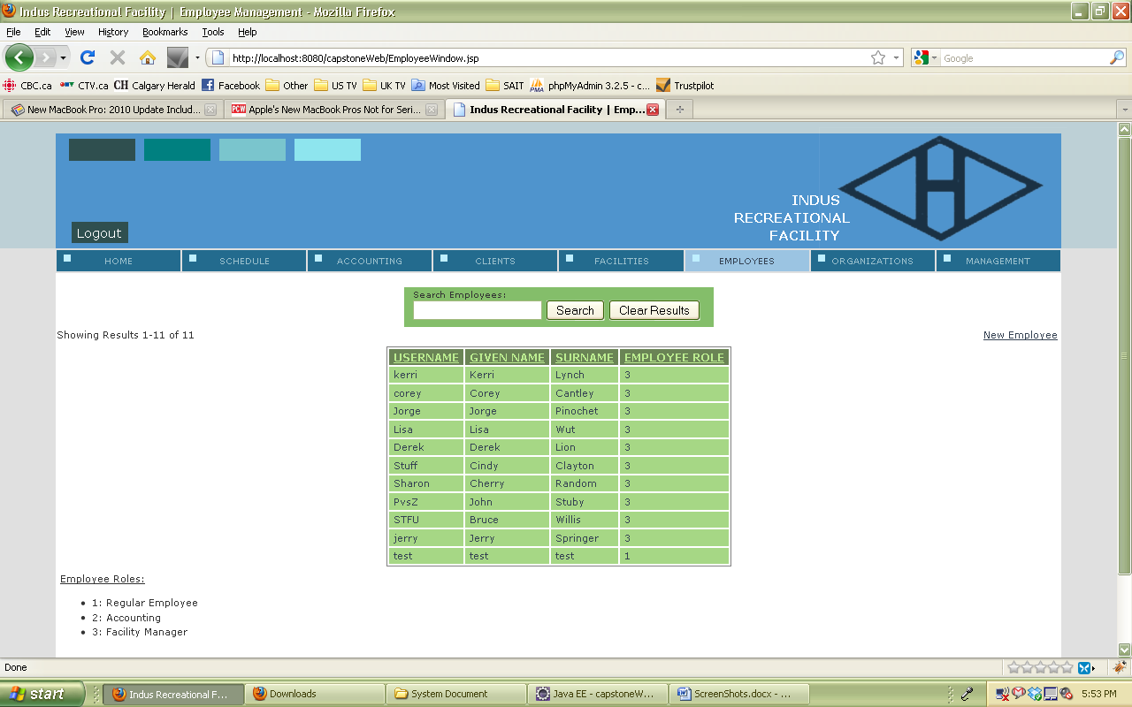

### 4.5.6.2 Search for Employees:

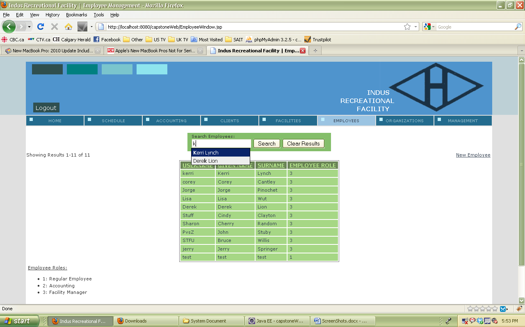

### 4.5.6.3 View Employee:

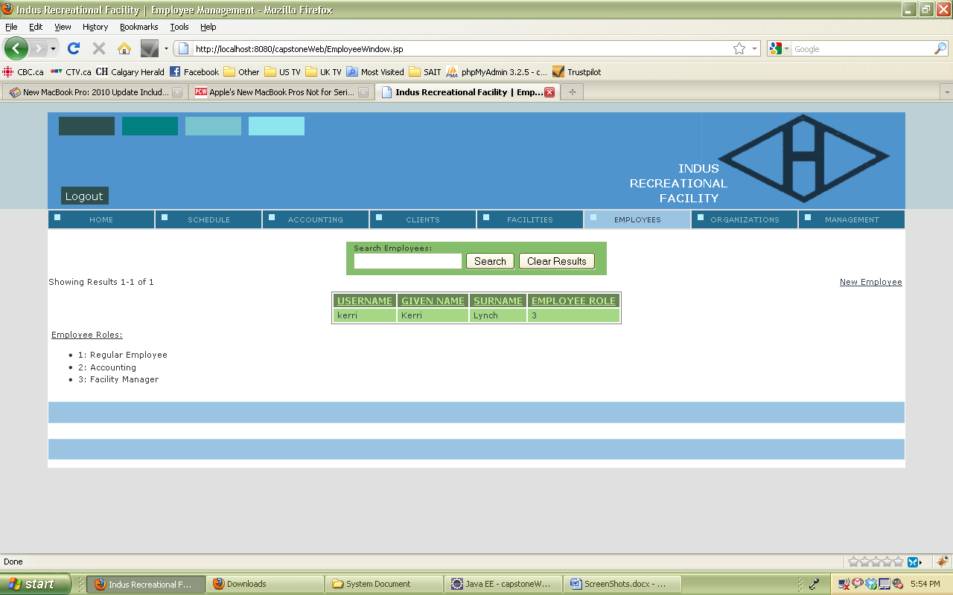

### 4.5.6.4 View Employee Details:

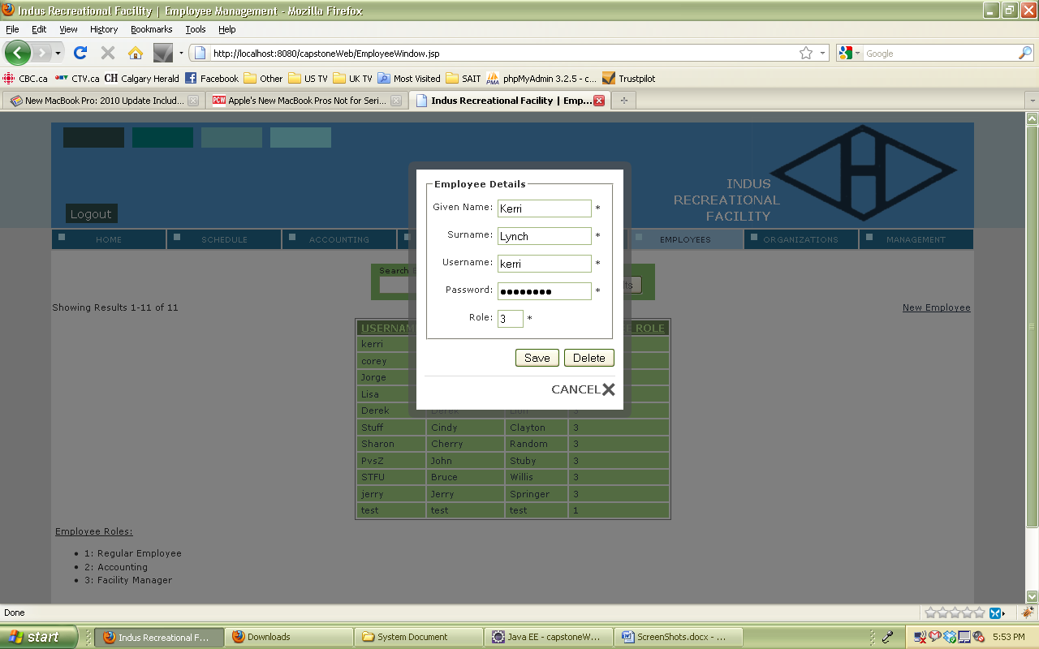

### 4.5.6.5 New Employee:

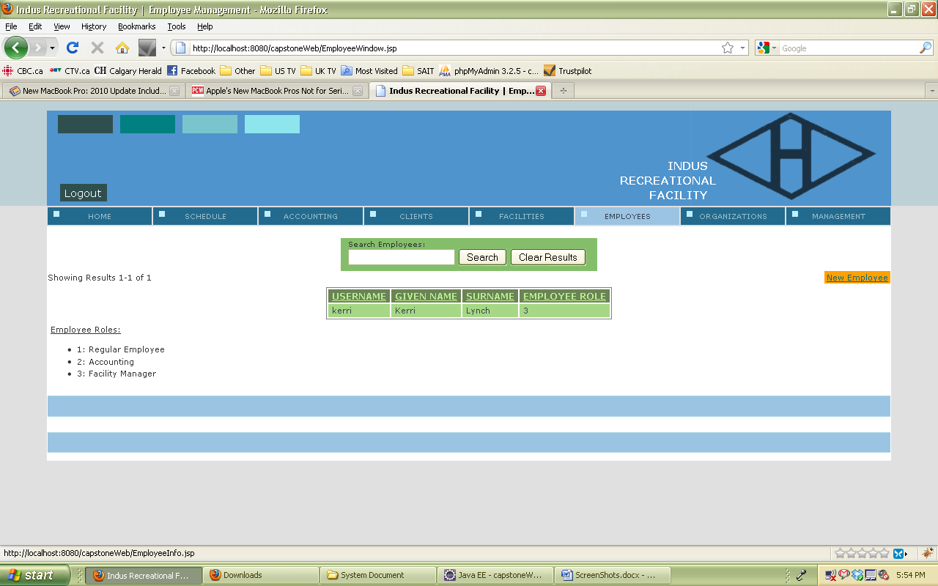

### 4.5.6.6 New Employee Form:

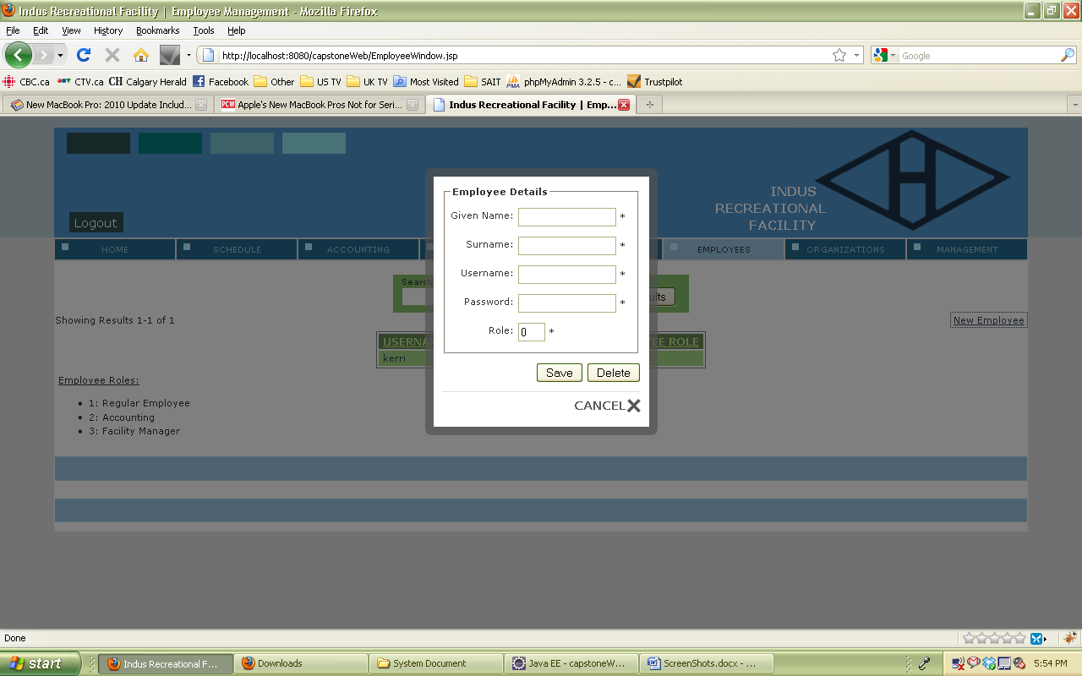

### 4.5.6.7 Employee Password Error:

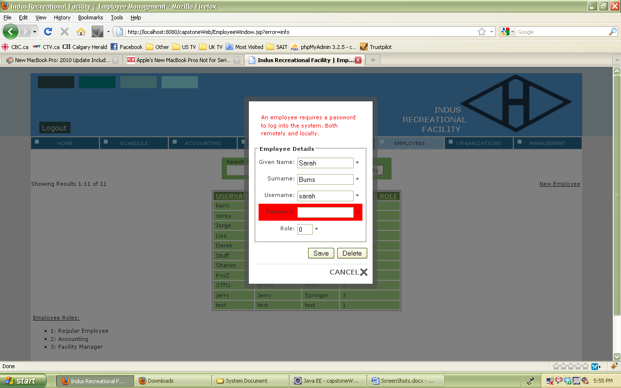

### 4.5.7 Organization:

### 4.5.7.1 List Organization:

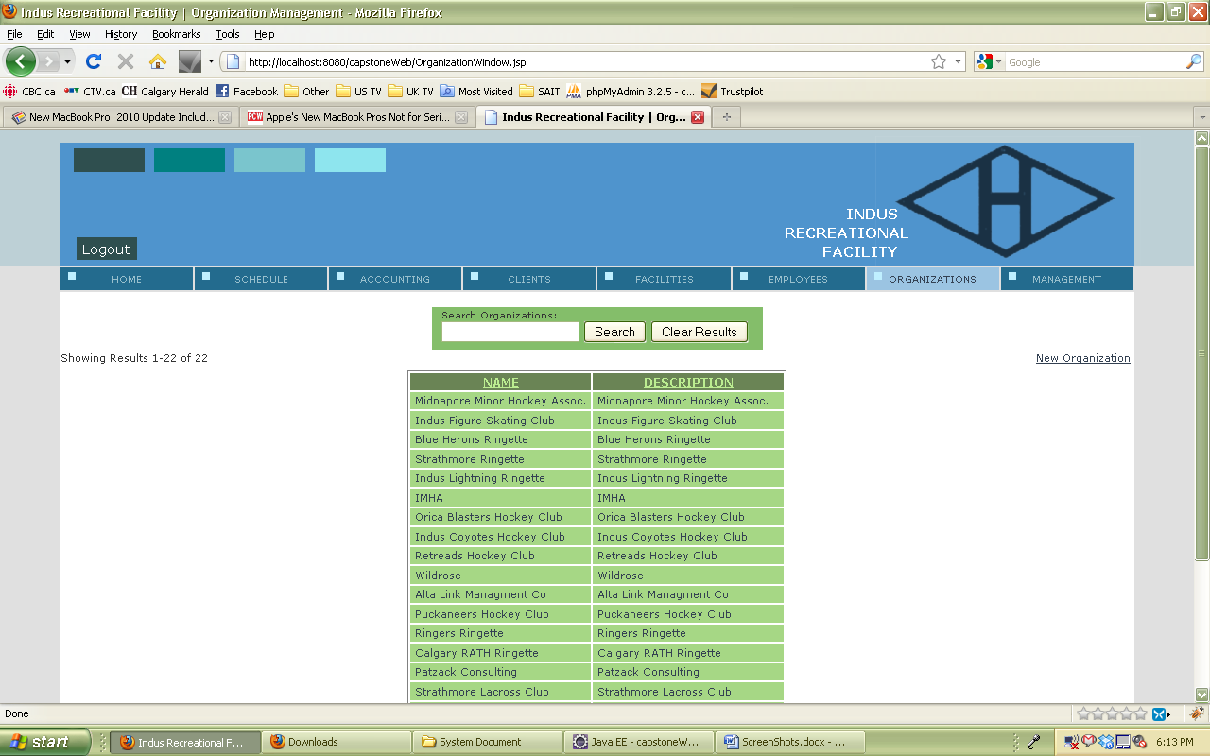

### 4.5.7.2 Search for Organization:

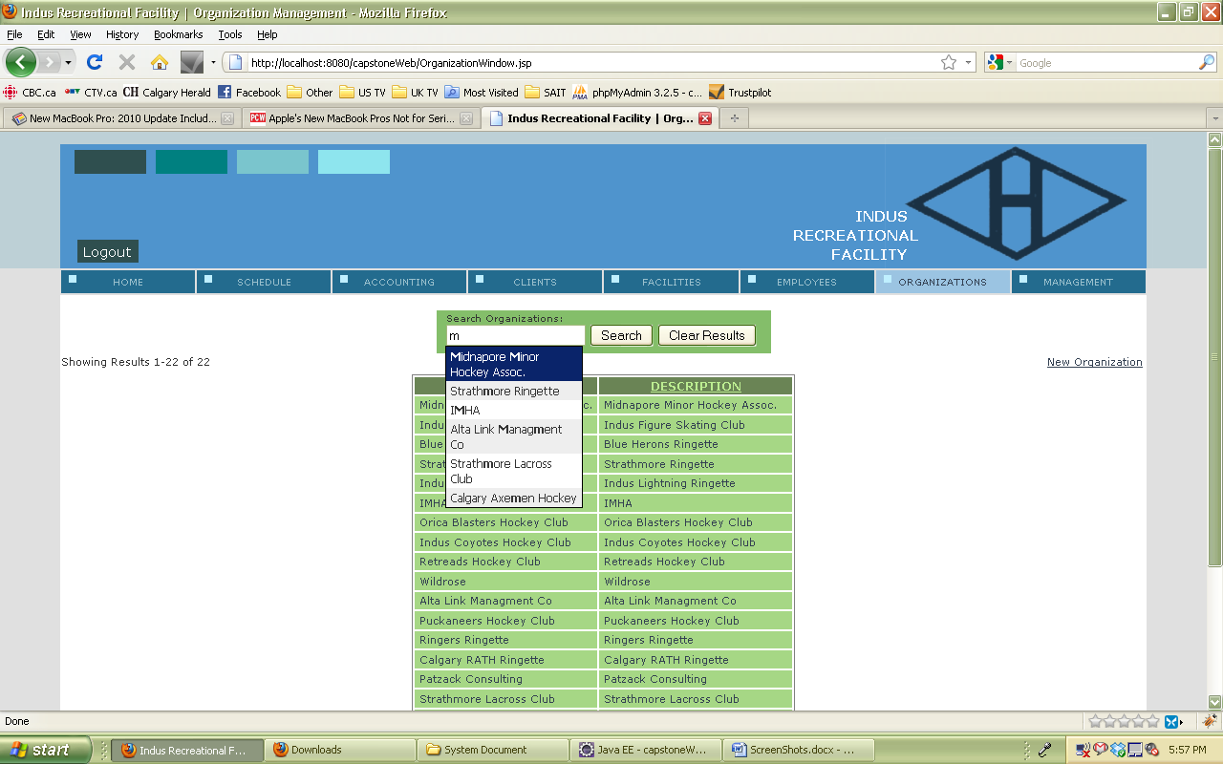

### 4.5.7.3 View search for organization:

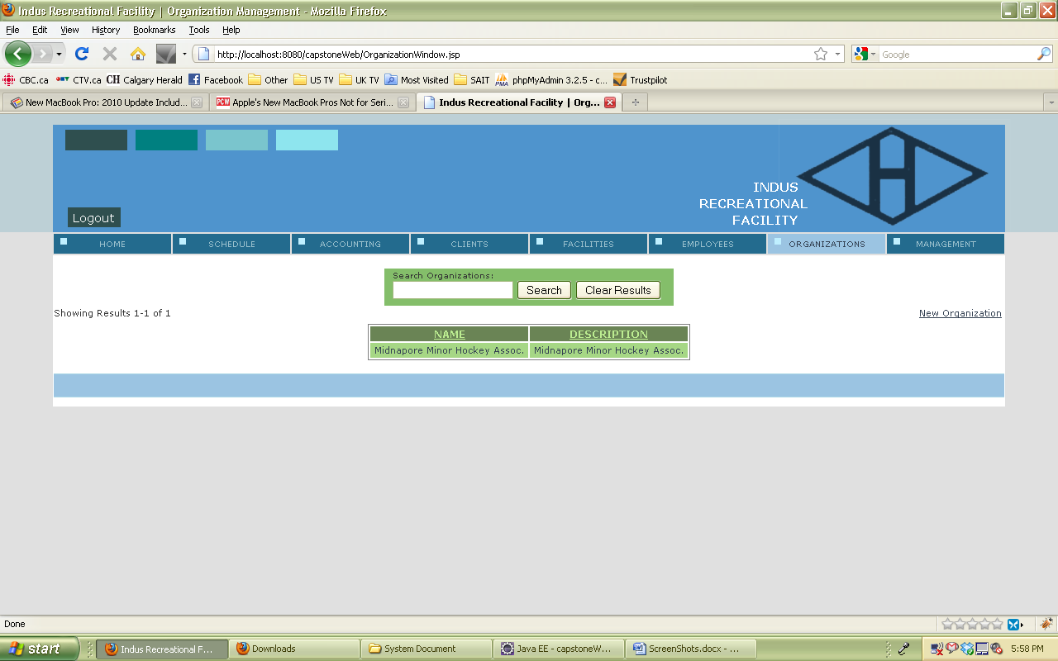

### 4.5.7.4 View detail about organizations:

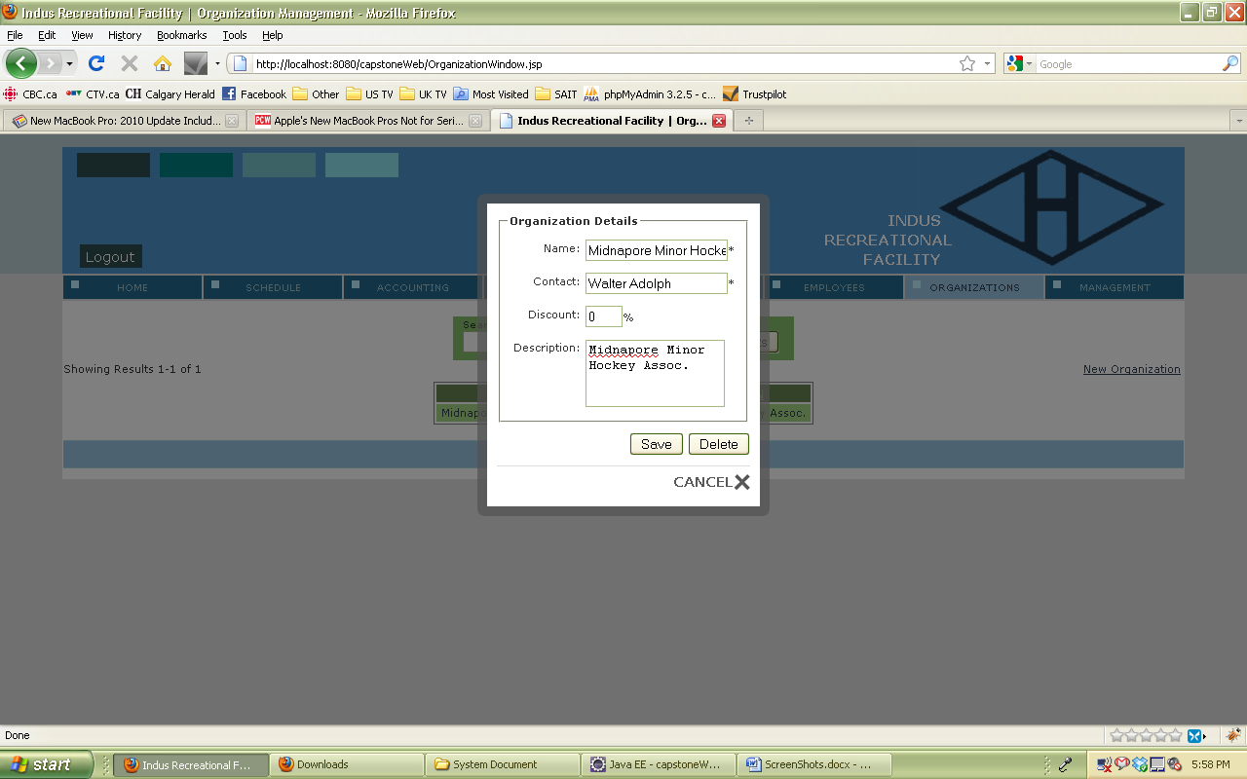

### 4.5.7.5 Add a new Organization:

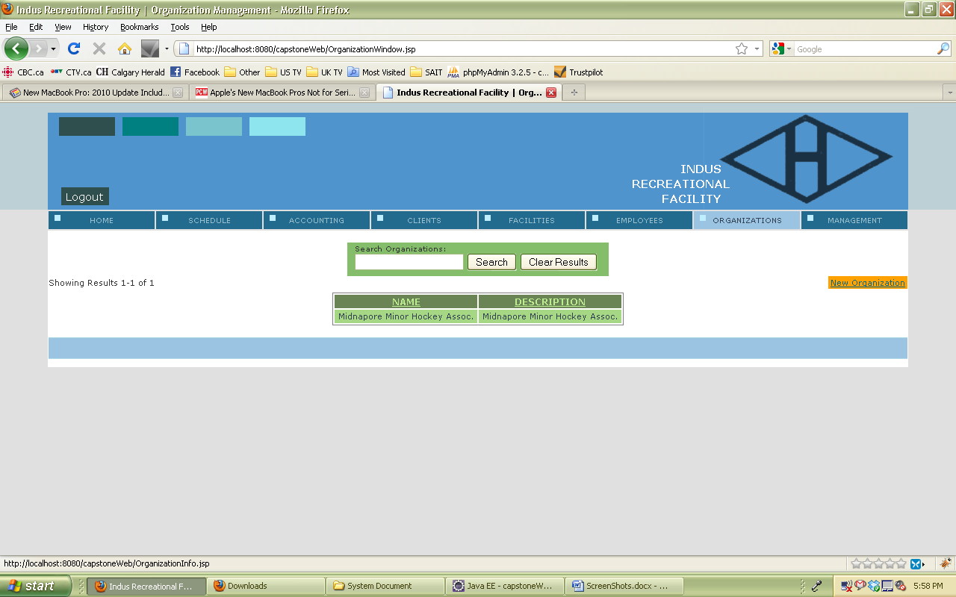

### 4.5.7.6 New organization form:

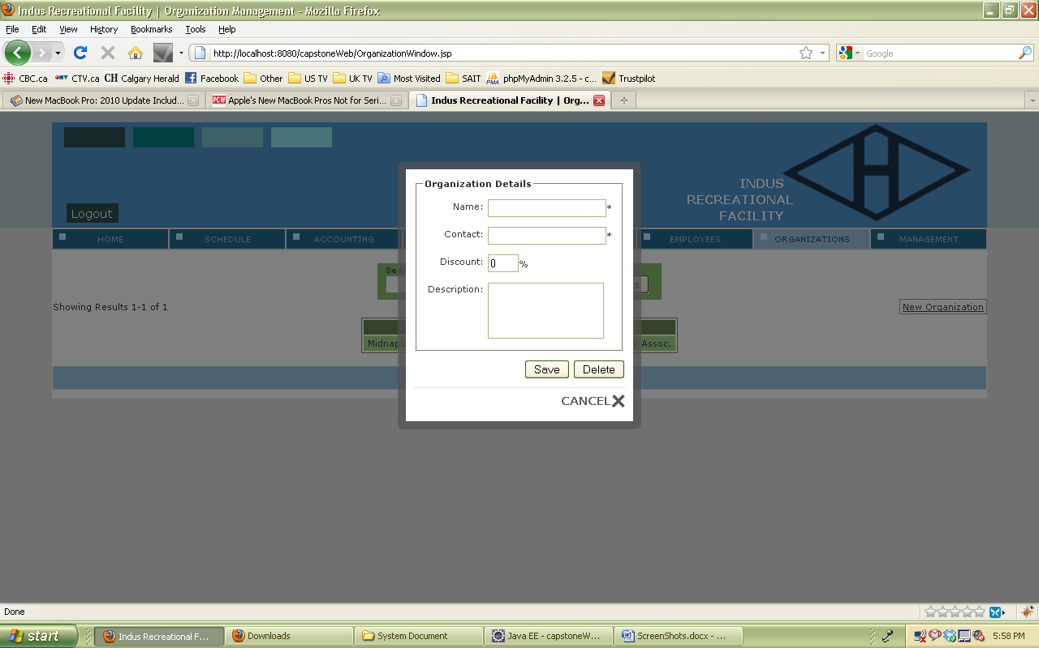

### 4.5.7.7 Organization must have a name:

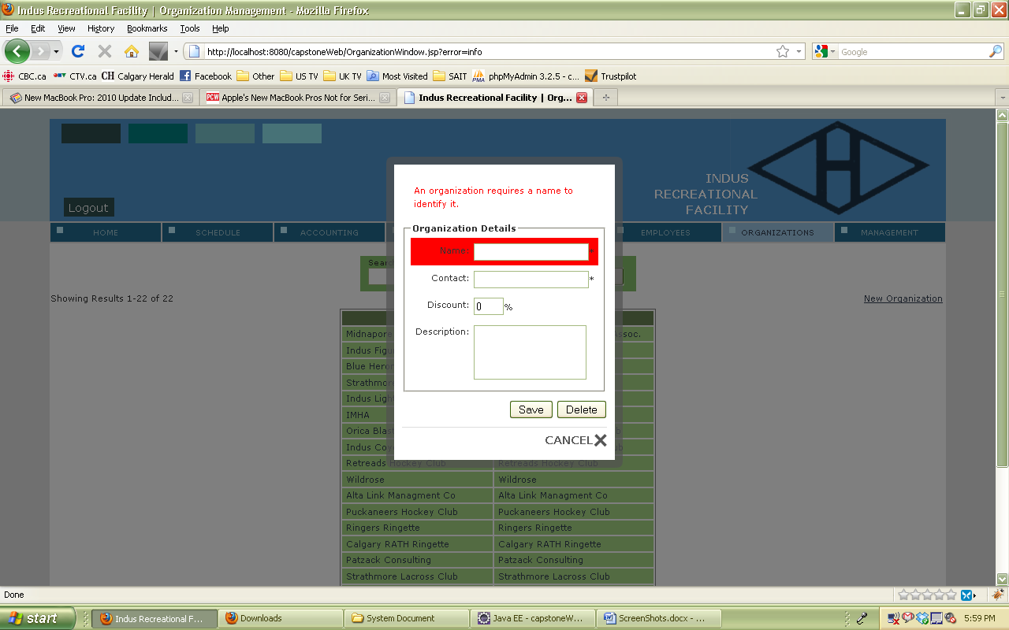

### 4.5.7.8 Organization must have a contact

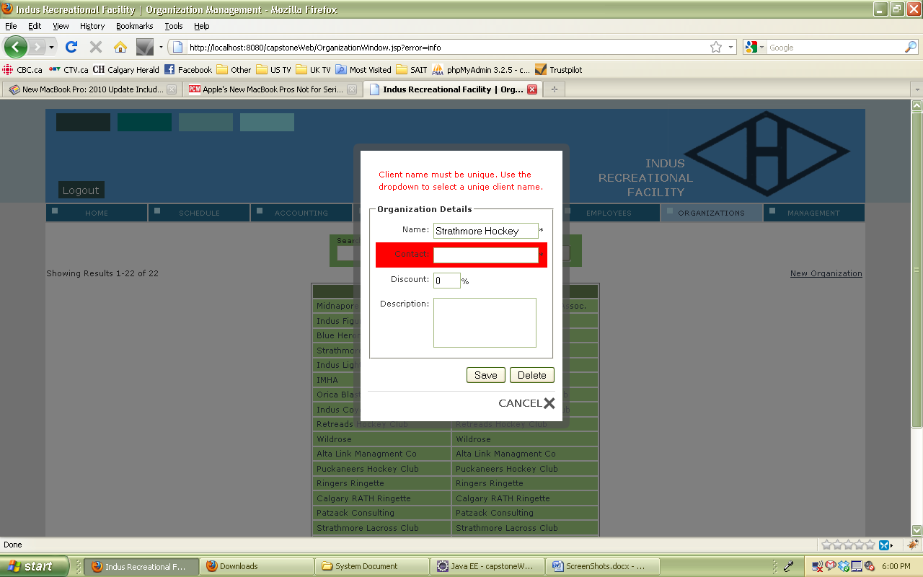

## 4.6 Usability Requirements

The new system was built with the legacy system in mind. Essentially the system has inherited several aspects visually and functionally. Giving existing users the familiarity of the legacy systems framework coupled with the added functionality of the new. While the colour scheme has changed the layout of the schedules has remained the same, with the added feature of being able to select different facilities for when the Indus recreational facility expands their facilities.

The reasoning behind designing the core functionality the same way as the legacy system is to keep the system intuitive for the user. It is important to keep in mind that there are also a lot of new features added to the system. These features include such things as adding new facilities, invoices, adding employees to the system for the usage of remote access. While keeping existing features, such as adding clients to book facility times for. It was important to integrate an interface with these features that will allow the users of the system to navigate the system without getting lost.

To reach the goal for the most intuitive interface we went through a number of interface designs. We tested these designs for the efficiency in completing tasks and also clarity of function. In other words whenever a user needs to input calculable information into the system there will be a label indicating the type of input the system will take to validate the information. It also means that when an employee accidently mistypes letters into a number field or inputs a percentage over 100% than an error will immediately inform them that an error has occurred and mention what format the data should be in.

## 4.7 Problem Domain Class Diagram

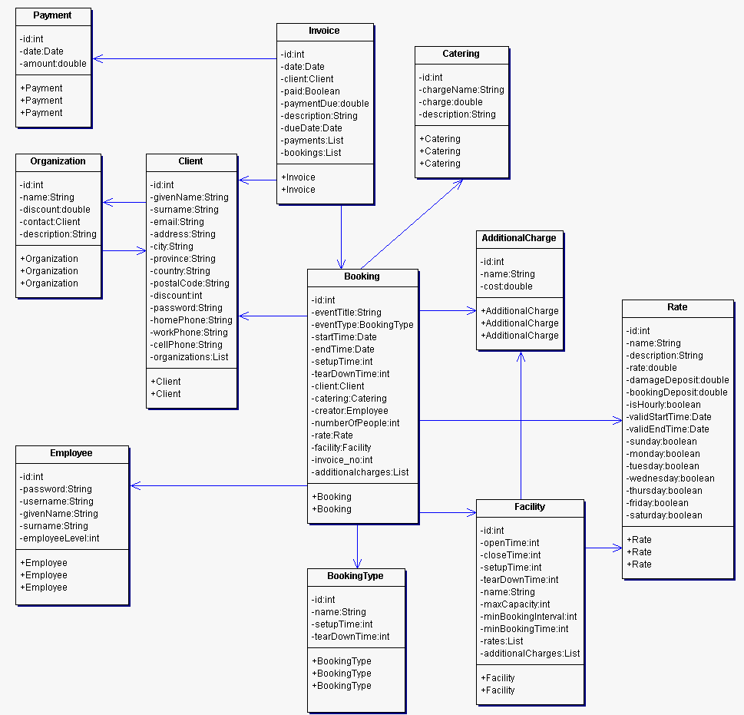

# 5.0 System Design

## 5.1 Layered Architecture

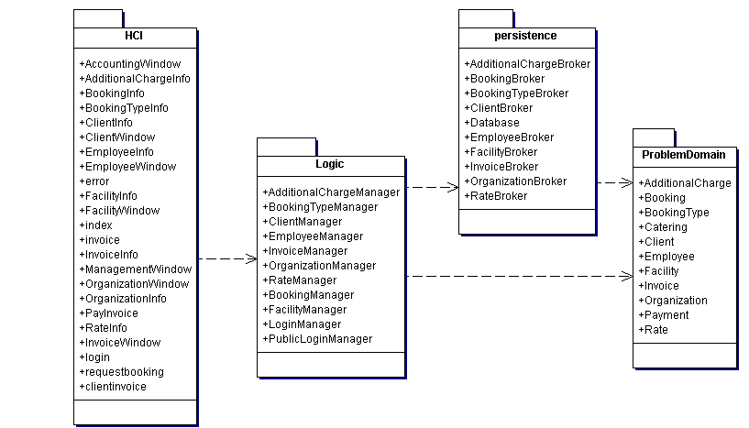

## 5.2 Hardware Architecture

There are currently three computers in use by the Indus Recreation Centre that the system will be deployed on. These computers will be controlled using a standard keyboard and mouse. Each of these computers will be connected to a central database server; the computers will be connected to the database through a TCP/IP connection and be able to access all required resources such as IRMS or MySQL. The central database is where all records processed by the system will be stored and retrieved. The system may also be deployed on additional computers in the future, which will also be connected to the database server.

## 5.3 Hardware Platform

### 5.3.1 Required Hardware Specifications for Development and Maintenance

In order for the ongoing development and maintenance of the system, the following hardware specifications are recommended: 2.0 GHz and 2.0 GB of RAM in order to sufficiently run the Java VM, Eclipse Galileo, and a MySQL database for testing. To allow for expansion of the of the database and extensive testing purposes 2.5 GB of hard drive space will be required for the storage of all Java source code, and text data for the MySQL database.

### 5.3.2 Required Hardware Specifications for the Production System

Desktop Computers:

In order for sufficient performance of the system, the following hardware specifications are recommended: 2.0 GHz CPU and 2.0 GB of RAM in order to sufficiently run the Java Virtual Machine, and all the other required software, including the dabase.

Database Server:

In order the sufficient database performance, the following hardware specifications are recommended: 1.0 GHz CPU and 1.0 GB of RAM in order to sufficiently handle all incoming database connections. To allow for the system to expand and grow 50 GB of space on the server are recommended for the MySQL server and the JVM.

### 5.3.3 Communication mechanism

The majority of communication being done in the IRC system will be done through JDBC, as the system will have to maintain only one repository for all its information needs. This will ensure data consistency and also simplify the network communication between the system(s) and the database repository.

## 5.4 Software Platform

### 5.4.1 Required Software Specifications for Development and Maintenance

Software Required to Develop the System:

* Eclipse Galileo:
  + - Need to create a program that the general public can use to access information about available times for all resources.
    - Need to create a program that the client is able to add bookings, delete bookings, create invoices, update schedule and change available resources.
  + MySQL 5.1:
    - Need to create a database to hold all client information, scheduling information and invoice information.
  + Tomcat 6.0:
    - Used as the server for the program

Software Required to Maintain the System:

* + Eclipse Galileo:
    - Need to be able to make easy and frequent changes to the system if required.
    - Need to have well documented, easily explained code
  + MySQL 5.1:
    - Need to be able to easily maintain database
    - Need to have well documented, easily explained sql code
  + Tomcat 6.0:
    - Used as the server for the program

### 5.4.2 Required Software Specifications for the Production System

* Excel: They need excel since the system exports files into a excel format.
* MySQL: They need MySQL to be able to update or delete tables at the clients command.
* Email application: They need an Email application since the user will be sending clients emails with invoice information and explanation of costs.
* Java Platform: They need the java platform installed on their systems, so that they will be able to run the java program.

### 5.4.3 Alternatives to Software:

* Excel Alternative: Open Office Calculate 3.0: This program has all the functionality of excel but is an open source alternative.
* MySQL Alternative: PostGreSQL: This program has all the functionality of MySQL but is an open source alternative.
* Email Application Alternative: There are many alternatives, it all depends on the users preferences.
* Java Platform Alternative: Visual Studios, Net Beans, and many others, it all depends on what the user’s preferences are towards these programs.
* Tomcat Alternative: Glassfish, java web server, bea weblogic

## 5.5 Interaction Model

When the system is asked to retrieve information, the details of said information, whether for a facility, employee, client, catering cost, etc. should be appropriately filled in the fields provided by the UI. This will allow for easy verification of data and easy access to change the information already stored in the database. Given the fields for each particular entry type in our system, this allows for easy addition to the system simplifying the process entirely for the user(s).

The majority of the error checking built into the interface as our user(s) will not understand the complex error messages been given to them from the application or database. Due to this fact some preventative errors will need to be in place to eliminate these kinds of problems. Such as built in mechanisms to prevent user errors, including red block over required fields for information, being able to highlight any missing input after attempting to commit data, or having smart searches so the users can quickly find clients, or other, information so as not to interfere with their regular business transactions.

Should the system have any major issues, a person or people will have to be trained in the maintenance of the system. In the event that the system isn’t responding, say from bad user input and/or just a crash attempting to retrieve information the system would prompt the user to contact the person maintaining the system and generate a report to aid in troubleshooting.

As well since our system only retrieves information from the database once (from start up) a mechanism will be in place that whenever the user wishes to save new or altered information on the system, that the database will be also updated with the new data. The information must be persisted whenever the data being manipulated by the user is not the same as the data inside the database, this should be re-laid and/or processed by either the application or the database to facilitate any error checking and fixing that might be necessary in the future.

The colour scheme we have chosen to use on our system is one that has been colour-coordinated, has been approved by all of our team members and is in the process of being approved by our customers.

## 5.6 Persistence Model

### 5.6.1 Logical ERD



5.6.2 Physical ERD



## 5.7 Class Diagram

### 5.7.1 Problem Domain Layer

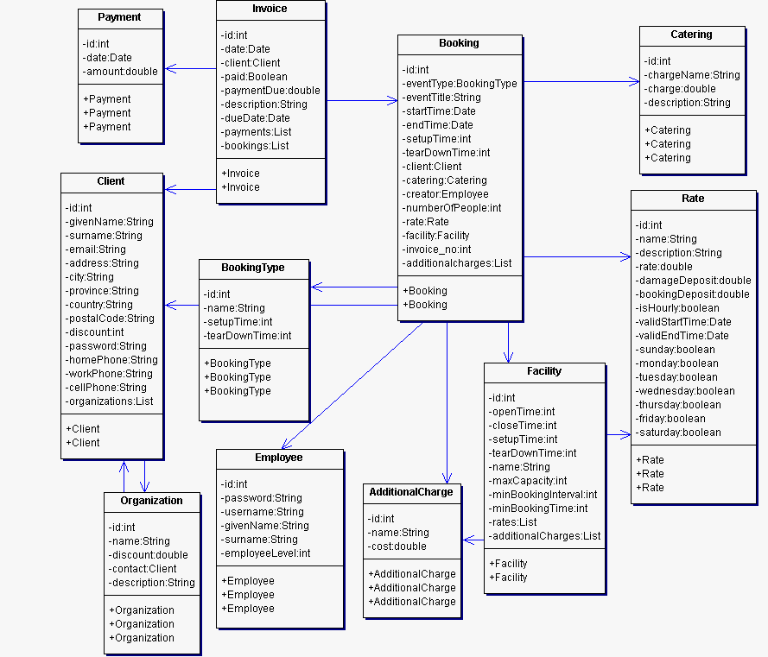

### 5.7.2 Persistence Layer

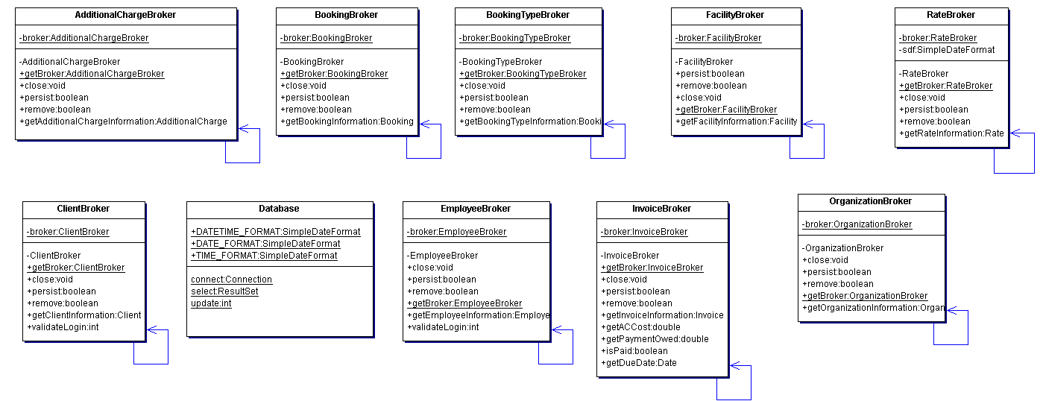

### 5.7.3 Logic Layer

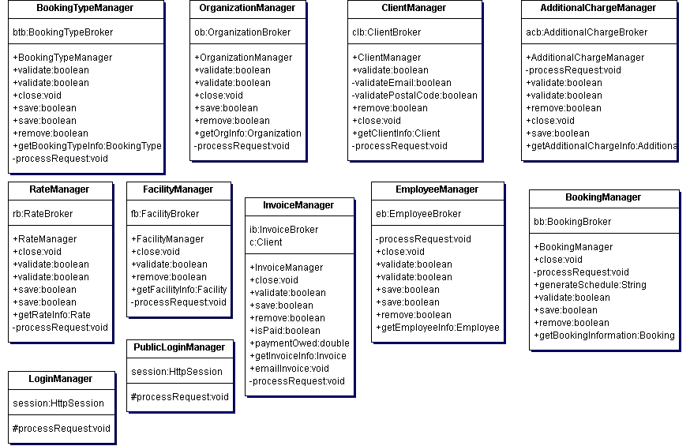

### 5.7.4 HCI Layer

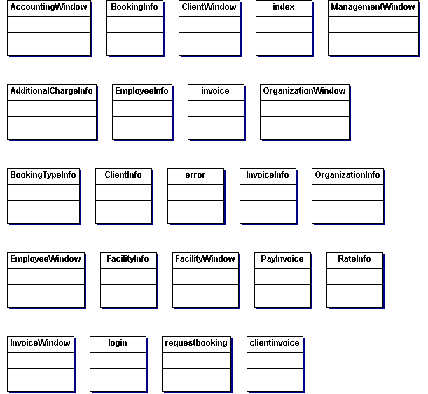

## 5.8 Interaction Sequence Diagrams

### 5.8.1 Additional Charge Sequence Diagram

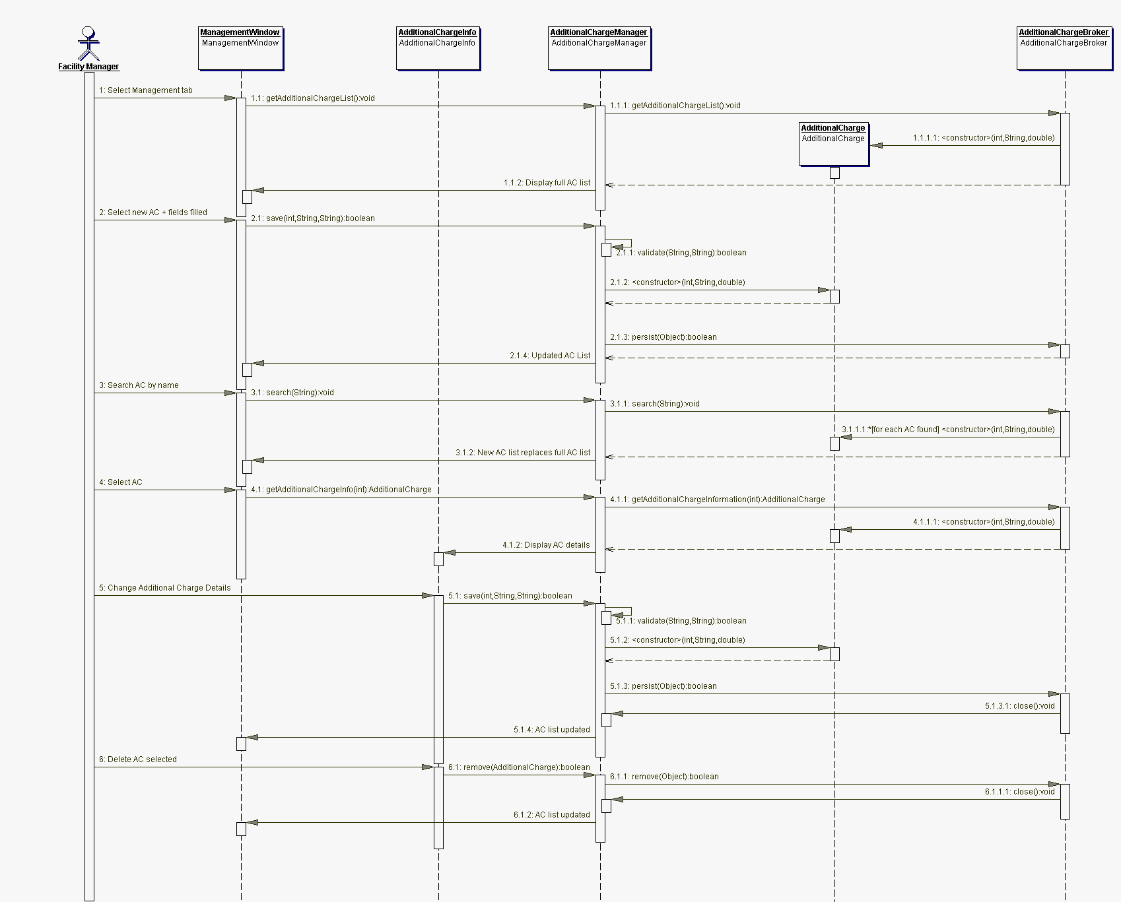

### 5.8.2 Booking Sequence Diagram

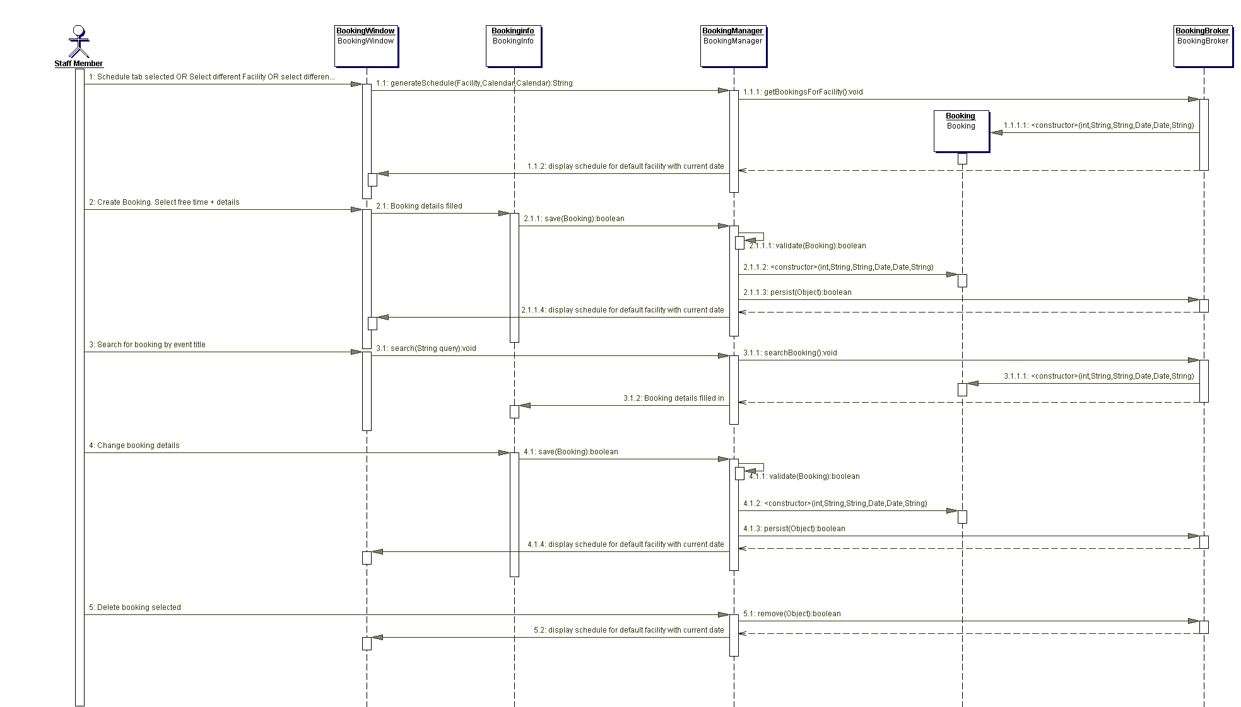

### 5.6.3 Booking Type Sequence Diagram

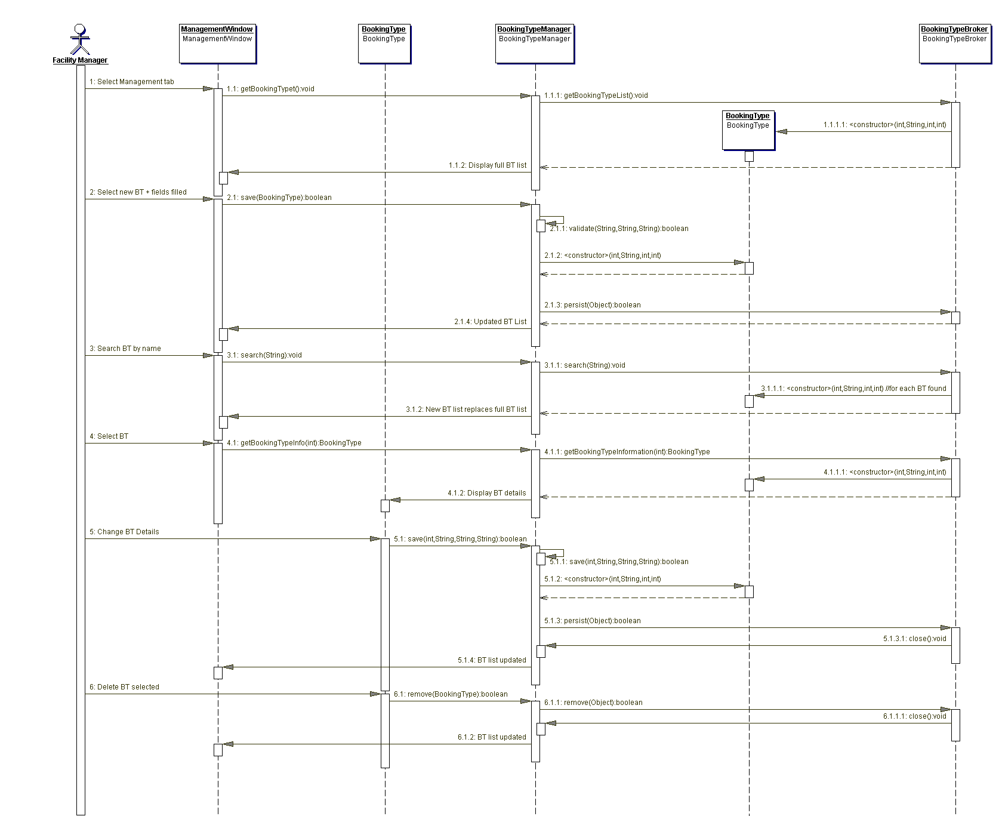

### 5.6.4 Client Request Booking Sequence Diagram

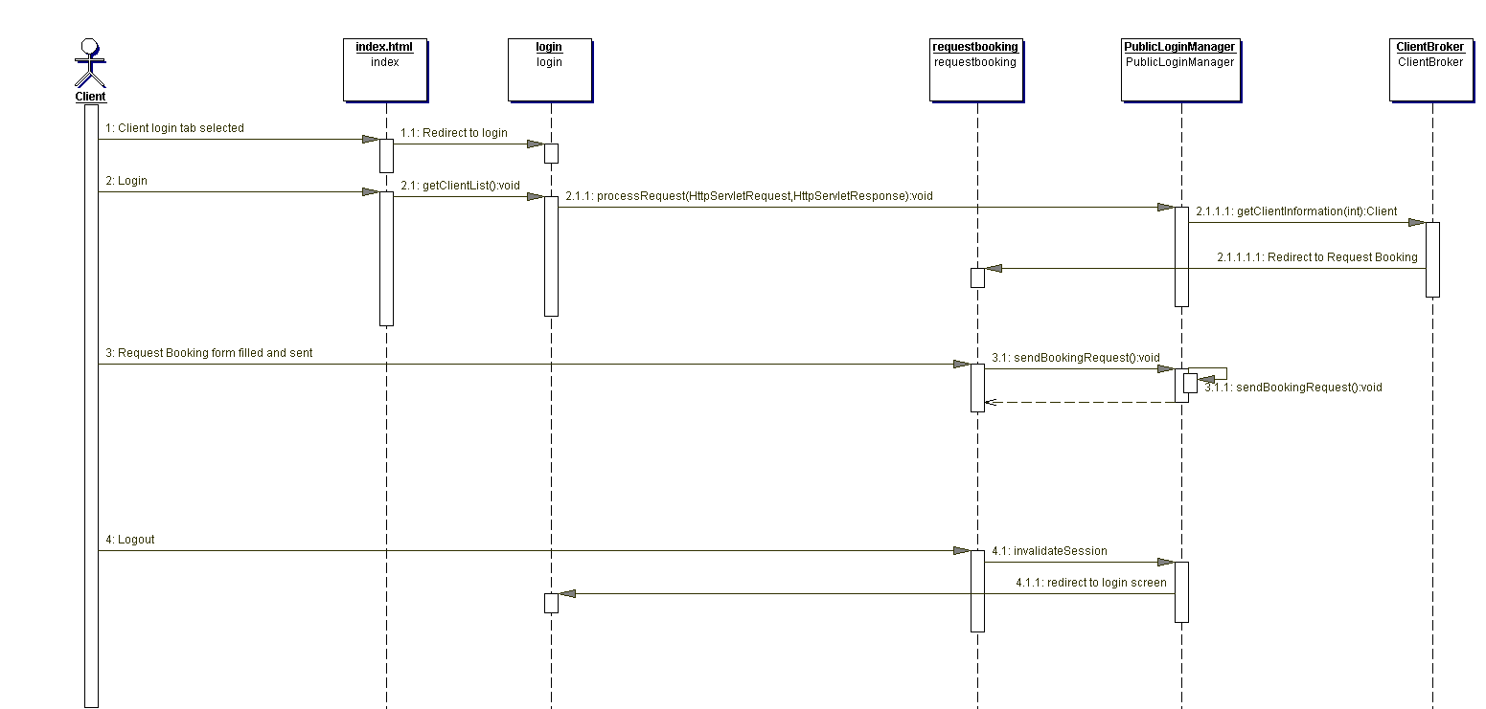

### 5.6.5 Maintain Client Sequence Diagram

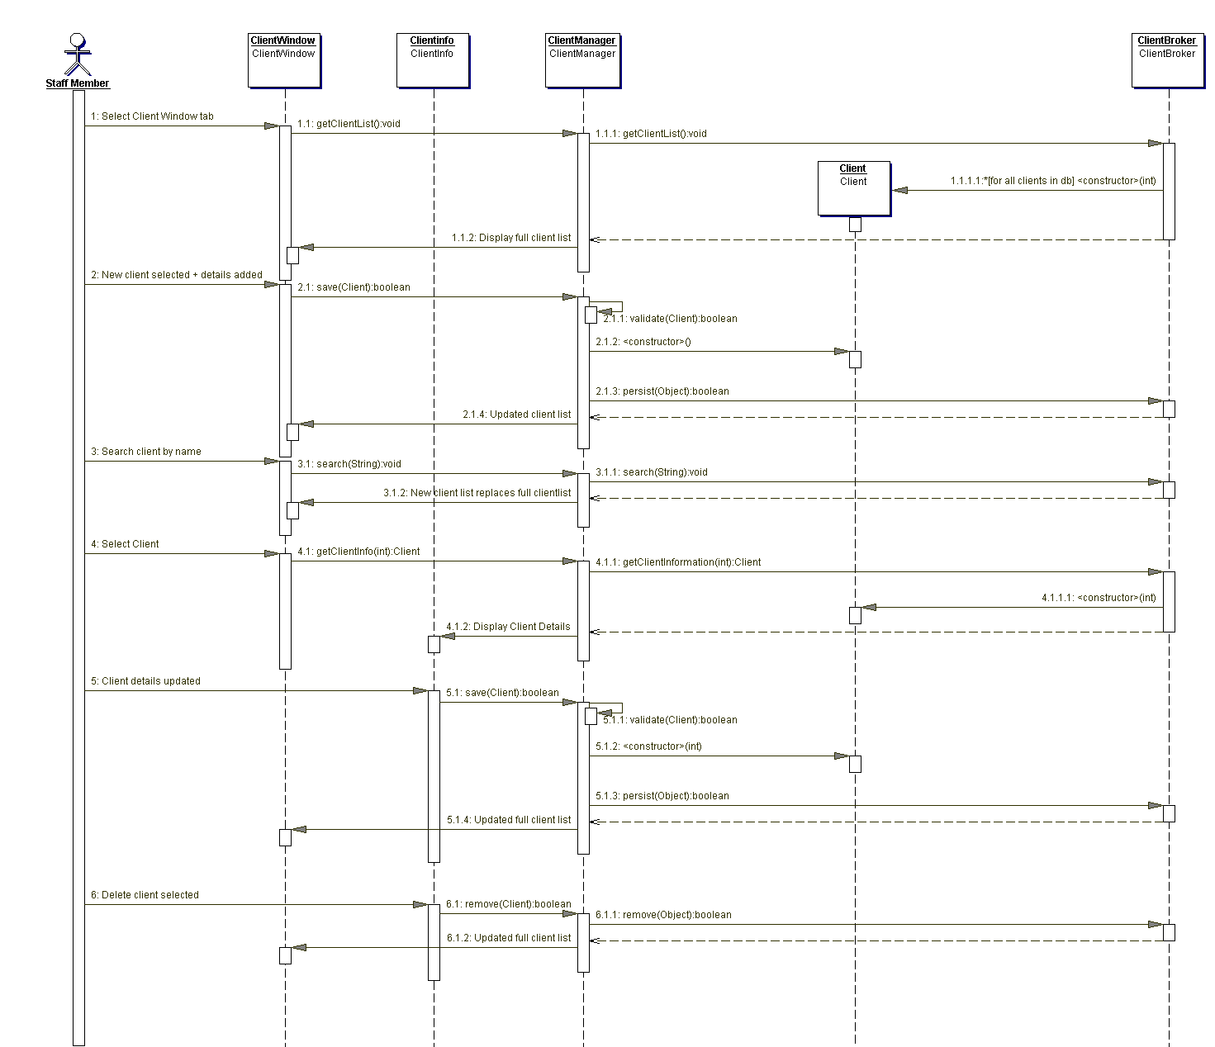

### 5.6.6 Client View Invoice Sequence Diagram

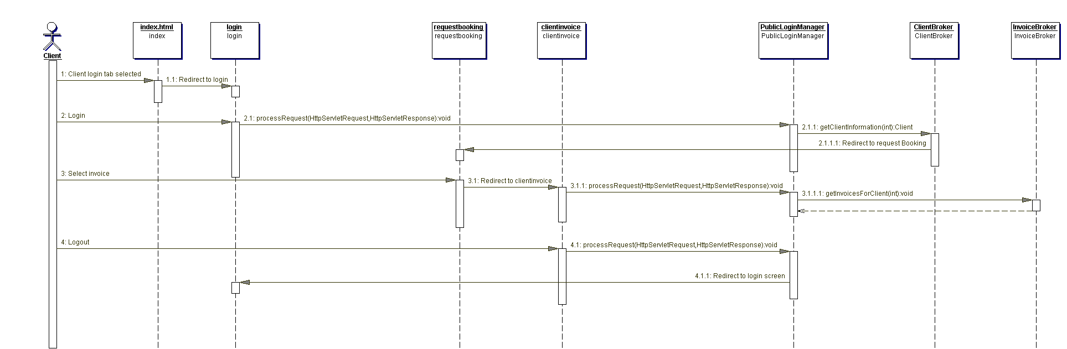

### 5.6.7 Employee Sequence Diagram

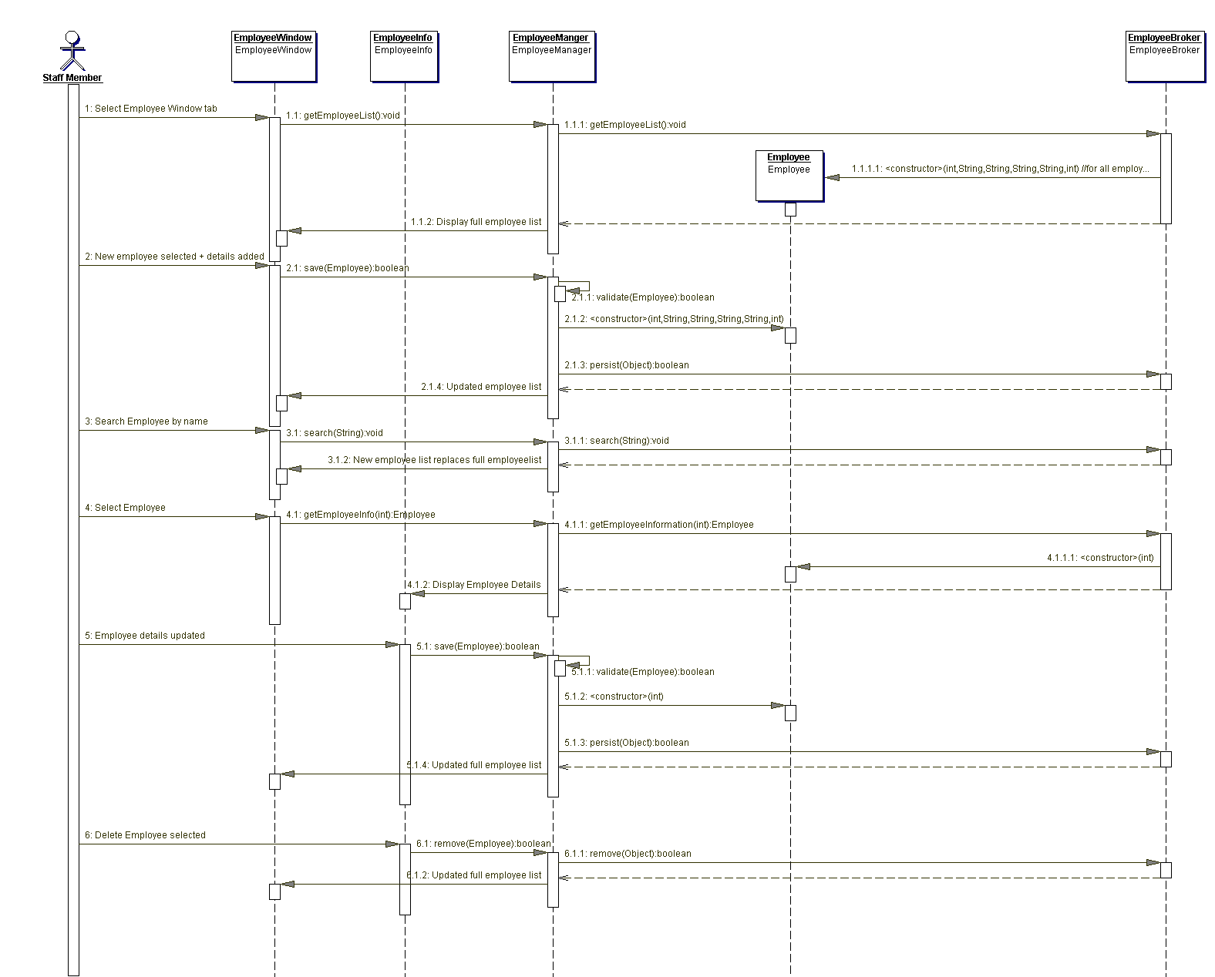

### 5.6.8 Facility Sequence Diagram

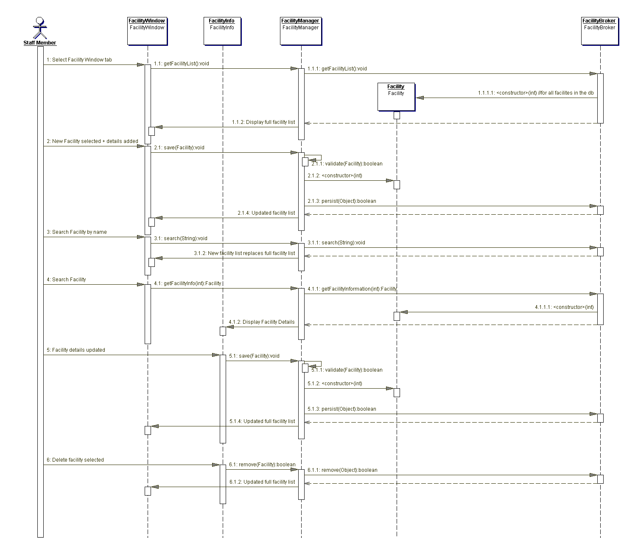

### 5.6.9 Invoice Sequence Diagram

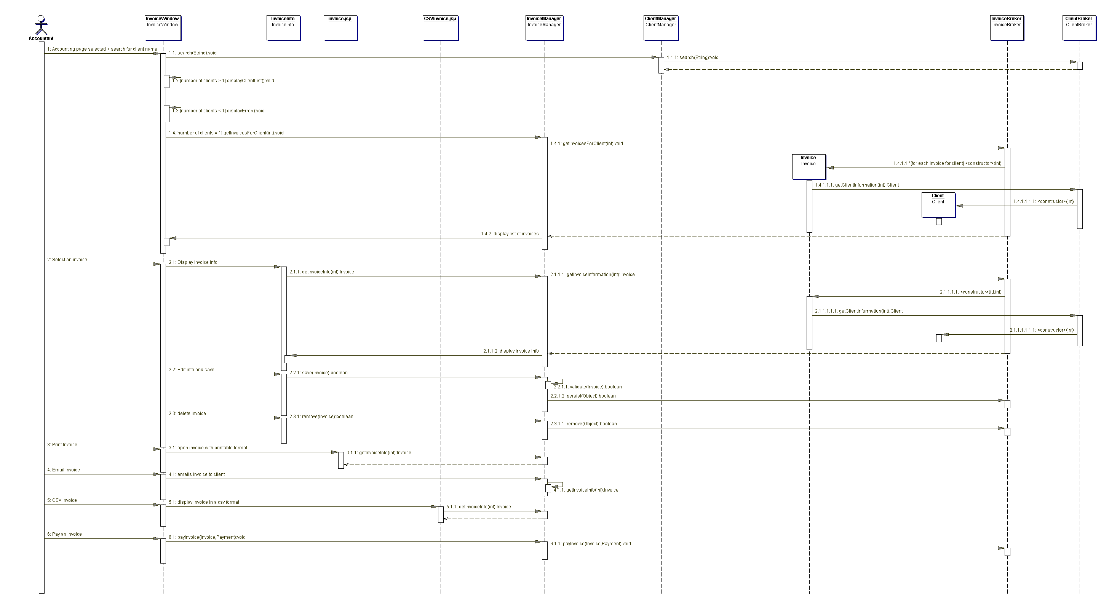

### 5.6.10 Organization Sequence Diagram

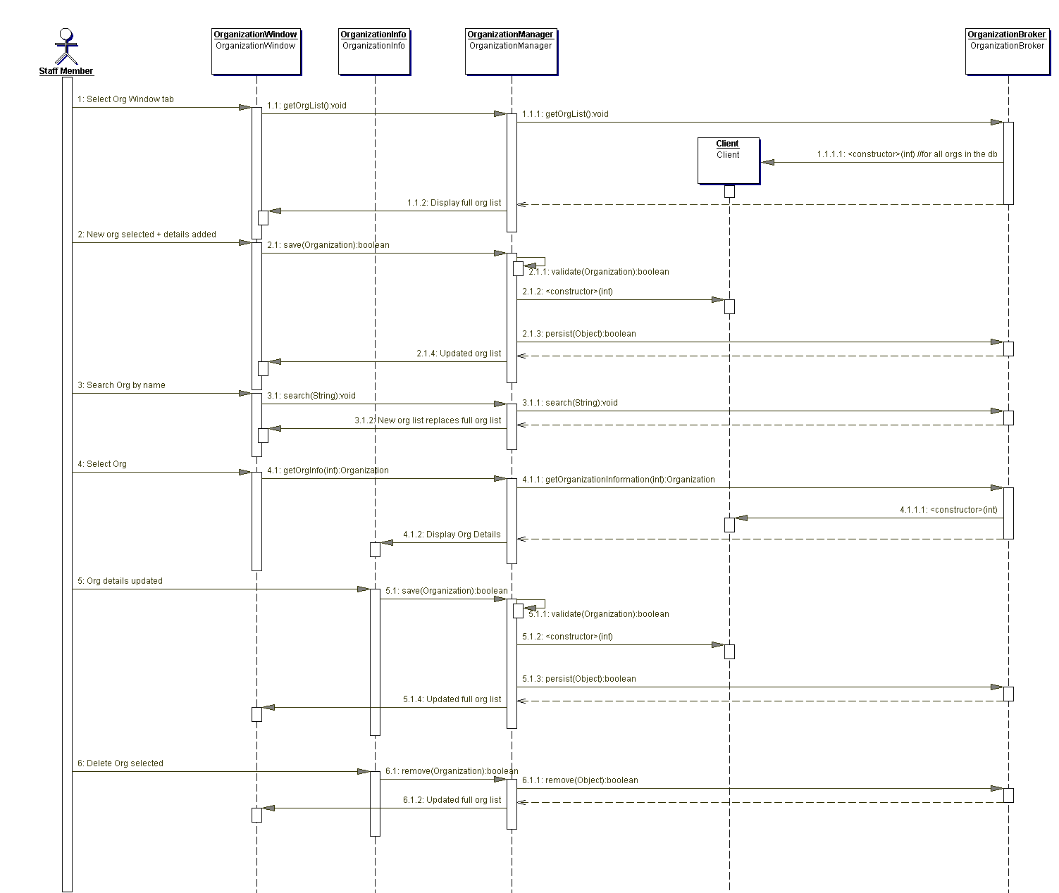

### 5.6.11 Rate Sequence Diagram

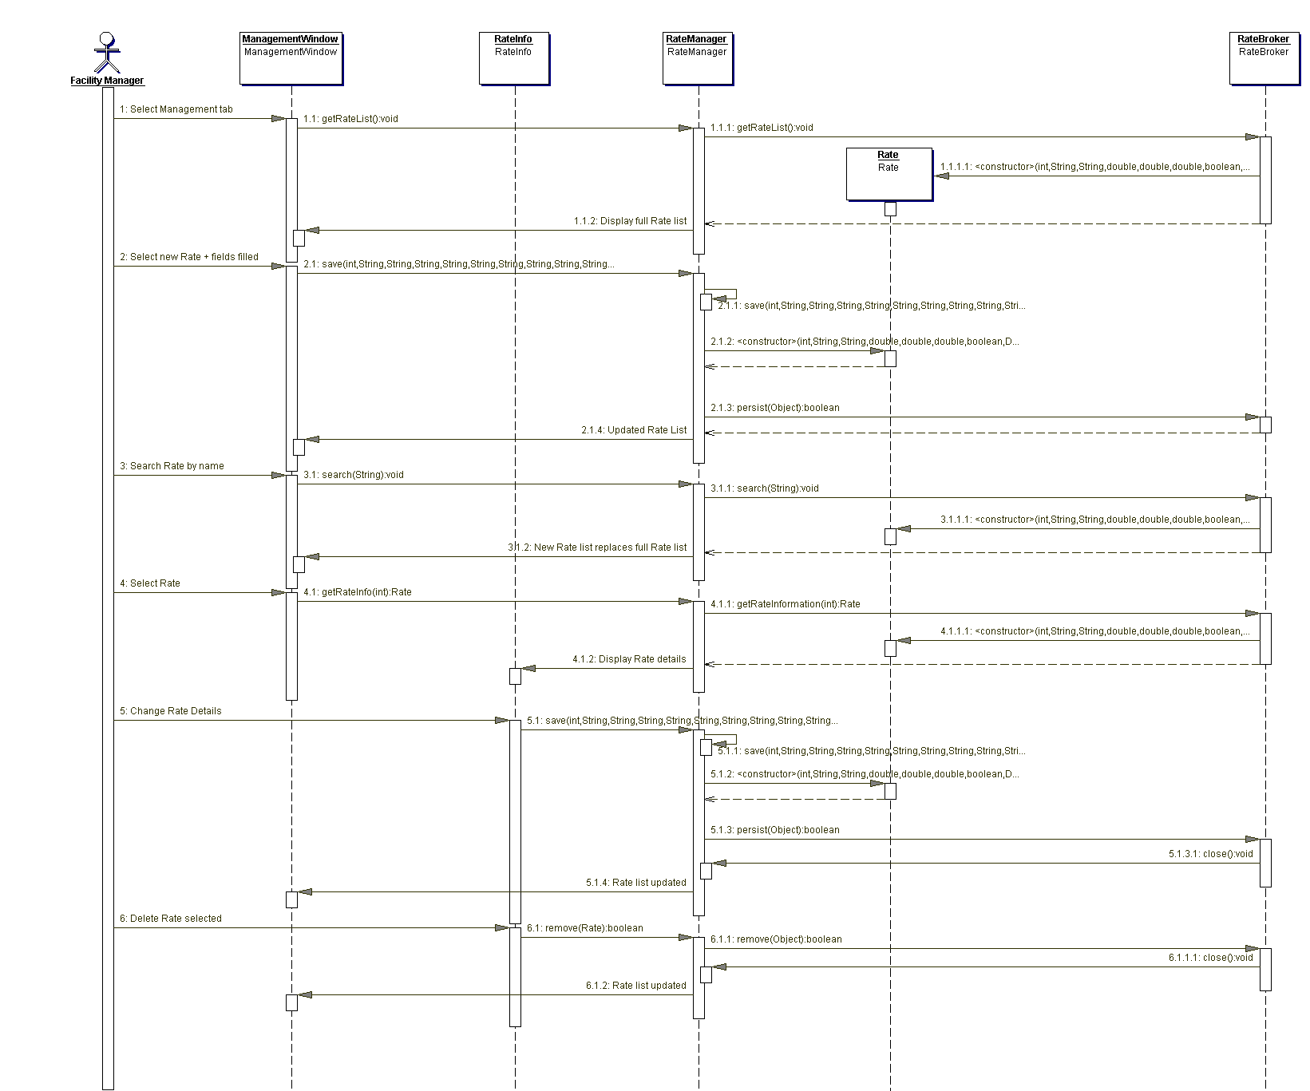

### 5.6.12 Report All Client Invoices Sequence Diagram

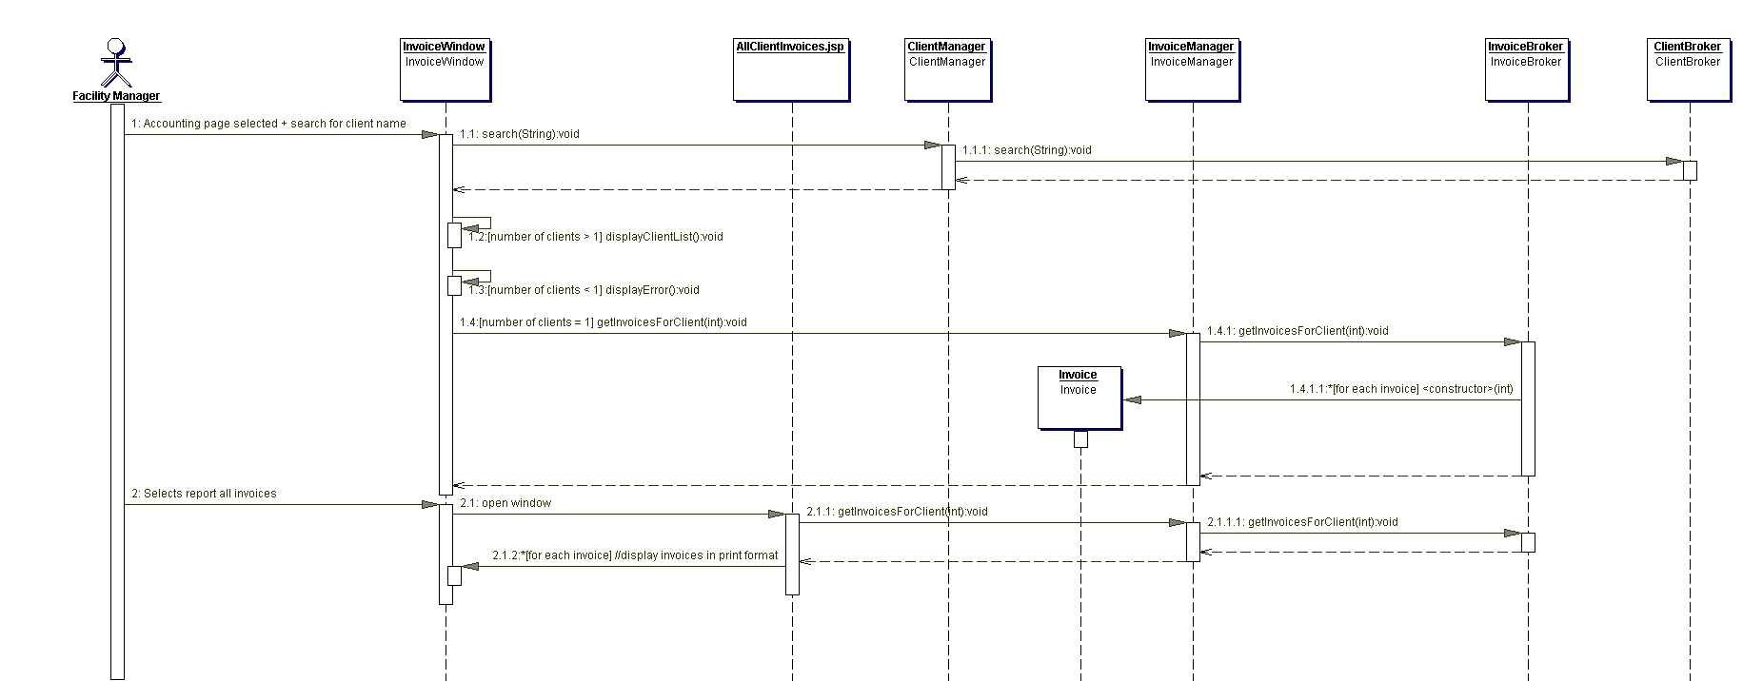

### 5.6.13 Report Unpaid Invoices Sequence Diagram

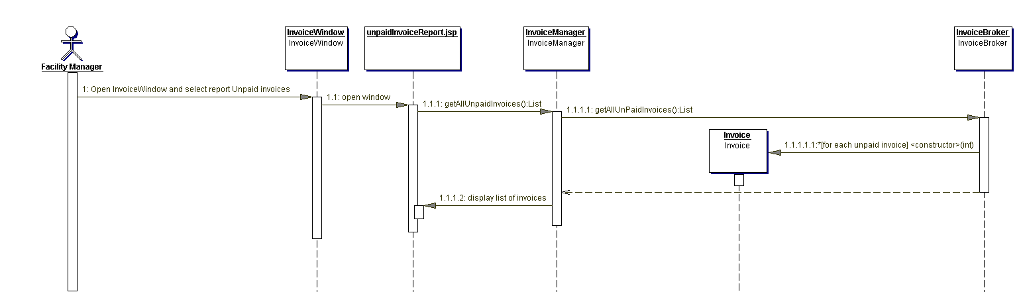

### 5.6.14 View Booking Sequence Diagram

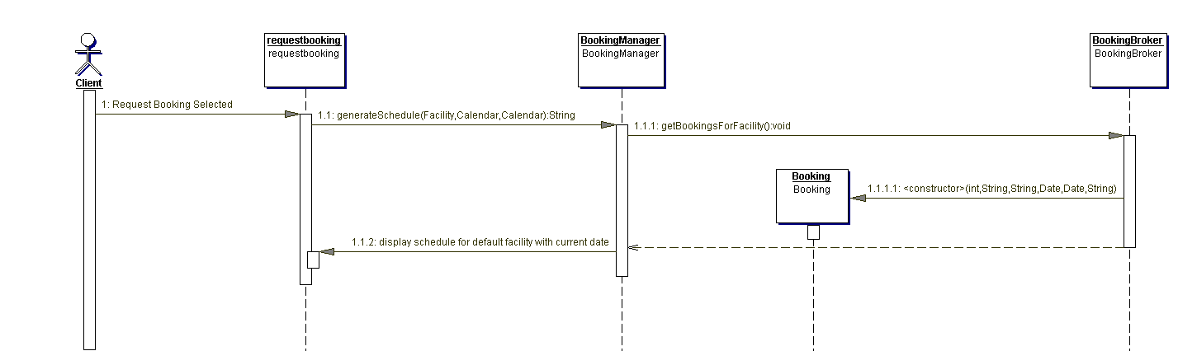

## 5.9 Statechart Diagram

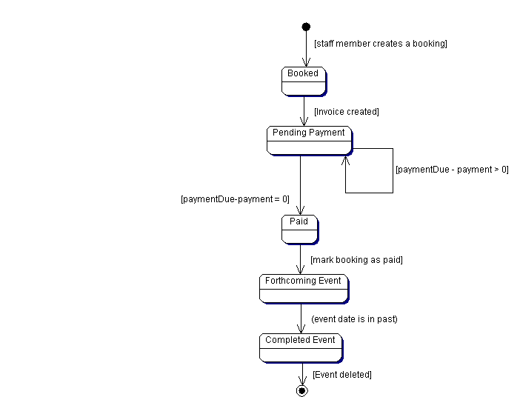

## 5.10 Activity Diagram

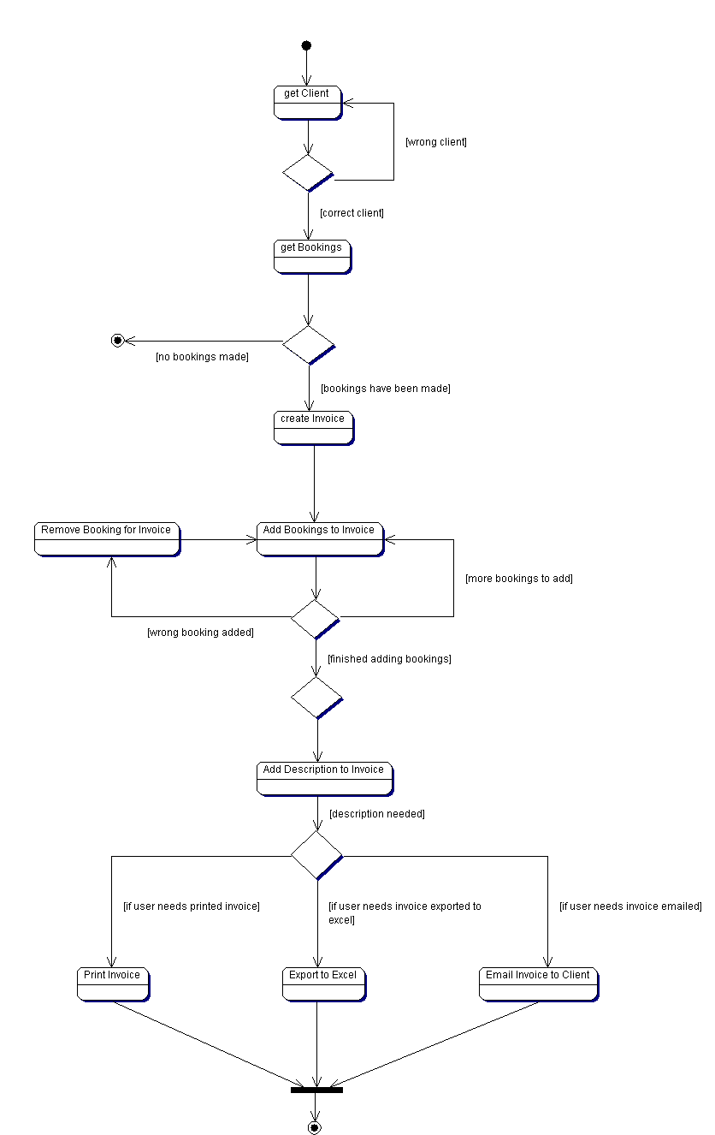

## 5.11 Data Dictionary

See Code & Javadoc Binder

# 6.0 Testing

## 6.1 Test Plans

Acceptance Test Objective:

This test will verify that the system meets the Client’s requirements and performs to the satisfaction of the Client.

Acceptance Test Entry Criteria:

The system will have successfully completed Module, Unit and System testing to the satisfaction of the system designers.

Acceptance Test Exit Criteria:

The system will successfully meet the criteria as identified by the client.

Acceptance Test Responsibility:

The criteria identified by the client will be tested by Corey Cantley, Jorge Pinochet, Kerri Lynch O’Loughlin, and John Stuby and we will initiate and complete the tests, verify the test results, and declare that the Test Exit Criteria have been met.

Test Procedures:

Specific test procedures will be identified on the Testing Form for each functional requirement and each non-functional requirement.

## Acceptance Test Criteria

The following criteria have been identified as necessary for Client approval of Indus Recreational Center System.

Generating a schedule:

Add a booking

Remove a booking

Modify an existing booking

Available time for facility

Choosing a facility

Adding a booking

Create a new user

Surname

Event title

Event type

Start time

End time

Setup time

Tear down time

Rate

Additional Charges

Invoice number

Database Maintenance:

Client

Add a new client

Delete a client

Modify information for an existing client

Facility

Add a new facility

Delete a facility

Modify information for an existing facility

Rate

Add a new rate

Delete a rate

Modify information for an existing rate

Employee

Add a new employee

Delete a employee

Modify information for an existing employee

Organization

Add a new organization

Delete a organization

Modify information for an existing organization

Additional Charge

Add a new additional charge

Delete a additional charge

Modify information for an existing additional charge

Booking Type

Add a new booking type

Delete a booking type

Modify information for an existing booking type

Invoice

Add a new invoice

Delete a invoice

Modify information for an existing invoice

Booking Creation:

Create a booking that allows for:

Automatic generation of a booking_id

Data entry of:

Client name

Surname

Event title

Event type

Start time

End time

Setup time

Tear down time

Rate

Additional Charges

Invoice number

Save and keep booking on active status until complete

Cancel the generation of the current booking

Update all information on an existing booking, with specific attention to:

Adjusting Client name and surname

Adjusting Event title

Adjusting Event type

Adding additional charges

Adjusting start time

Adjusting end time

Delete an existing booking

Invoice Creation:

Correct calculation of price including additional charges, rates, subtotal, GST, and total

Report Generation:

Reports are to be generated automatically on the first or last day of the month, and also when requested by the Client. Report modification by the Client is not required.

The following reports have been identified as required by the Client:

Email Customer report:

Client/Organization Name, Billing Address (street address, city, province, postal code), Invoice number, bookings.

Print Customer Report:

Client/Organization Name, Billing Address (street address, city, province, postal code), Invoice number, bookings.

Export invoices to QuickBooks

Client/Organization name, invoice numbers, bookings, etc

Non-Functional Requirements Tests (may be incorporated into Functional Tests)

Database size – At least 1000 customers and reasonable associated data can be accommodated.

Speed – Each report will be generated within 5 seconds

Multiple database connections support. All the IRC customers, estimated maximum 100 at any one time, and all the IRC employees, estimated maximum 15, should all be able to access a facilities booking Schedule at the same time.

# Acceptance Testing Form

| **Client**: Indus Recreational center |  |
| --- | --- |
| **System**: Indus Recreational Center Scheduling System |  |
| **Objective**:  Verify that when a booking is created, all information is updated in the booking table located in database | |
| **Tester Name:** Kerri Lynch-O’Loughlin | |
| **Developer Name:** John Stuby | |

|  |  |  |
| --- | --- | --- |
| **Component**: Create booking | | **Test Date:** |
| **Test** | **Description** | **Actual Result** |
| 1. | *Select free time in schedule for facility*  **Procedure**:  Open the program  -The application should display the home page  Log in with a valid username and password  -Login with username as kerri and password as password  Click on the schedule tab  -Located on the top left in the menu bar  Click on a free time on the schedule  -Click on white space of the timetable displayed  **Expected Result**:  Opens up the booking screen  -A popup menu should appear with empty fields  -The time fields however will auto fill | The Booking screen is opened |
| 2. | *Fill in all information in booking screen*  **Procedure**:  Fill in all available fields in booking screen  -Fill in fields as follows:  -given name : test  -surname: test  -client: testClient  -Event name: testEvent  -BookingType: Hockey Game  -Rate: PrimeTime Ice 1  -Guest Count: 100  -Start time: N/A  -Length: 60 minutes  -Setup time: N/A  -Teardown Time: N/A  -Additional Charges: Ctrl click each of the following:  -Pop Fountain  -Ice Machine  **Expected Result**:  All fields are filled in  -Fields should contain information the user has input | All fields are filled in |
| 3. | *Click on save to update schedule to show new booking*  **Procedure**:  Click on save to update schedule and return to main schedule page for the selected facility  -The booking created should appear with appropriate time on the time schedule  **Expected Result**:  Save: updates schedule with new booking and returns to the schedule page for selected facility  -The time schedule from the booking will be filled into the schedule and colored red | On main schedule page, new booking is created for specified time frame with requested event name |
| 4. | *Click on delete to delete current booking and return to previous screen*  **Procedure:**  Click on delete to delete current booking and return to main schedule page for the selected facility  -Select the booking you just created. Click on the delete button  **Expected Result:**  Select the previously created booking  Click on the “delete” button: deletes current booking and return to main schedule page for the selected facility  -The time schedule will no longer display the booking that was scheduled | Returned to previous screen |

|  |
| --- |
| **Comments**: |
| **Client Signature of Approval**: |
| **IT Use Only:**  Redesign Complete: 🞏 Yes 🞏 No  Retest Complete: 🞏 Yes 🞏 No  Details if Retest not complete: |
| **Date:** |
| **Developer Name and Signature:** |

|  |  |  |
| --- | --- | --- |
| **Client**: Indus Recreational Center | |  |
| **System**: Indus Recreational Center Scheduling System | |  |
| **Objective**:  Verify that invoice information is returned to the invoice screen and proper exporting options are taken | | |
| **Tester Name:** Kerri Lynch-O’Loughlin | | |
| **Developer Name:** John Stuby | | |
| **Component**: Create Invoice | | **Test Date:** March 27, 2010 |
| **Test** | **Description** | **Actual Result** |
| 1. | *Select bookings to add to invoice*  **Procedure**:  Open the program  -The application should display the home page  Log in with a valid username and password  -Login with kerri and password  Click on the accounting tab  -Located on the menu bar, top-left  Search for a client  -Use the available search box located by client and type in “testClient”  Click on correct client  **Expected Result**:  Opens up the invoice screen  -Two tables appear with available bookings and booking included on invoice | Invoice screen is opened |
| 2. | *Click on the selected bookings*  **Procedure**:  Select appropriate bookings available in booking table  Once all bookings selected  - Ctrl click the first 3 bookings on the list  -Click the *add to invoice* button  **Expected Result**:  All bookings selected will move from bookings table to invoice table | Selected bookings are moved from booking table to invoice table. |
| 3. | *Remove unnecessary bookings*  **Procedure:**  Select unnecessary bookings from invoice table  -Click the remove booking button  **Expected Result:**  All bookings selected will be removed from invoice table and put back in bookings table | Removes the unnecessary bookings selected from the invoice table, and returns them to the booking table. |
| 4. | *Save the invoice*  **Procedure**:  Click on the save button  -Located at the bottom of the screen  **Expected Result**:  Invoice list will be updated in accounting list | Invoice list is updated to include the new invoice |
| 5. | *Select option to pay for invoice*  **Procedure**:  Click on the due date located in the paid column  **Expected Result**:  Payment window pops up  -First field shows payment amount for invoice  -Second field is open allowing the user to choose amount to pay. | Payment window pops up, the first field shows required payment, second field is for the user to input the amount they want to pay for invoice at current time |
| 6. | *Click on the save*  **Procedure**:  Click on save to update paid column in invoice table and return to previous page  **Expected Result**:  Return to accounting page with updated information | Returns to the accounting page with updated information for the invoice. The information in the paid column will be updated to paid if the entire amount of invoice was paid. |
| 7. | *Delete the invoice*  ***Procedure:***  Click on the invoice created earlier.  Click on the delete button if invoice is not to be completed  -Located at the bottom of the screen  **Expected Result:**  Invoice will be deleted and the user will be returned to accounting screen | Invoice is deleted and user is returned to accounting screen. |
| 8. | *Print an invoice*  **Procedure**:  Click on print icon  Select printer MD201  **Expected Result**:  Invoice is sent to printer. Invoice printed | Printer menu pops up, after selecting which printer to print to, the invoice is sent to the printer. |
| 9. | *Email an invoice*  **Procedure**:  Click on email icon  **Expected Result**:  Invoice is emailed to selected customer | Invoice is emailed to selected customer |
| 10. | *Export to Excel*  **Procedure**:  Click on invoice icon  **Expected Result**:  Invoice is exported to excel, it is exported in CSV format | Invoice is exported to excel, it is exported in a CSV format. |
| **Comments**: | | |
| **Client Signature of Approval**: | | |
| **IT Use Only:**  Redesign Complete: 🞏 Yes 🞏 No  Retest Complete: 🞏 Yes 🞏 No  Details if Retest not complete: | | |
| **Date:** | | |
| **Developer Name and Signature:** | | |

| **Client**: Indus Recreational Center |  |
| --- | --- |
| **System**: Indus Recreational Center Scheduling System R1.0 |  |
| **Objective**: Verify that schedule is generated correctly and shows all created bookings | |
| **Tester Name:** Kerri Lynch-O’Loughlin | |
| **Developer Name:** John Stuby | |

|  |  |  |
| --- | --- | --- |
| **Component**: Generate Schedule | | **Test Date:** March 27, 2010 |
| **Test** | **Description** | **Actual Result** |
| 1. | *Select free time in schedule for facility*  **Procedure**:  Open the program  -The application should display the home page  Log in with a valid username and password  -Login with username as test and password as password  Click on the *Schedule tab* button.  -Click of the Schedule tab on the top menu bar  -Select a different facility: Banquette Hall  -Select a monthly time view for next month  **Expected Result**:  Opens up the schedule for the selected facility and timeframe | Opens up schedule for the selected facility and time frame |
| 2. | *Select an existing booking*  **Procedure**:  Click on booking in the schedule for the requested facility  -Click on a red booking called “changeThis”  **Expected Result**:  Brings up information on selected booking  -The booking details , will now be displayed | Brings up information on selected booking  -The booking details, will now be displayed |
| 3. | *Change existing booking*  **Procedure**:  Inside of booking screen change information if necessary, change first name, surname, address  -Change event title to testing  **Expected Result**:  The updated details of the booking will be changed | Booking being updated will have details that were changed updated |
| 4. | *Save changed booking*  **Procedure**:  Select save button  -Single click upon the button labeled “Save”  **Expected Result**:  Updates booking information and schedule for the selected facility  -The booking that was previously selected will now be updated | Updates booking information and schedule for the selected facility  -The booking that was previously selected will now be updated |
| 5. | *Delete existing booking*  **Procedure**:  Inside of booking screen delete booking  -While in the detailed booking notes select the delete button  **Expected Result**:  Deletes booking from schedule for facility and returns to schedule with updated bookings  -The schedule will be updated and the free time, white space, will be displayed where the booking use to take place | Deletes booking from schedule for facility and returns to schedule with updated bookings  -The schedule will be updated and the free time, white space, will be displayed where the booking use to take place |
| 6. | *Create new booking for facility for schedule*  **Procedure**:  Select empty timeframe for selected facility  -Select white space that is not colored in  **Expected Result**:  Opens up new booking screen  -A popup screen will prompt you for event details | Opens up new Booking screen.  - A popup screen will prompt for event details |
| 7. | *Create new booking*  **Procedure**:  Fill in all requested fields for booking  -Fill in fields as follows:  -given name : test  -surname: test  -client: testClient  -Booking Type: Wedding  -Rate: Night Banquette Standard  -Guest Count: 300  -Start time: N/A  -Length: 60 minutes  -Setup time: N/A  -Teardown Time: N/A  -Additional Charges: Ctrl-click each of the following:  -Bar Service  -Bar BQ  **Expected Result**:  All selected fields are filled  -There should no longer be anymore blank spaces unless previously indicated. | All selected fields are filled  -There should no longer be anymore blank spaces unless previously indicated. |
| 8. | *Save new booking*  **Procedure**:  Click on save button  -In the details popup menu, select the button named “save”  **Expected Result**:  New booking is created  Schedule for facility is updated to include new booking | New booking is created  Schedule for facility is updated to include new booking |
| 9. | *Delete Booking*  **Procedure**:  Click on the the previously created booking  Click on *delete*  -In the booking details popup menu, select the button named “delete”  **Result**:  All fields are set to original state and user is returned to previous screen  -The schedule will update with whitespace where the booking use to be in. | All fields are set to original state and user is returned to previous screen  -The schedule will update with whitespace where the booking use to be in. |
| **Comments**: | | |
| **Client Signature of Approval**: | | |
| **IT Use Only:**  Redesign Complete: 🞏 Yes 🞏 No  Retest Complete: 🞏 Yes 🞏 No  Details if Retest not complete: | | |
| **Date:** | | |
| **Developer Name and Signature:** | | |

# 7.0 System Deployment

## 7.1 Overview

### Purpose

The purpose of the deployment plan is to outline how the IRFMS will be implemented, including software and training.

### Business Context

The Indus Recreational Facility staff will have a more advanced version of their current management system; this will help increase productivity by increasing the efficiency of staff tasks in their day to day activities. It will cut down on written work by providing online functionality to cover specific tasks that would otherwise have to be accomplished by pen and paper.

The use of the new system will help the Indus Recreational Facility by giving the users new functionality. This will include: exporting, printing and emailing options for invoices, thus reducing the requirement of having to manually generate them.

### Summary

The IRFMS will require many activities to get the finished product into deployment, this includes:

* Testing all components of the program through the use of a test plan
* User Guide: ensuring that the user guide is up to date and detailed enough to help any level of user will be able to use the Indus System effectively.
* Beta runs of the installation process to ensure that the program can be installed on a different computer without any problems.

## 7.2 Assumptions, Dependencies, Constraints

### Assumptions

The current system will enable let users:

* View schedules for a specific facility for a specific time frame.
* View employees
* View clients
* View organizations
* View rates
* View additional Charges
* View facilities
* View invoices
* Creating bookings for a specific facility at a specific time
* Create new employees
* Create new clients
* Create new organizations
* Create new rates
* Create new additional charges
* Create new facilities
* Create a invoice based on multiple bookings for a client
  + From the invoice created you have the option to:
    - Print the invoice
    - Email the invoice to the client or organization
    - Export the invoice in a cvs format to excel
* Delete employees
* Delete clients
* Delete organizations
* Delete rates
* Delete additional charges
* Delete facilities
* Modify employee information
* Modify client information
* Modify organization information
* Modify rate information
* Modify additional charge information
* Modify facility information

### Dependencies

The IRFMS is dependent on:

* MySQL server

### Constraints

Constraints that affect the IRFMS ability to be deployed include:

* Unintended errors within system
* Limited hardware such as insufficient ram
* Inaccurate installation guide

## 7.3 Operational Readiness

### Deployment Diagram

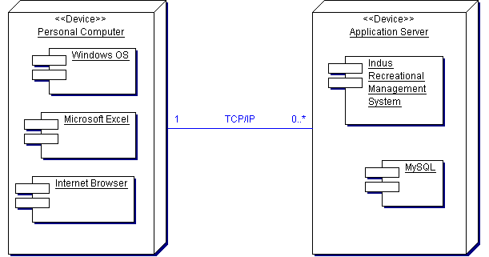

The Windows operating system along with Microsoft Excel and the internet browser of the users choosing will all reside on the personal computer of the Indus Recreational Facility staff members.

The IRFMS and MySQL will be located on an application server at the Indus Recreational Facility, the System and personal computer will be connected through a TCP/IP connection.

### Site Preparation

The preparation required to ensure that the system works on the required system properly includes:

* An in-depth installation guide to ensure an easy and efficient way to install the program on the user’s computer
* An in-depth user manual that explains the processes of using the IRFMS effectively and efficiently.
* An easy to use installation CD, this will run the script necessary to run the program on the user’s computer.

### Assessment of Deployment Readiness

Currently the methods used to ensure that deployment of IRFMS is up to date and efficient include:

* Test plan: this ensures that all areas of the program work as specified.
* User manual: this is used to test the system by following the instructions step by step to ensure that they are easy to use, efficient and have the same result as specified.
* Installation process: this is tested regularly to ensure that the system can be easily installed on other computers.

## 7.4 Data Creation/Conversion

The IRFMS allows the Staff of the Indus Recreational Facility to be able to create, update, view, delete multiple components of the system, such as:

* View schedules for a specific facility for a specific time frame.
* View employees
* View clients
* View organizations
* View rates
* View additional Charges
* View facilities
* View invoices
* Creating bookings for a specific time for a specific facility
* Create new employees
* Create new clients
* Create new organizations
* Create new rates
* Create new additional charges
* Create new facilities
* Create a invoice based on multiple bookings for a client
  + From the invoice created you have the option to:
    - Print the invoice
    - Email the invoice to the client or organization
    - Export the invoice in a cvs format to excel
* Delete employees
* Delete clients
* Delete organizations
* Delete rates
* Delete additional charges
* Delete facilities
* Modify employee information
* Modify client information
* Modify organization information
* Modify rate information
* Modify additional charge information
* Modify facility information

All the information entered when creating or updating any of the above components is validated as soon as the information is inputted to ensure that it is in the correct format and has the required information.

## 7.5 Training and Documentation

### Training

The IRFMS will come with a user guide that explains the main functions of the program in an easy to follow format.

### Documentation

All the IRFMS code is documented to help future programmers be able to maintain and update the system.

Other documentation that s included for the IRFMS is the Test Plan This tests the main components of the system to ensure that they work as described. This will assist future developers of the system in adding extra enhancements as they will be able to see how the code performs under certain conditions.

The last document is the User Guide, this will introduce users to the system. The guide is in depth and shows how each component of the system interacts with one another in a systematic manner. It also shows the user how certain components of the system interact with each other on the final product.

### Documents

The installation document with instructions on how to install the IRFMS system will be included in the:

* The User guide: this guide will help the user step by step throughout all important components of the system; it will also provide help in certain areas if the user is having difficulty.

### Documentation Activities

The activities required for the test plan include:

* Multiple tests of system
* Testing each field to ensure quality
* Testing the system with invalid information
* Testing the creation, deletion and updating of different components such as clients, employees, etc.

The activities required for the User Guide include:

* Multiple run through of using the system in different environments.
* Ensuring that step by step instructions are exactly the same as actual actions in the system.
* Ensuring that the guide is written in a clear and easy to understand fashion to be able to help users of any level.

## 7.6 Maintenance Planning

The entire system is documented this will assist in understanding what every class’s main function is supposed to be. Each method within the class and all variables are documented to help explain the purpose and logic behind how the IRFMS was designed and built.

By documenting throughout the system it helps convey the reasoning behind why it was built this way. It will help any future programmers figure out the connections between classes and how everything works together.

## 7.7 Release Planning

### Release of the Product

The process for releasing the IRFMS to users is to ensure that all components that work are polished and work completely, ensuring that any components that currently do not meet standards of quality are commented out or made inactive to be worked upon on a later date.

### Contingency Planning

The contingency plan in case an error occurs while show casing the IRFMS is to be able to move onto different components if one or more components fail to work.

## 7.8 Changeover Strategy

The Indus Recreational Facility staff will install the new system on all required systems for the facility, than manually move all the existing database information into the new MySQL server included with the installation of Indus Recreational Facility Management System.

Once all the data has been inputted into the MySQL database, the system should help improve the Indus Recreational Facility staff ability to deal with their daily tasks by improving efficiency as well as reducing the redundancy of work by staff members to accomplish certain tasks such as creating invoices or creating clients utilizing an easy and intuitive HCI. The new system will make previously expensive processes such as adding facilities, an easy and cost effective task for staff.

# 8.0 System Administration and Maintenance

## 8.1 System Administration

The tasks that are required for system administration include:

* Cold backups on a nightly basis for Indus Recreational Facility Management System, done to ensure that no data is lost
* Creation of new accounts for all users of the system
* The ability to reset client passwords if necessary.
* Creation of new facilities
* Creation of new booking types
* Creation of new additional charges
* Creation of new rate
* The ability to report unpaid invoices
* The ability to report invoices for clients

## 8.2 System Maintenance

The System Maintenance required for the Indus Recreational Facility Management System includes:

* Creation of employees
* Updating employee information as necessary
* Deleting employees as necessary
* Creation of clients
* Updating client information as necessary
* Deleting clients as necessary
* Creation of organization
* Updating organization information as necessary
* Deleting organizations as necessary
* Creation of rates
* Updating rate information as necessary
* Deleting rates as necessary
* Creation of additional charges
* Updating additional charge information as necessary
* Deleting additional charges as necessary
* Creation of facilities
* Updating facilities information as necessary
* Deleting facilities as necessary
* Creation of invoices
* Updating invoice information as necessary
* Deleting invoices as necessary
* Creation of booking
* Updating booking information as necessary
* Deleting booking as necessary

# 9.0 Deficiency List

## 9.1 Requirements Not Met

* ToDoItem Broker and Manager are designed but have not been implemented for the system.
* Employee level was not completely implemented
* Client accessing to the system is not designed or developed
* Proper handling of catered bookings was not designed
* Have a rate automatically assigned based on what time the booking is at.
* Search functionality in the Schedule Information pages.
* The ability to quickly add or view information in separate areas of the system. (e.g. When creating or viewing a booking, being able to add of view a client.)
* Special characters are not properly escaped in SQL. Ex commas

## 9.2 Non-Functioning Components

The components of Indus Recreational Facility management System that currently do not work include:

* Catering currently is not functioning at all
* Special characters cannot currently be inputted in any field throughout the program
* Currently you cannot search bookings on the scheduling page or the invoice page
* Available time located in the schedule page for the program currently isn’t generated for the free time of the schedule
* Employee roles currently have no effect on the Indus System
* The rate validation fields located in the rate detail screen currently have no functionality

# Glossary

**Facility:** A user defined complex for activities organized at the Indus Recreation Centre.

**Facility Manager:** The manager of the facility, who is in charge or organizing and running Indus recreational centre.

**Accountant:** takes care of money issues, and keeps/updates the books.

**Employee(s):** (upkeep of facility, caterers): clean facility and maintain all recreational resources’.

**Remote Access:** The ability to retrieve information from the system at a decentralized location.

**Invoice:** Are the statements of billing from activities being held at the Indus Recreation Centre.

**Client/Users:** A person or organization that books a facility during a specific time period.

**Quality of Life:** The measurement of a person’s lifestyle, and how it affects them.

**Twinning:** The doubling of a facilities resources, such as ice rinks, outdoor facilities and meeting rooms/ banquet halls.

**Facility:** Current system used for scheduling and invoicing at the Indus Recreational Centre.

**Organization:** A group that will book facility resources.

**Booking:** The lock of time that a client or organization schedules to use facilities.

**Booking Type:** Purpose of a rental.

**Rate:** Hourly charge for facilities.

**Additional Charge:** Optional services that can be added to certain bookings such as meeting rooms or banquet halls.

## Appendix A

### Interview Questions:

1. Do you rent any sort of equipment?
   1. If so, what sort of equipment do you rent?
2. How many users will use the system?
3. How do you prefer bookings done?
4. Do you need a web based version of the system?
   1. What sort of functions should be available from the web interface?
5. What do you believe the major limitations of the current system are?
6. Do you need access levels for staff to use the system?
   1. If so what access levels do you need?
   2. Do volunteers require access to the system?
7. Do you plan to expand your staff, in the future?
8. Should the curling rink, and fields be part of the booking system?
9. How are programs scheduled? (day care, summer camps)
10. How are payments handled? (visa, interact)
11. How do you handle catering requests?
12. Do you handle decoration requests also?

### Interview Answers

1. No they don’t rent any equipment at Indus recreational facility.
   1. N/A
2. 3 users currently, if they twin it will probably double.
3. They want clients to be able to see timetables online, after they have chosen a time; they can phone in and book it.
4. Yes they prefer a web based version.
   1. Identical to system currently installed.
5. If they don’t have internet, then their system is inaccessible. All the facilities are not currently included in schedule. Don’t have the functionality to add new facilities. The cost of using the system is expensive (monthly payment)
6. No, the user login is just a security feature; all programs are available to book for all staff.
   1. N/A
   2. No
7. Yes, if a twinning occurs, their staff will double.
8. The curling rink is not a part of the Indus recreational facility. The outdoor fields should be included in the scheduling feature of the system and also future outdoor fields should be taken into consideration.
9. At the current time, a staff member (Lisa) does bookings on paper. These include day care, summer camp, catering and other programs.
10. Have to generate an invoice number, for each invoice, so that the centre may receive payment for their services. The debit machine requires the invoice number before it will process a transaction.
11. There is a kitchen manager who handles all catering requests.
12. Decoration requests are handled by the clients.

## Appendix B

### User requests:

1. Bring up one user group, example IMHA for the month of September. (billed monthly)
2. Send an email (invoice) with an explanation of expenses (attachment).
3. Have the booking and invoicing systems integrated together with Quick books to increase efficiency.
4. Arena, hall, meeting room, outdoor sports (soccer, baseball) all be included in schedule.
5. Available ice time for a predetermined amount of time, take into account 15 minute flood time after each use.
6. There is a possibility of Twinning in 2 – 5 years system should have the ability to add new complexes built in.
7. The accounting software that is presently used is only compatible with excel. Would like the system to be able to save the invoice in excel format as well as word.
8. All content available online tied into their current system.

## Appendices: C

Page 120 contains: Invoice

Page 121 & 122 contains: Current facility prices and times



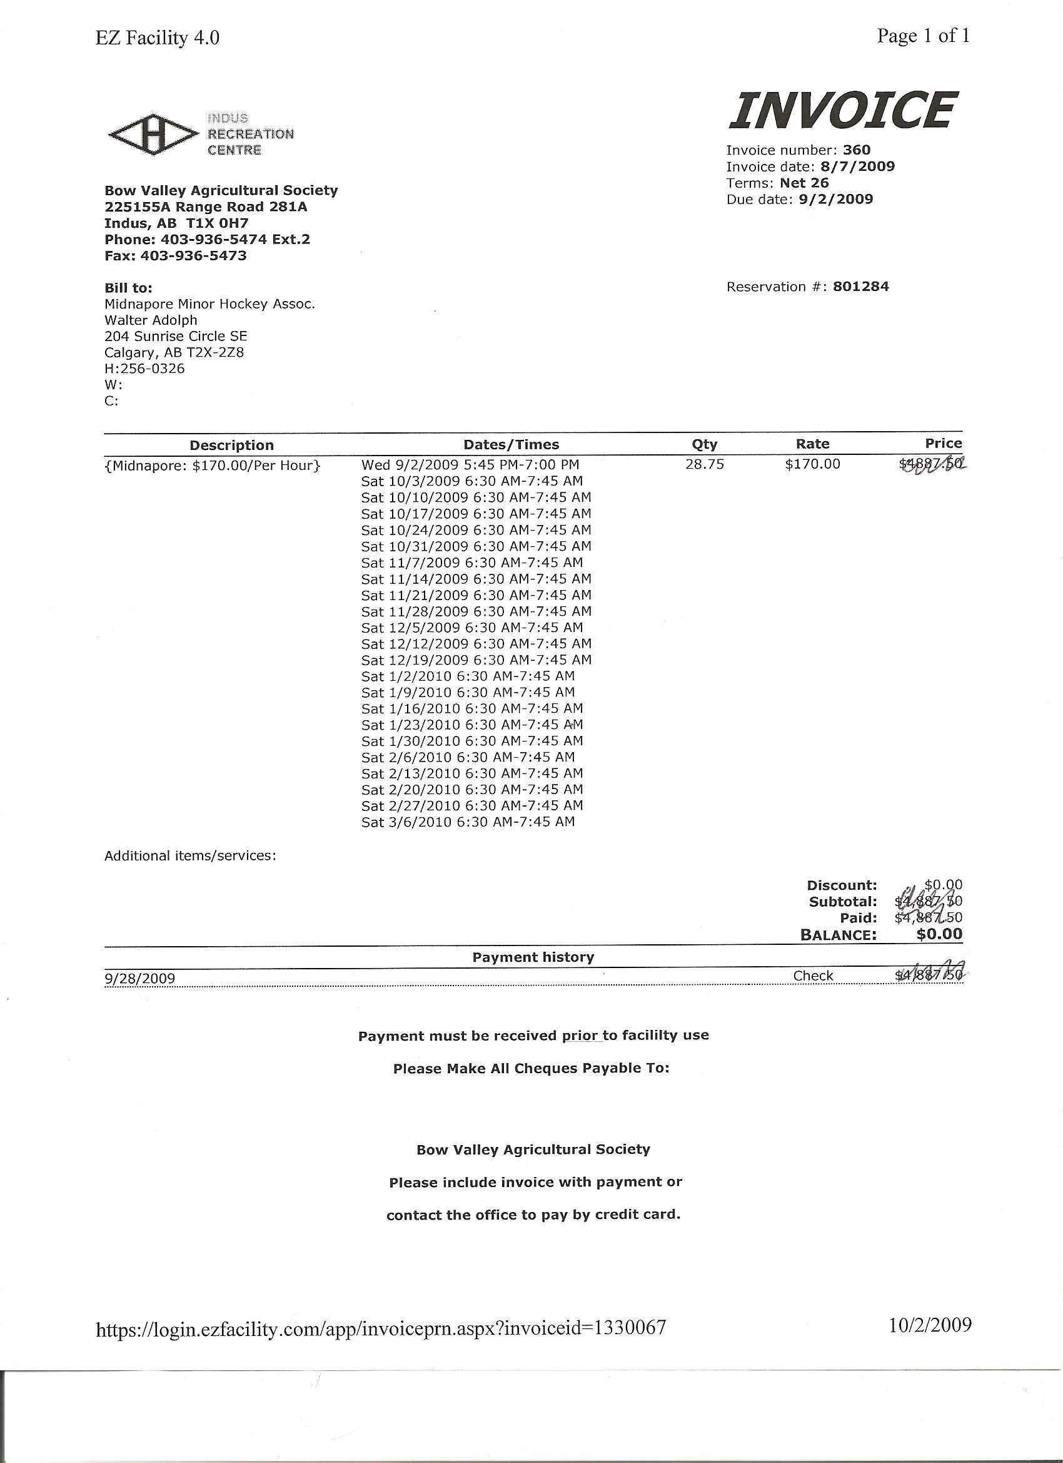

## Appendix D

The following are screenshots of the current Indus EZ Facility system.



## Appendices: E

See code

# Index

catering, 13, 14

Current System, 15

Documentation Standards, 10

Extended Use Case Descriptions, 17

EZFacility, 15

invoice, 13, 14

Maintain Additional Charge(s), 19

Maintain Bookings, 25, 26

Maintain Clients, 24

Maintain Employees, 17

Maintain Event Types, 18

Maintain Facilities, 18

Maintain Invoicing, 23

Maintain Organizations, 24

Maintain Rates, 21

Project Overview, 13

Project Scope, 13

Purpose, 10

quality of life, 13

Statement of the Problem, 13

System Environment, 14